UNITED STATES
SECURITIES AND EXCHANGE COMMISSION
WASHINGTON, D.C. 20549
FORM 8-K
CURRENT REPORT
Pursuant to Section 13 or 15(d) of The Securities Exchange Act of 1934

September 3, 2026
Date of Report (Date of earliest event reported)

Red River Bancshares, Inc.
(Exact Name of Registrant as Specified in its Charter)
Louisiana |  |  | 001-38888 |  |  | 72-1412058
(State or Other Jurisdiction  of Incorporation) |  |  | (Commission  File Number) |  |  | (IRS Employer  Identification No.)
1412 Centre Court Drive, Suite 301, Alexandria, Louisiana |  |  |  |  |  | 71301
(Address of Principal Executive Offices) |  |  |  |  |  | (Zip Code)
(318) 561-4000
Registrant’s telephone number, including area code

Check the appropriate box below if the Form 8-K filing is intended to simultaneously satisfy the filing obligation of the registrant under any of the following provisions:

☐ Written communications pursuant to Rule 425 under the Securities Act (17 CFR 230.425)

☐ Soliciting material pursuant to Rule 14a-12 under the Exchange Act (17 CFR 240.14a-12)

☐ Pre-commencement communications pursuant to Rule 14d-2(b) under the Exchange Act (17 CFR 240.14d-2(b))

☐ Pre-commencement communications pursuant to Rule 13e-4(c) under the Exchange Act (17 CFR 240.13e-4(c))

Securities registered pursuant to Section 12(b) of the Act:
Title of each class |  |  | Trading  Symbol(s) |  |  | Name of each exchange  on which registered
Common Stock, no par value |  |  | RRBI |  |  | The Nasdaq Stock Market, LLC

Indicate by check mark whether the registrant is an emerging growth company as defined in Rule 405 of the Securities Act of 1933 (§230.405 of this chapter) or Rule 12b-2 of the Securities Exchange Act of 1934 (§240.12b-2 of this chapter).

Emerging growth company ☐

If an emerging growth company, indicate by check mark if the registrant has elected not to use the extended transition period for complying with any new or revised financial accounting standards provided pursuant to Section 13(a) of the Exchange Act. ☐

Item. 7.01 Regulation FD Disclosure.
Red River Bancshares, Inc. (the “Company”) intends to participate in various conferences in September 2026. During these conferences, members of the Company’s executive management team will meet with investors and analysts. Attached as Exhibit 99.1 to this Current Report on Form 8-K is the presentation the Company’s executive management team will present. The presentation is also available on the Investor Relations page of the Company’s website at www.redriverbank.net.
All information included in the presentation is presented as of the dates indicated, and the Company does not assume any obligation to correct or update such information in the future. In addition, the Company disclaims any inferences regarding the materiality of such information that may arise as a result of it furnishing such information under Item 7.01 of this Current Report on Form 8-K.
As provided in General Instruction B.2. to Form 8-K, the information furnished in Item 7.01 and Exhibit 99.1 of this Current Report on Form 8-K shall not be deemed “filed” for purposes of Section 18 of the Securities Exchange Act of 1934, as amended (the “Exchange Act”), or otherwise subject to the liabilities of that section, and such information shall not be deemed incorporated by reference in any filing under the Securities Act of 1933, as amended, or the Exchange Act, except as shall be expressly set forth by specific reference in such filing.
Item. 9.01 Financial Statements and Exhibits.
(d) Exhibits. The following are furnished as exhibits to this Current Report on Form 8-K.
Exhibit Number |  |  |  |  |  | Description of Exhibit
99.1 |  |  |  |  |  | Red River Bancshares, Inc. Investor Presentation for September 2026 Conferences
104 |  |  |  |  |  | Cover Page Interactive Data File (embedded within the Inline XBRL document)

SIGNATURES

Pursuant to the requirements of the Securities Exchange Act of 1934, the registrant has duly caused this report to be signed on its behalf by the undersigned hereunto duly authorized.

Dated: September 3, 2026
 |  |  | RED RIVER BANCSHARES, INC.
 |  |  | By: |  |  | /s/ Isabel V. Carriere
 |  |  |  |  |  | Isabel V. Carriere, CPA, CGMA
 |  |  |  |  |  | Senior Executive Vice President and Chief Financial Officer
 |  |  |  |  |  | (Principal Financial Officer and Principal Accounting Officer)
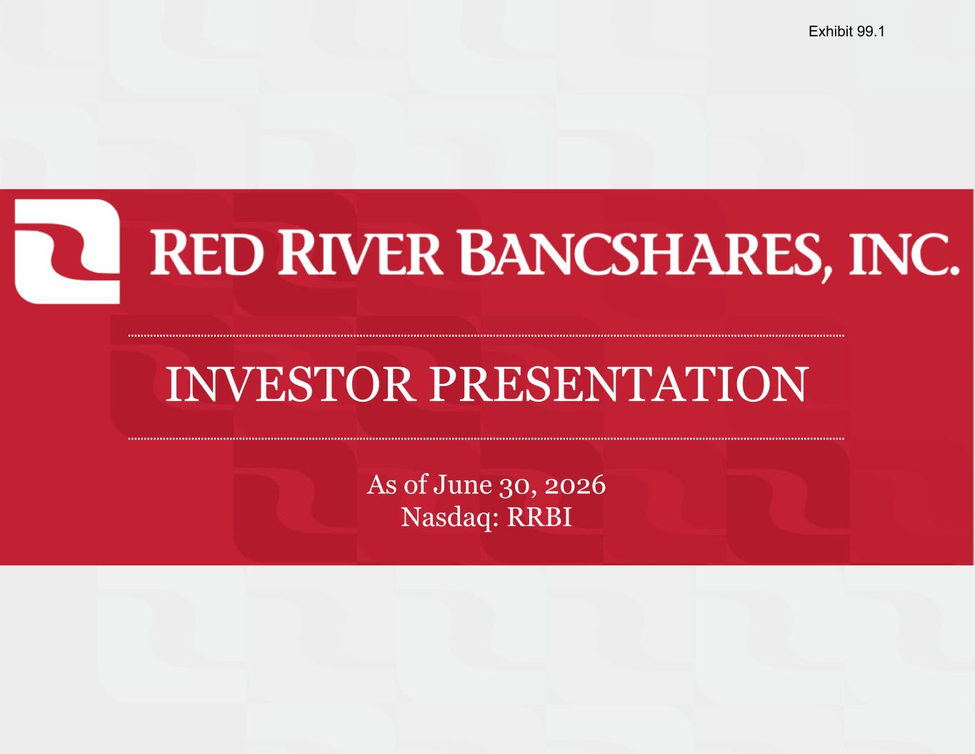

INVESTOR PRESENTATION As of June 30, 2026 Nasdaq: RRBI Exhibit 99.1

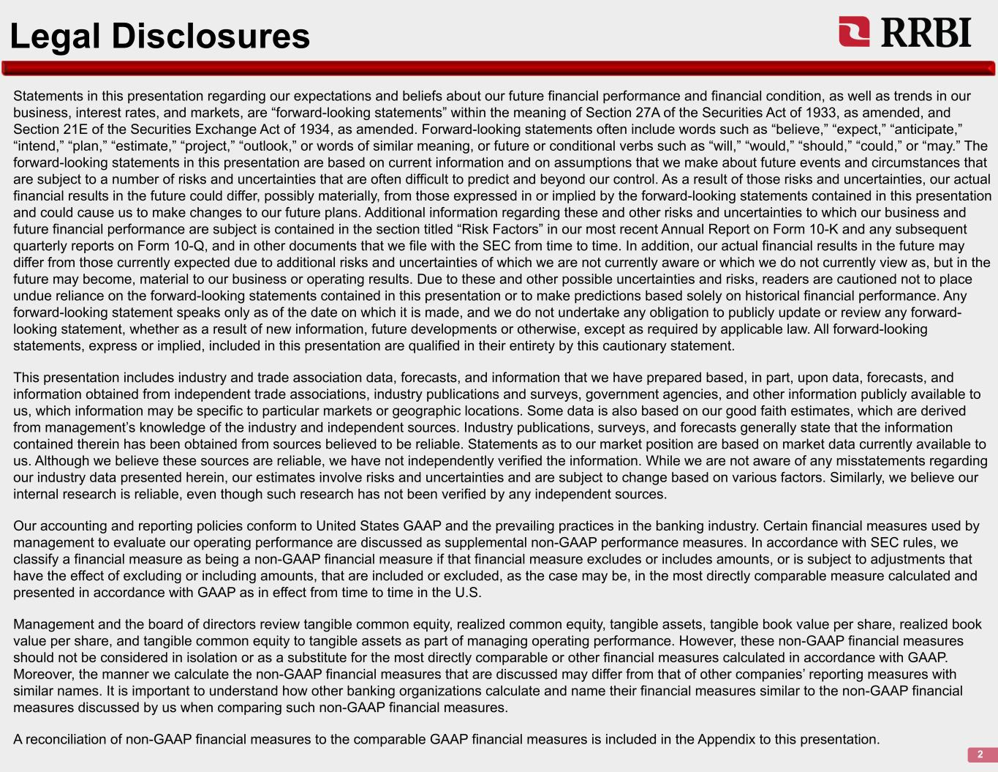
Legal Disclosures Statements in this presentation regarding our expectations and beliefs about our future financial performance and financial condition, as well as trends in our business, interest rates, and markets, are “forward-looking statements” within the meaning of Section 27A of the Securities Act of 1933, as amended, and Section 21E of the Securities Exchange Act of 1934, as amended. Forward-looking statements often include words such as “believe,” “expect,” “anticipate,” “intend,” “plan,” “estimate,” “project,” “outlook,” or words of similar meaning, or future or conditional verbs such as “will,” “would,” “should,” “could,” or “may.” The forward-looking statements in this presentation are based on current information and on assumptions that we make about future events and circumstances that are subject to a number of risks and uncertainties that are often difficult to predict and beyond our control. As a result of those risks and uncertainties, our actual financial results in the future could differ, possibly materially, from those expressed in or implied by the forward-looking statements contained in this presentation and could cause us to make changes to our future plans. Additional information regarding these and other risks and uncertainties to which our business and future financial performance are subject is contained in the section titled “Risk Factors” in our most recent Annual Report on Form 10-K and any subsequent quarterly reports on Form 10-Q, and in other documents that we file with the SEC from time to time. In addition, our actual financial results in the future may differ from those currently expected due to additional risks and uncertainties of which we are not currently aware or which we do not currently view as, but in the future may become, material to our business or operating results. Due to these and other possible uncertainties and risks, readers are cautioned not to place undue reliance on the forward-looking statements contained in this presentation or to make predictions based solely on historical financial performance. Any forward-looking statement speaks only as of the date on which it is made, and we do not undertake any obligation to publicly update or review any forward- looking statement, whether as a result of new information, future developments or otherwise, except as required by applicable law. All forward-looking statements, express or implied, included in this presentation are qualified in their entirety by this cautionary statement. This presentation includes industry and trade association data, forecasts, and information that we have prepared based, in part, upon data, forecasts, and information obtained from independent trade associations, industry publications and surveys, government agencies, and other information publicly available to us, which information may be specific to particular markets or geographic locations. Some data is also based on our good faith estimates, which are derived from management’s knowledge of the industry and independent sources. Industry publications, surveys, and forecasts generally state that the information contained therein has been obtained from sources believed to be reliable. Statements as to our market position are based on market data currently available to us. Although we believe these sources are reliable, we have not independently verified the information. While we are not aware of any misstatements regarding our industry data presented herein, our estimates involve risks and uncertainties and are subject to change based on various factors. Similarly, we believe our internal research is reliable, even though such research has not been verified by any independent sources. Our accounting and reporting policies conform to United States GAAP and the prevailing practices in the banking industry. Certain financial measures used by management to evaluate our operating performance are discussed as supplemental non-GAAP performance measures. In accordance with SEC rules, we classify a financial measure as being a non-GAAP financial measure if that financial measure excludes or includes amounts, or is subject to adjustments that have the effect of excluding or including amounts, that are included or excluded, as the case may be, in the most directly comparable measure calculated and presented in accordance with GAAP as in effect from time to time in the U.S. Management and the board of directors review tangible common equity, realized common equity, tangible assets, tangible book value per share, realized book value per share, and tangible common equity to tangible assets as part of managing operating performance. However, these non-GAAP financial measures should not be considered in isolation or as a substitute for the most directly comparable or other financial measures calculated in accordance with GAAP. Moreover, the manner we calculate the non-GAAP financial measures that are discussed may differ from that of other companies’ reporting measures with similar names. It is important to understand how other banking organizations calculate and name their financial measures similar to the non-GAAP financial measures discussed by us when comparing such non-GAAP financial measures. A reconciliation of non-GAAP financial measures to the comparable GAAP financial measures is included in the Appendix to this presentation. 2

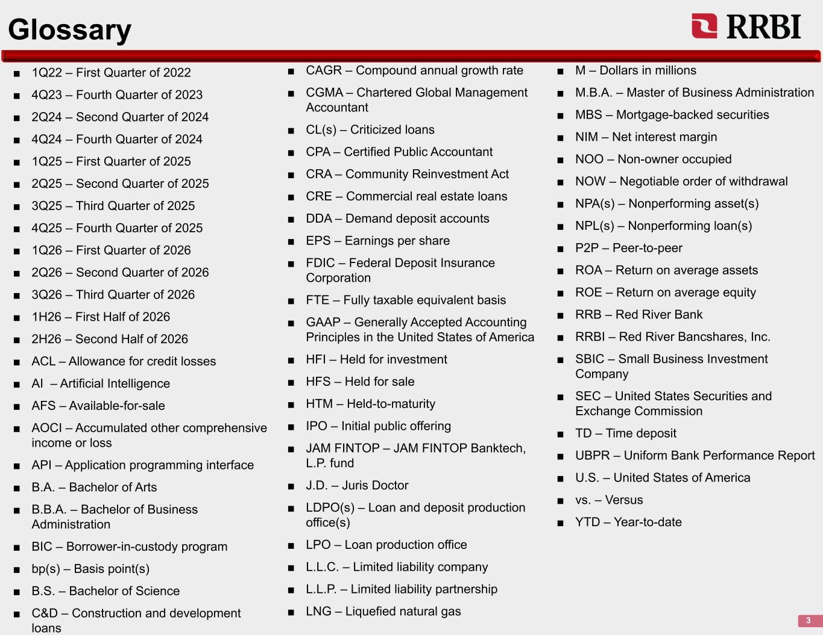
Glossary 3 ■ 1Q22 – First Quarter of 2022 ■ 4Q23 – Fourth Quarter of 2023 ■ 2Q24 – Second Quarter of 2024 ■ 4Q24 – Fourth Quarter of 2024 ■ 1Q25 – First Quarter of 2025 ■ 2Q25 – Second Quarter of 2025 ■ 3Q25 – Third Quarter of 2025 ■ 4Q25 – Fourth Quarter of 2025 ■ 1Q26 – First Quarter of 2026 ■ 2Q26 – Second Quarter of 2026 ■ 3Q26 – Third Quarter of 2026 ■ 1H26 – First Half of 2026 ■ 2H26 – Second Half of 2026 ■ ACL – Allowance for credit losses ■ AI – Artificial Intelligence ■ AFS – Available-for-sale ■ AOCI – Accumulated other comprehensive income or loss ■ API – Application programming interface ■ B.A. – Bachelor of Arts ■ B.B.A. – Bachelor of Business Administration ■ BIC – Borrower-in-custody program ■ bp(s) – Basis point(s) ■ B.S. – Bachelor of Science ■ C&D – Construction and development loans ■ CAGR – Compound annual growth rate ■ CGMA – Chartered Global Management Accountant ■ CL(s) – Criticized loans ■ CPA – Certified Public Accountant ■ CRA – Community Reinvestment Act ■ CRE – Commercial real estate loans ■ DDA – Demand deposit accounts ■ EPS – Earnings per share ■ FDIC – Federal Deposit Insurance Corporation ■ FTE – Fully taxable equivalent basis ■ GAAP – Generally Accepted Accounting Principles in the United States of America ■ HFI – Held for investment ■ HFS – Held for sale ■ HTM – Held-to-maturity ■ IPO – Initial public offering ■ JAM FINTOP – JAM FINTOP Banktech, L.P. fund ■ J.D. – Juris Doctor ■ LDPO(s) – Loan and deposit production office(s) ■ LPO – Loan production office ■ L.L.C. – Limited liability company ■ L.L.P. – Limited liability partnership ■ LNG – Liquefied natural gas ■ M – Dollars in millions ■ M.B.A. – Master of Business Administration ■ MBS – Mortgage-backed securities ■ NIM – Net interest margin ■ NOO – Non-owner occupied ■ NOW – Negotiable order of withdrawal ■ NPA(s) – Nonperforming asset(s) ■ NPL(s) – Nonperforming loan(s) ■ P2P – Peer-to-peer ■ ROA – Return on average assets ■ ROE – Return on average equity ■ RRB – Red River Bank ■ RRBI – Red River Bancshares, Inc. ■ SBIC – Small Business Investment Company ■ SEC – United States Securities and Exchange Commission ■ TD – Time deposit ■ UBPR – Uniform Bank Performance Report ■ U.S. – United States of America ■ vs. – Versus ■ YTD – Year-to-date



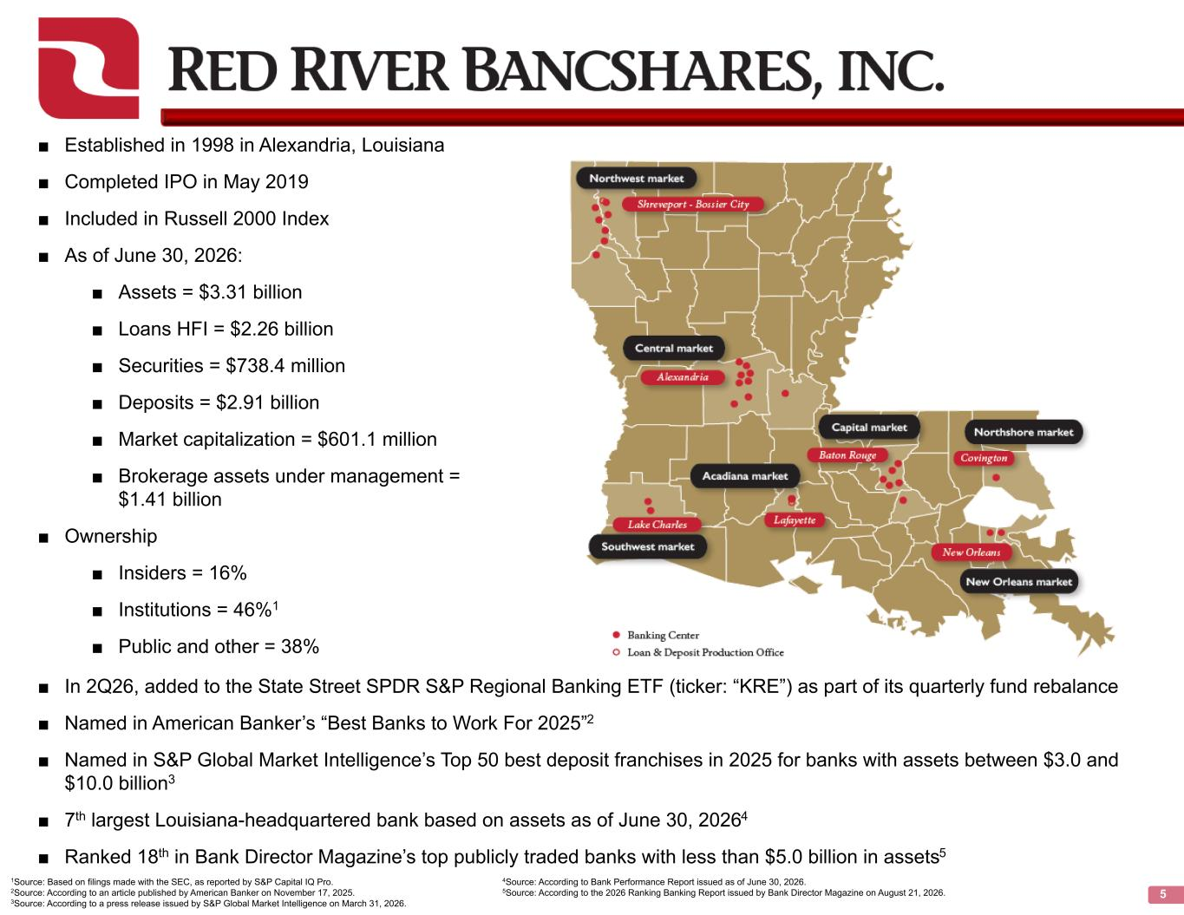
5 ■ Established in 1998 in Alexandria, Louisiana ■ Completed IPO in May 2019 ■ Included in Russell 2000 Index ■ As of June 30, 2026: ■ Assets = $3.31 billion ■ Loans HFI = $2.26 billion ■ Securities = $738.4 million ■ Deposits = $2.91 billion ■ Market capitalization = $601.1 million ■ Brokerage assets under management = $1.41 billion ■ Ownership ■ Insiders = 16% ■ Institutions = 46%1 ■ Public and other = 38% ■ In 2Q26, added to the State Street SPDR S&P Regional Banking ETF (ticker: “KRE”) as part of its quarterly fund rebalance ■ Named in American Banker’s “Best Banks to Work For 2025”2 ■ Named in S&P Global Market Intelligence’s Top 50 best deposit franchises in 2025 for banks with assets between $3.0 and $10.0 billion3 ■ 7th largest Louisiana-headquartered bank based on assets as of June 30, 20264 ■ Ranked 18th in Bank Director Magazine’s top publicly traded banks with less than $5.0 billion in assets5 1Source: Based on filings made with the SEC, as reported by S&P Capital IQ Pro. 2Source: According to an article published by American Banker on November 17, 2025. 3Source: According to a press release issued by S&P Global Market Intelligence on March 31, 2026. 4Source: According to Bank Performance Report issued as of June 30, 2026. 5Source: According to the 2026 Ranking Banking Report issued by Bank Director Magazine on August 21, 2026.

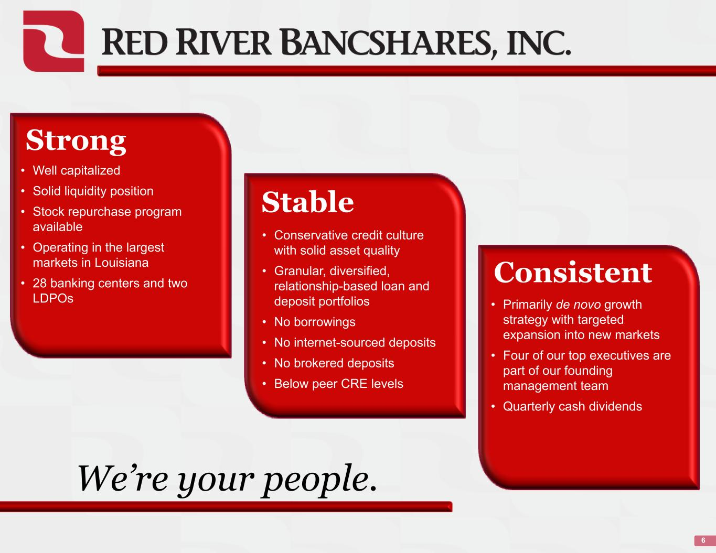
6 Strong • Well capitalized • Solid liquidity position • Stock repurchase program available • Operating in the largest markets in Louisiana • 28 banking centers and two LDPOs Stable • Conservative credit culture with solid asset quality • Granular, diversified, relationship-based loan and deposit portfolios • No borrowings • No internet-sourced deposits • No brokered deposits • Below peer CRE levels Consistent • Primarily de novo growth strategy with targeted expansion into new markets • Four of our top executives are part of our founding management team • Quarterly cash dividends We’re your people.


History & Strategy

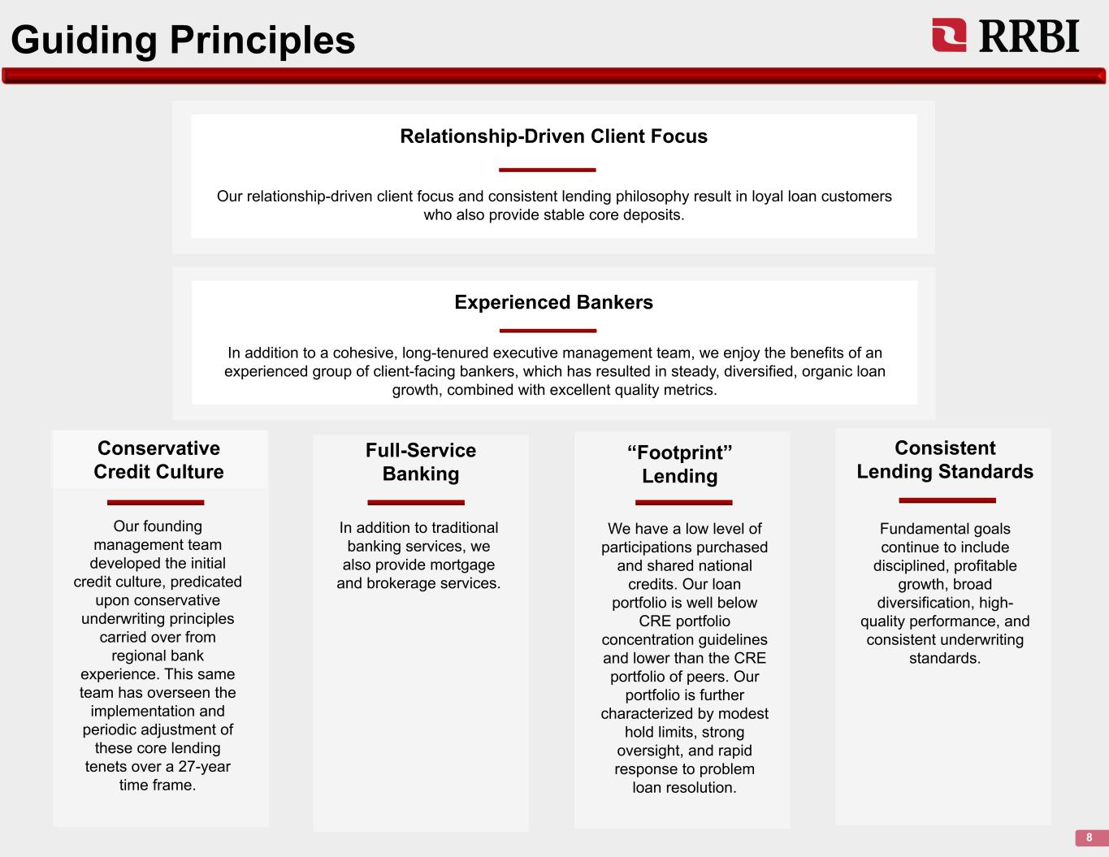
Guiding Principles 8 Conservative Credit Culture Our founding management team developed the initial credit culture, predicated upon conservative underwriting principles carried over from regional bank experience. This same team has overseen the implementation and periodic adjustment of these core lending tenets over a 27-year time frame. “Footprint” Lending We have a low level of participations purchased and shared national credits. Our loan portfolio is well below CRE portfolio concentration guidelines and lower than the CRE portfolio of peers. Our portfolio is further characterized by modest hold limits, strong oversight, and rapid response to problem loan resolution. Relationship-Driven Client Focus Our relationship-driven client focus and consistent lending philosophy result in loyal loan customers who also provide stable core deposits. Experienced Bankers In addition to a cohesive, long-tenured executive management team, we enjoy the benefits of an experienced group of client-facing bankers, which has resulted in steady, diversified, organic loan growth, combined with excellent quality metrics. Consistent Lending Standards Fundamental goals continue to include disciplined, profitable growth, broad diversification, high- quality performance, and consistent underwriting standards. Full-Service Banking In addition to traditional banking services, we also provide mortgage and brokerage services.

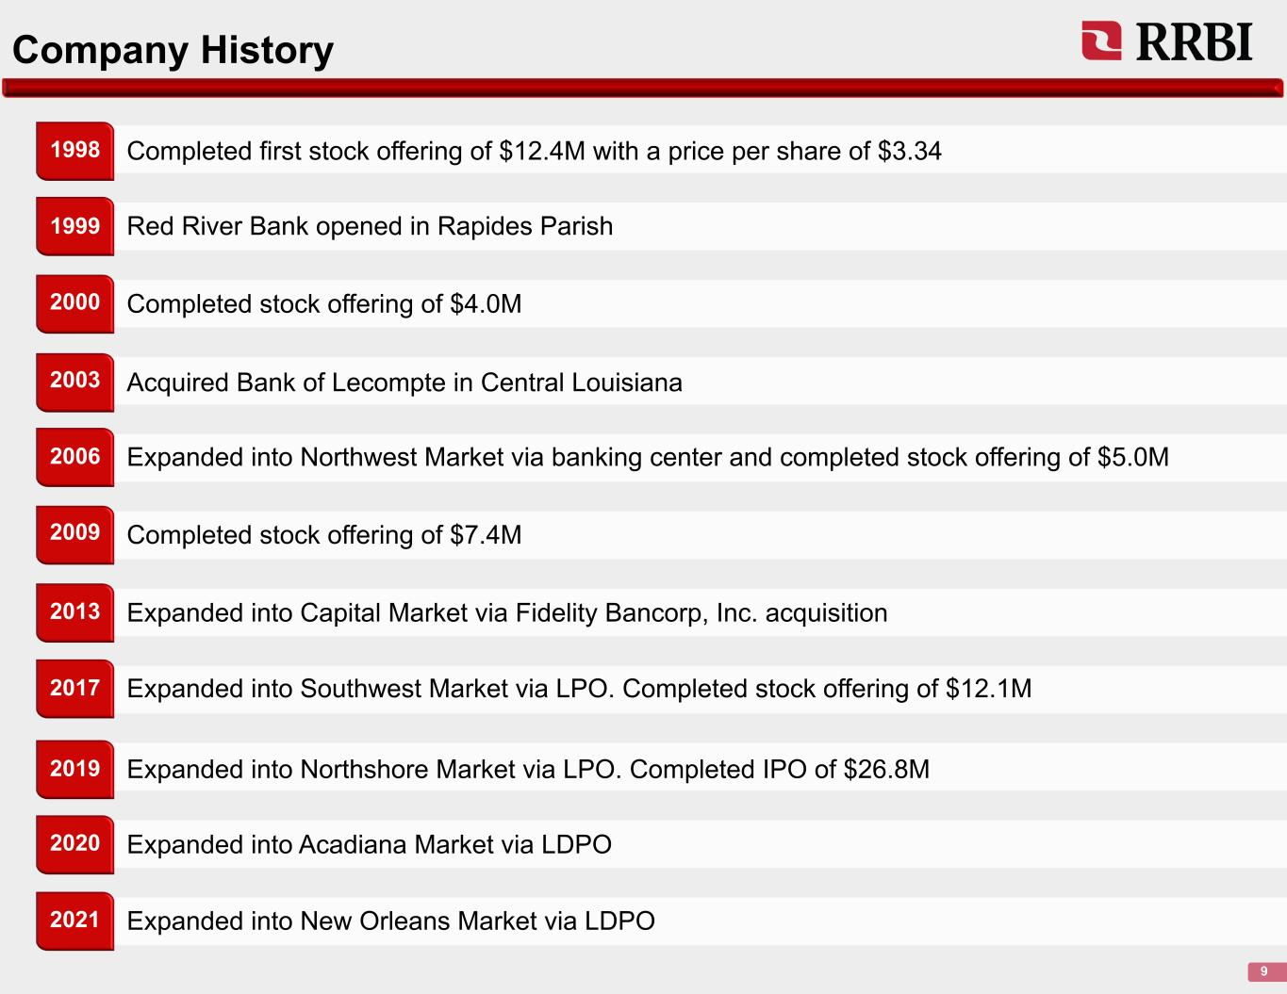
Company History 9 Completed first stock offering of $12.4M with a price per share of $3.341998 Red River Bank opened in Rapides Parish Completed stock offering of $4.0M Acquired Bank of Lecompte in Central Louisiana Expanded into Northwest Market via banking center and completed stock offering of $5.0M Completed stock offering of $7.4M Expanded into Capital Market via Fidelity Bancorp, Inc. acquisition Expanded into Southwest Market via LPO. Completed stock offering of $12.1M Expanded into Northshore Market via LPO. Completed IPO of $26.8M Expanded into Acadiana Market via LDPO Expanded into New Orleans Market via LDPO 1999 2000 2003 2006 2009 2013 2017 2019 2020 2021

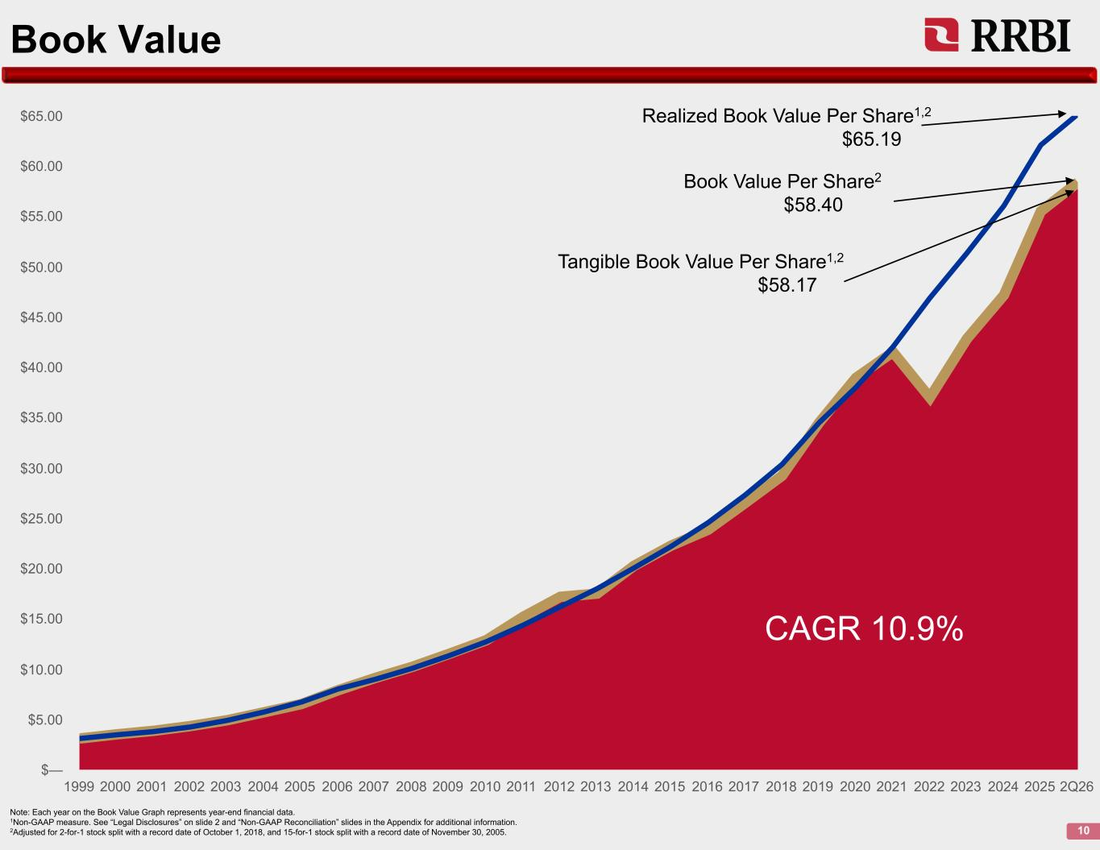
Book Value 10 Note: Each year on the Book Value Graph represents year-end financial data. 1Non-GAAP measure. See “Legal Disclosures” on slide 2 and “Non-GAAP Reconciliation” slides in the Appendix for additional information. 2Adjusted for 2-for-1 stock split with a record date of October 1, 2018, and 15-for-1 stock split with a record date of November 30, 2005. 1999 2000 2001 2002 2003 2004 2005 2006 2007 2008 2009 2010 2011 2012 2013 2014 2015 2016 2017 2018 2019 2020 2021 2022 2023 2024 2025 2Q26 $— $5.00 $10.00 $15.00 $20.00 $25.00 $30.00 $35.00 $40.00 $45.00 $50.00 $55.00 $60.00 $65.00 Realized Book Value Per Share1,2 $65.19 Book Value Per Share2 $58.40 Tangible Book Value Per Share1,2 $58.17 CAGR 10.9%

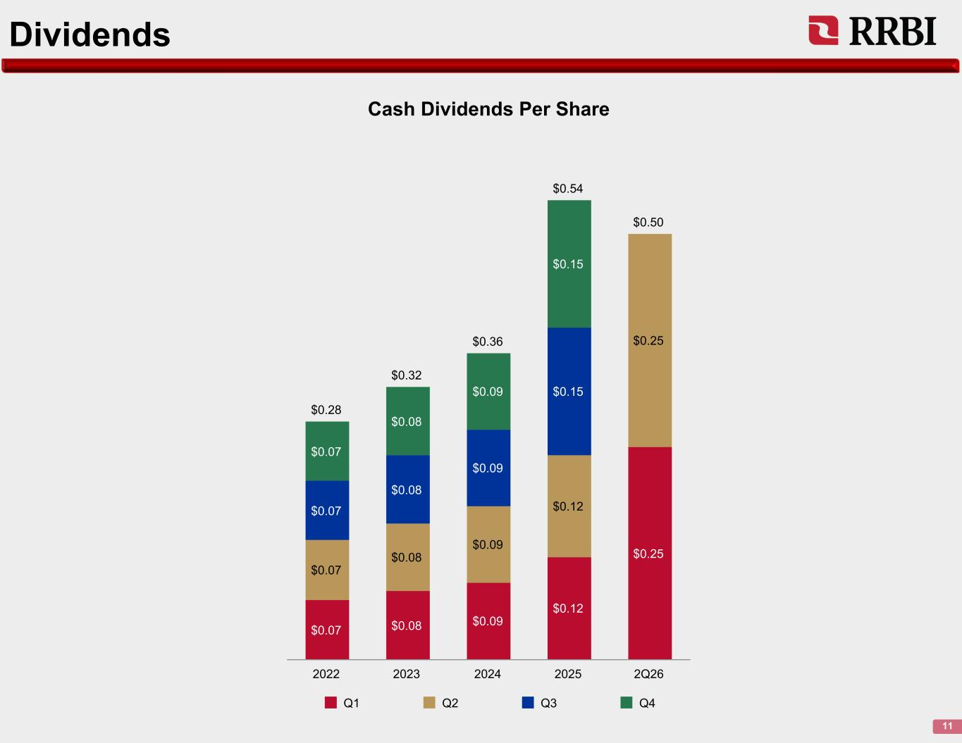
Dividends 11 $0.28 $0.32 $0.36 $0.54 $0.50 $0.07 $0.08 $0.09 $0.12 $0.25 $0.07 $0.08 $0.09 $0.12 $0.25 $0.07 $0.08 $0.09 $0.15 $0.07 $0.08 $0.09 $0.15 Q1 Q2 Q3 Q4 2022 2023 2024 2025 2Q26 Cash Dividends Per Share

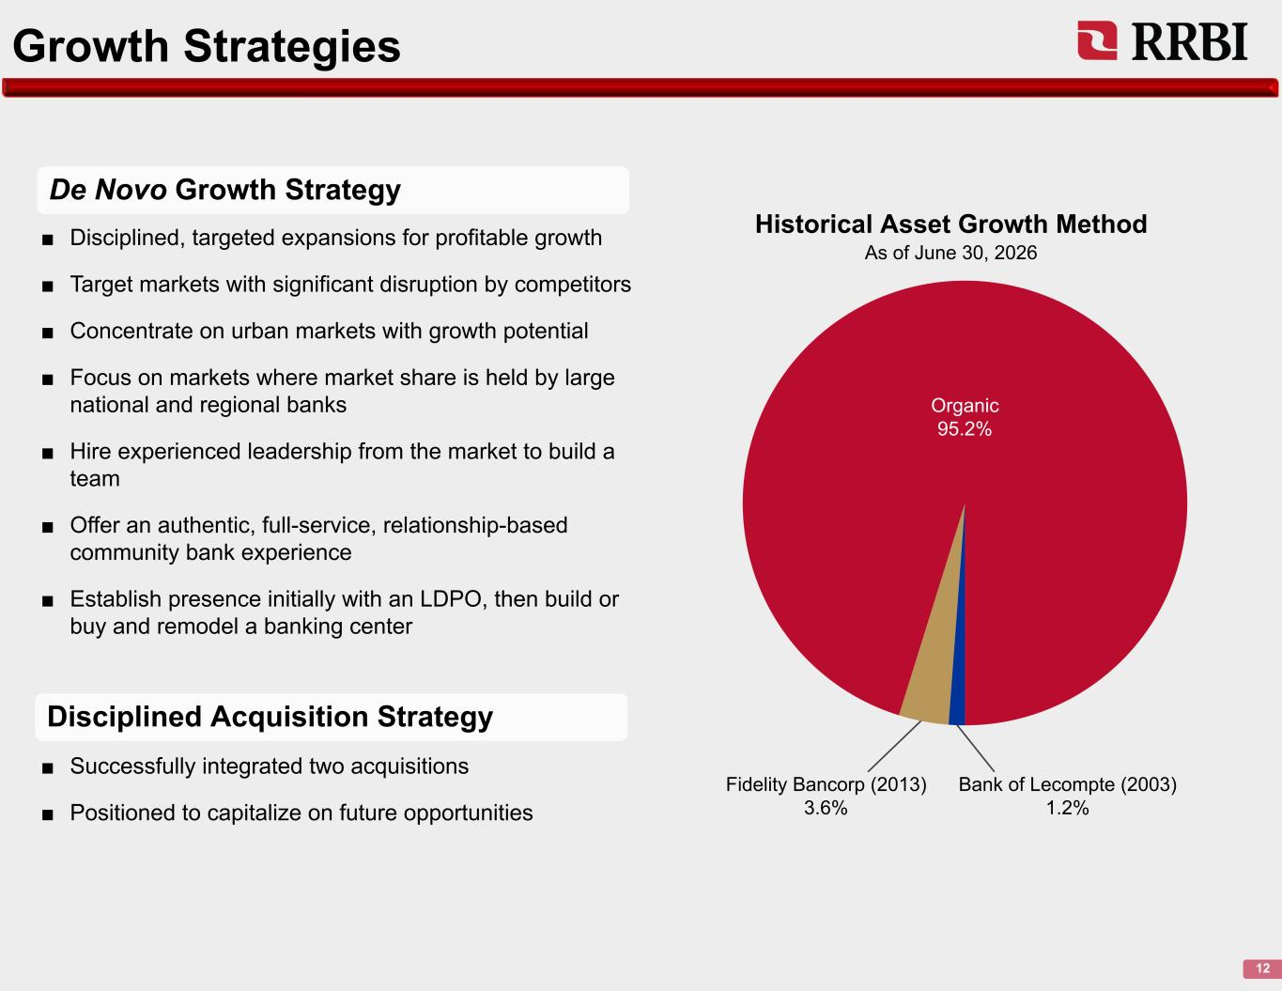
Growth Strategies 12 De Novo Growth Strategy ■ Disciplined, targeted expansions for profitable growth ■ Target markets with significant disruption by competitors ■ Concentrate on urban markets with growth potential ■ Focus on markets where market share is held by large national and regional banks ■ Hire experienced leadership from the market to build a team ■ Offer an authentic, full-service, relationship-based community bank experience ■ Establish presence initially with an LDPO, then build or buy and remodel a banking center ■ Successfully integrated two acquisitions ■ Positioned to capitalize on future opportunities Fidelity Bancorp (2013) 3.6% Bank of Lecompte (2003) 1.2% Historical Asset Growth Method As of June 30, 2026 Organic 95.2% Disciplined Acquisition Strategy

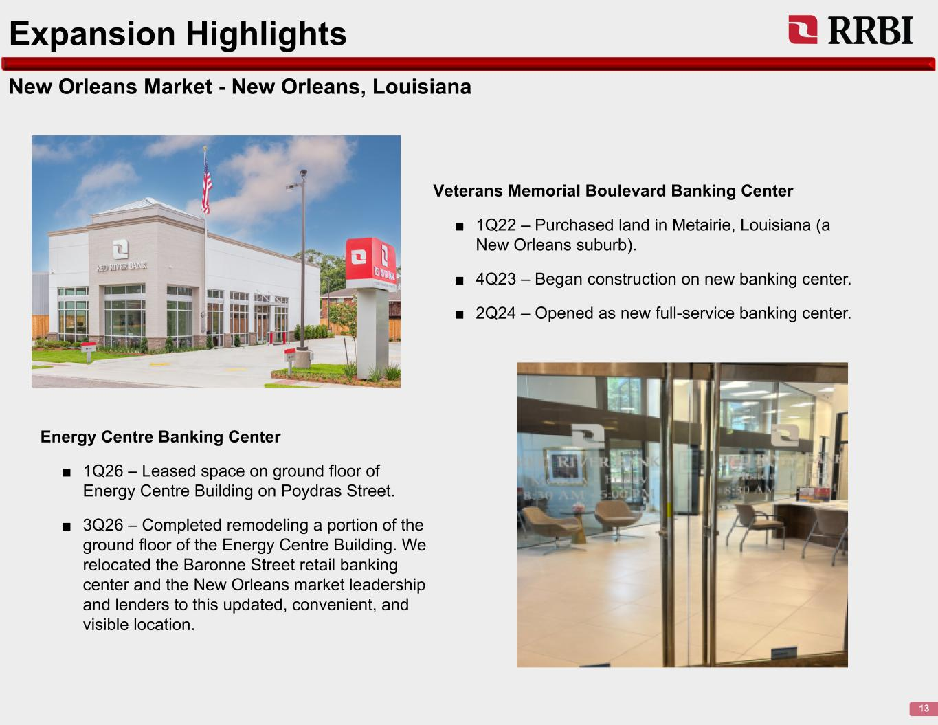
New Orleans Market - New Orleans, Louisiana 13 Expansion Highlights Veterans Memorial Boulevard Banking Center ■ 1Q22 – Purchased land in Metairie, Louisiana (a New Orleans suburb). ■ 4Q23 – Began construction on new banking center. ■ 2Q24 – Opened as new full-service banking center. Energy Centre Banking Center ■ 1Q26 – Leased space on ground floor of Energy Centre Building on Poydras Street. ■ 3Q26 – Completed remodeling a portion of the ground floor of the Energy Centre Building. We relocated the Baronne Street retail banking center and the New Orleans market leadership and lenders to this updated, convenient, and visible location.

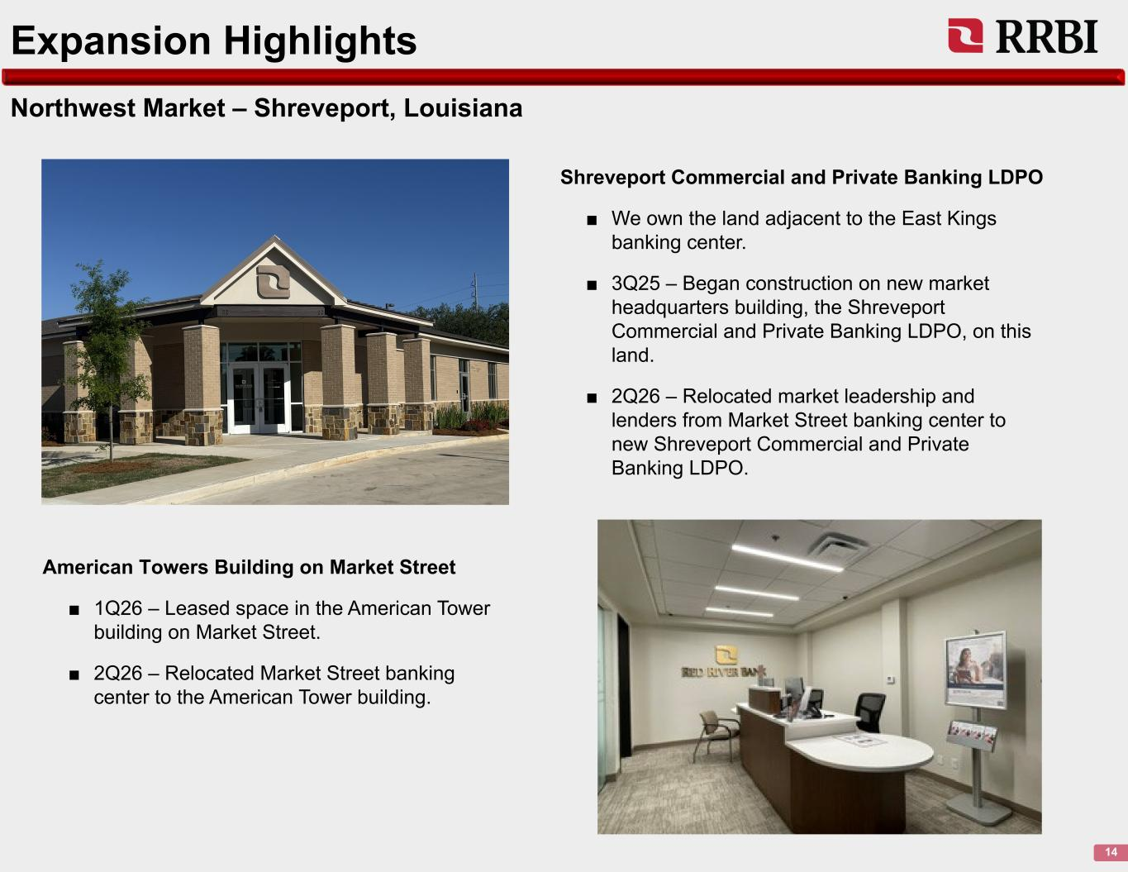
Northwest Market – Shreveport, Louisiana 14 Expansion Highlights Shreveport Commercial and Private Banking LDPO ■ We own the land adjacent to the East Kings banking center. ■ 3Q25 – Began construction on new market headquarters building, the Shreveport Commercial and Private Banking LDPO, on this land. ■ 2Q26 – Relocated market leadership and lenders from Market Street banking center to new Shreveport Commercial and Private Banking LDPO. American Towers Building on Market Street ■ 1Q26 – Leased space in the American Tower building on Market Street. ■ 2Q26 – Relocated Market Street banking center to the American Tower building.

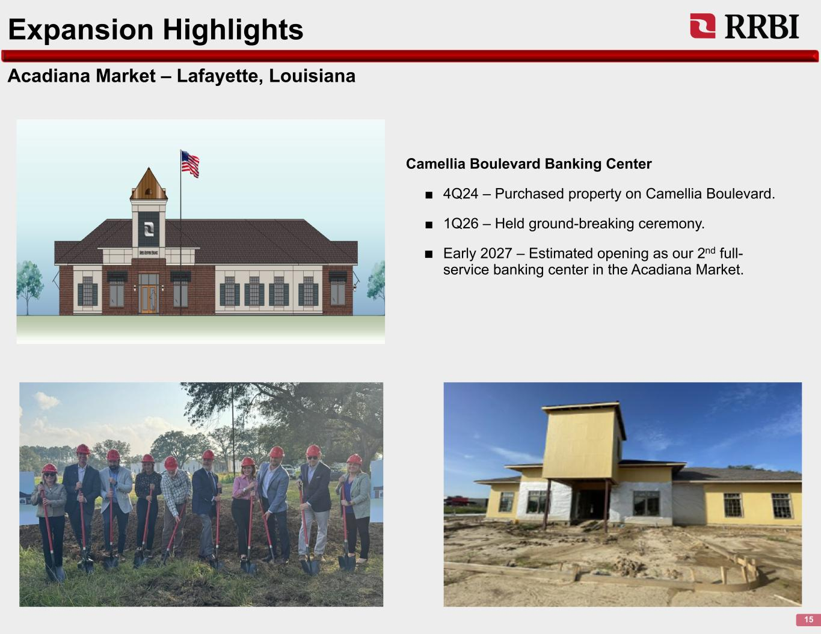
Acadiana Market – Lafayette, Louisiana 15 Expansion Highlights Camellia Boulevard Banking Center ■ 4Q24 – Purchased property on Camellia Boulevard. ■ 1Q26 – Held ground-breaking ceremony. ■ Early 2027 – Estimated opening as our 2nd full- service banking center in the Acadiana Market.

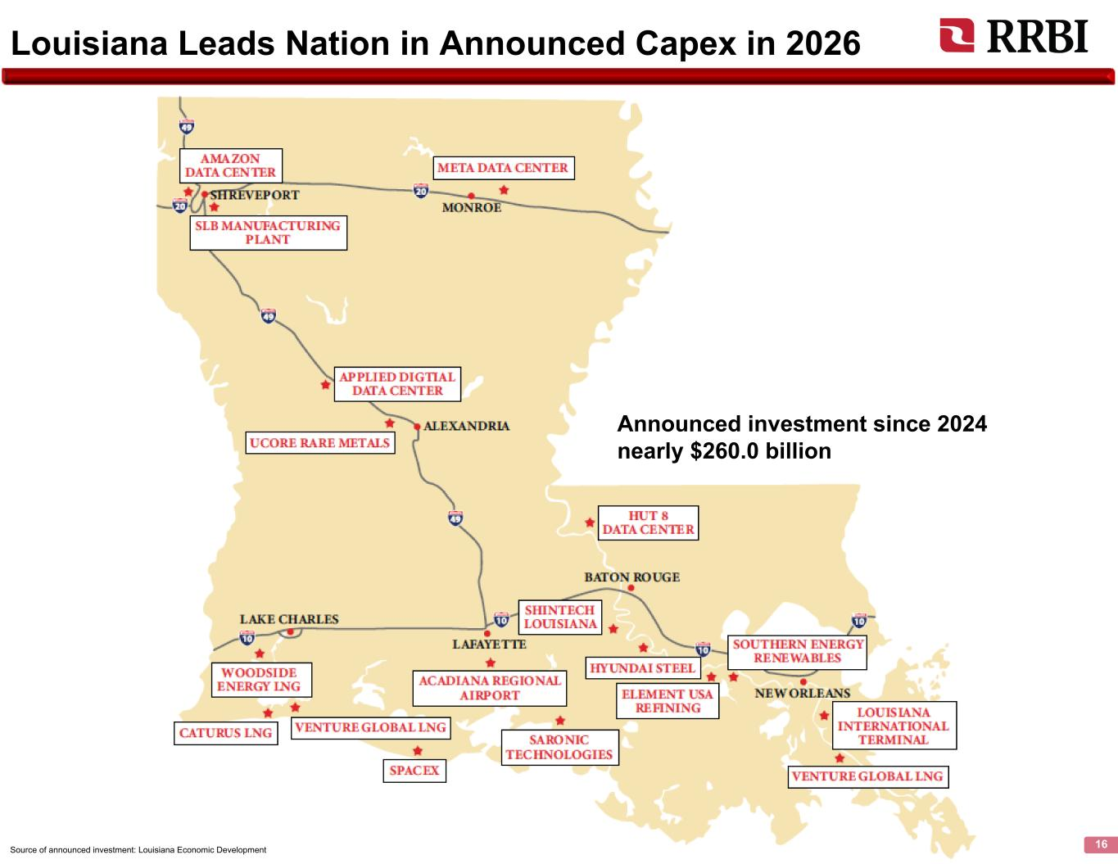
Louisiana Leads Nation in Announced Capex in 2026 16 Announced investment since 2024 nearly $260.0 billion Source of announced investment: Louisiana Economic Development

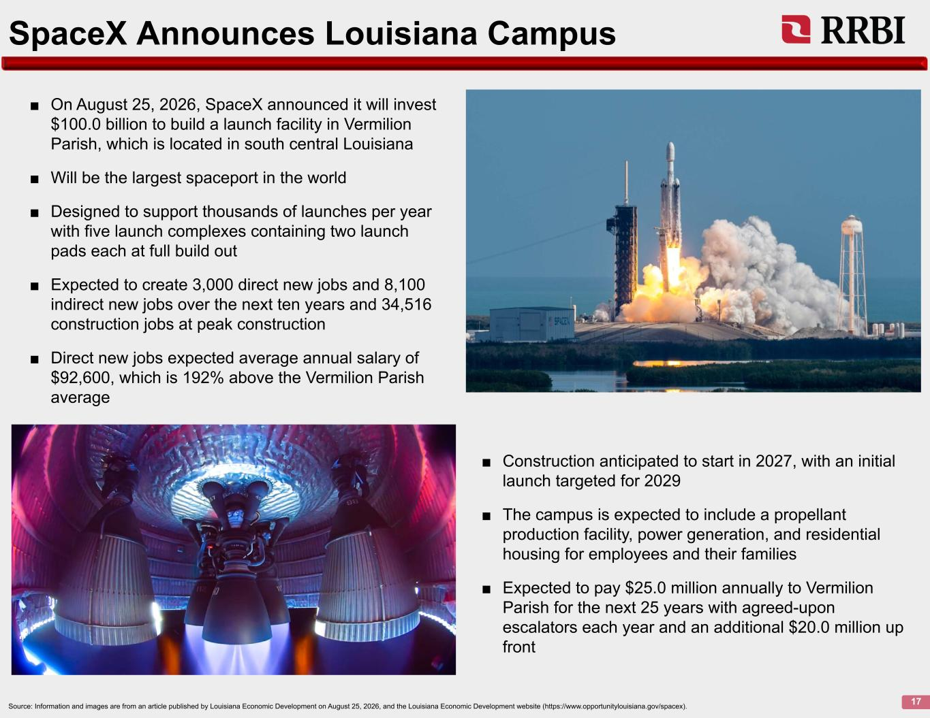
SpaceX Announces Louisiana Campus 17 ■ On August 25, 2026, SpaceX announced it will invest $100.0 billion to build a launch facility in Vermilion Parish, which is located in south central Louisiana ■ Will be the largest spaceport in the world ■ Designed to support thousands of launches per year with five launch complexes containing two launch pads each at full build out ■ Expected to create 3,000 direct new jobs and 8,100 indirect new jobs over the next ten years and 34,516 construction jobs at peak construction ■ Direct new jobs expected average annual salary of $92,600, which is 192% above the Vermilion Parish average ■ Construction anticipated to start in 2027, with an initial launch targeted for 2029 ■ The campus is expected to include a propellant production facility, power generation, and residential housing for employees and their families ■ Expected to pay $25.0 million annually to Vermilion Parish for the next 25 years with agreed-upon escalators each year and an additional $20.0 million up front Source: Information and images are from an article published by Louisiana Economic Development on August 25, 2026, and the Louisiana Economic Development website (https://www.opportunitylouisiana.gov/spacex).

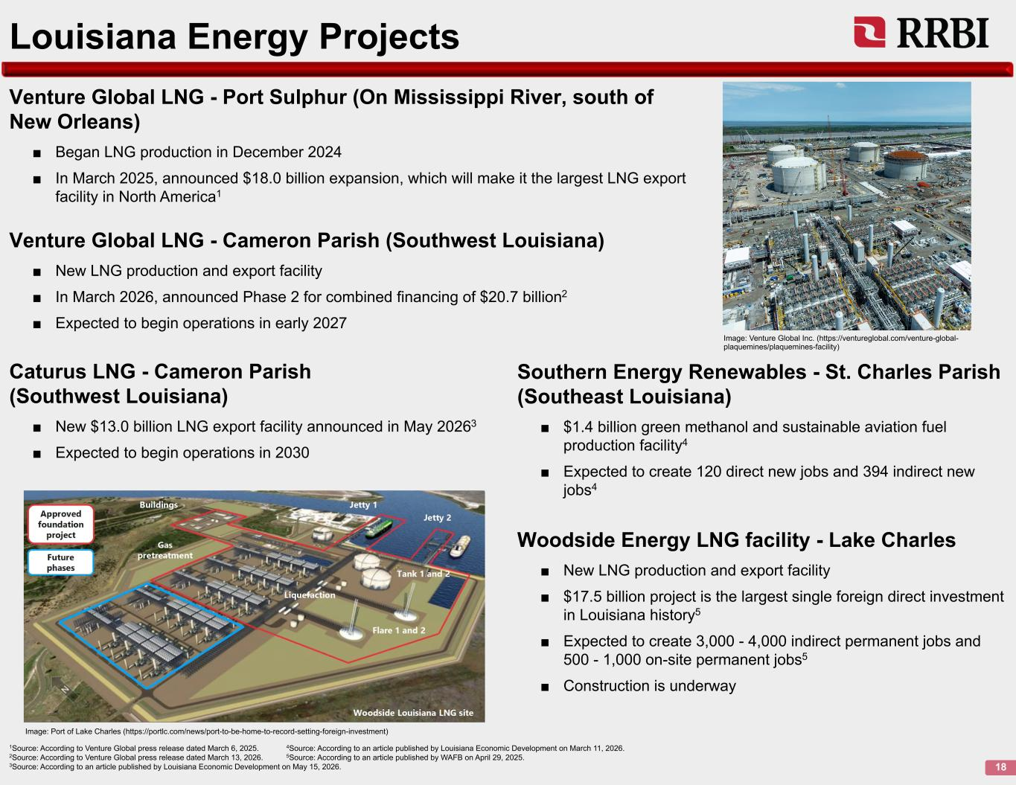
18 Louisiana Energy Projects Woodside Energy LNG facility - Lake Charles ■ New LNG production and export facility ■ $17.5 billion project is the largest single foreign direct investment in Louisiana history5 ■ Expected to create 3,000 - 4,000 indirect permanent jobs and 500 - 1,000 on-site permanent jobs5 ■ Construction is underway Venture Global LNG - Port Sulphur (On Mississippi River, south of New Orleans) ■ Began LNG production in December 2024 ■ In March 2025, announced $18.0 billion expansion, which will make it the largest LNG export facility in North America1 1Source: According to Venture Global press release dated March 6, 2025. 4Source: According to an article published by Louisiana Economic Development on March 11, 2026. 2Source: According to Venture Global press release dated March 13, 2026. 5Source: According to an article published by WAFB on April 29, 2025. 3Source: According to an article published by Louisiana Economic Development on May 15, 2026. Image: Venture Global Inc. (https://ventureglobal.com/venture-global- plaquemines/plaquemines-facility) Image: Port of Lake Charles (https://portlc.com/news/port-to-be-home-to-record-setting-foreign-investment) Venture Global LNG - Cameron Parish (Southwest Louisiana) ■ New LNG production and export facility ■ In March 2026, announced Phase 2 for combined financing of $20.7 billion2 ■ Expected to begin operations in early 2027 Caturus LNG - Cameron Parish (Southwest Louisiana) ■ New $13.0 billion LNG export facility announced in May 20263 ■ Expected to begin operations in 2030 Southern Energy Renewables - St. Charles Parish (Southeast Louisiana) ■ $1.4 billion green methanol and sustainable aviation fuel production facility4 ■ Expected to create 120 direct new jobs and 394 indirect new jobs4

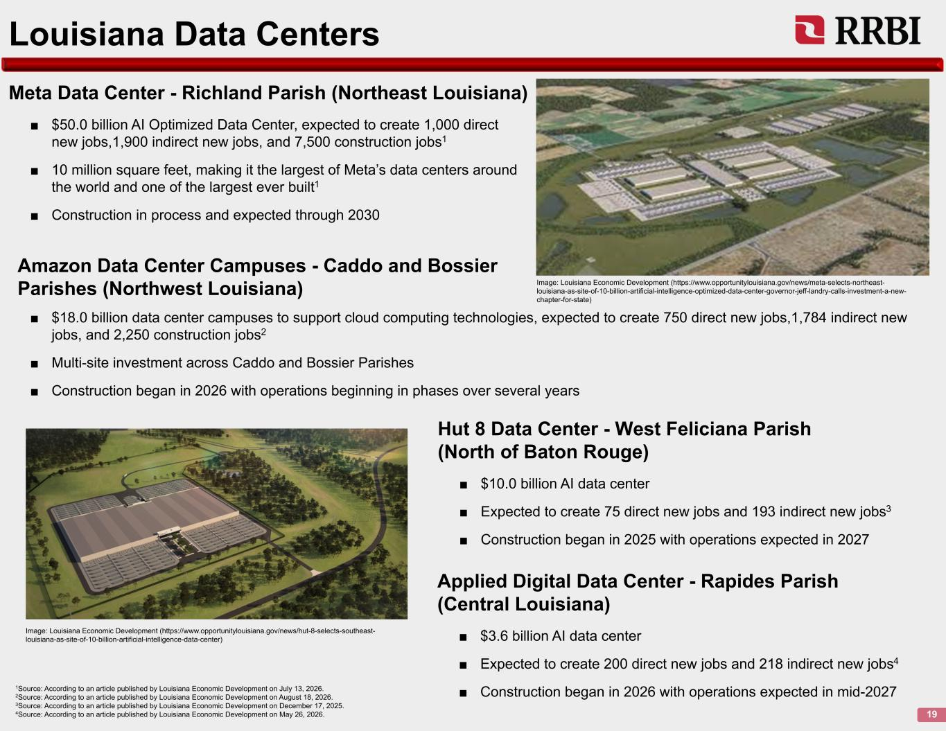
19 Louisiana Data Centers 1Source: According to an article published by Louisiana Economic Development on July 13, 2026. 2Source: According to an article published by Louisiana Economic Development on August 18, 2026. 3Source: According to an article published by Louisiana Economic Development on December 17, 2025. 4Source: According to an article published by Louisiana Economic Development on May 26, 2026. Hut 8 Data Center - West Feliciana Parish (North of Baton Rouge) ■ $10.0 billion AI data center ■ Expected to create 75 direct new jobs and 193 indirect new jobs3 ■ Construction began in 2025 with operations expected in 2027 Meta Data Center - Richland Parish (Northeast Louisiana) ■ $50.0 billion AI Optimized Data Center, expected to create 1,000 direct new jobs,1,900 indirect new jobs, and 7,500 construction jobs1 ■ 10 million square feet, making it the largest of Meta’s data centers around the world and one of the largest ever built1 ■ Construction in process and expected through 2030 Image: Louisiana Economic Development (https://www.opportunitylouisiana.gov/news/meta-selects-northeast- louisiana-as-site-of-10-billion-artificial-intelligence-optimized-data-center-governor-jeff-landry-calls-investment-a-new- chapter-for-state) Image: Louisiana Economic Development (https://www.opportunitylouisiana.gov/news/hut-8-selects-southeast- louisiana-as-site-of-10-billion-artificial-intelligence-data-center) ■ $18.0 billion data center campuses to support cloud computing technologies, expected to create 750 direct new jobs,1,784 indirect new jobs, and 2,250 construction jobs2 ■ Multi-site investment across Caddo and Bossier Parishes ■ Construction began in 2026 with operations beginning in phases over several years Amazon Data Center Campuses - Caddo and Bossier Parishes (Northwest Louisiana) Applied Digital Data Center - Rapides Parish (Central Louisiana) ■ $3.6 billion AI data center ■ Expected to create 200 direct new jobs and 218 indirect new jobs4 ■ Construction began in 2026 with operations expected in mid-2027

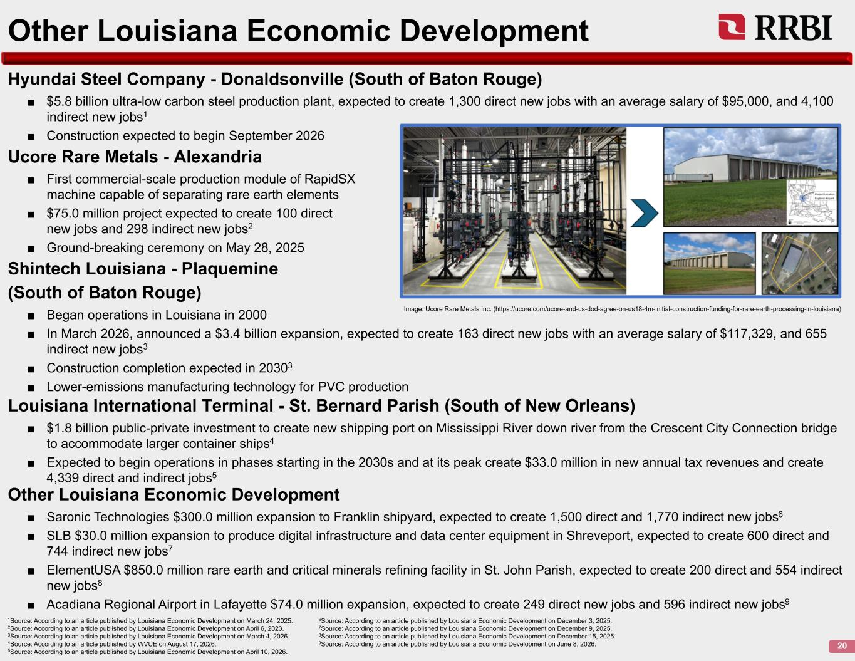
Hyundai Steel Company - Donaldsonville (South of Baton Rouge) ■ $5.8 billion ultra-low carbon steel production plant, expected to create 1,300 direct new jobs with an average salary of $95,000, and 4,100 indirect new jobs1 ■ Construction expected to begin September 2026 20 Other Louisiana Economic Development 1Source: According to an article published by Louisiana Economic Development on March 24, 2025. 6Source: According to an article published by Louisiana Economic Development on December 3, 2025. 2Source: According to an article published by Louisiana Economic Development on April 6, 2023. 7Source: According to an article published by Louisiana Economic Development on December 9, 2025. 3Source: According to an article published by Louisiana Economic Development on March 4, 2026. 8Source: According to an article published by Louisiana Economic Development on December 15, 2025. 4Source: According to an article published by WVUE on August 17, 2026. 9Source: According to an article published by Louisiana Economic Development on June 8, 2026. 5Source: According to an article published by Louisiana Economic Development on April 10, 2026. Ucore Rare Metals - Alexandria ■ First commercial-scale production module of RapidSX machine capable of separating rare earth elements ■ $75.0 million project expected to create 100 direct new jobs and 298 indirect new jobs2 ■ Ground-breaking ceremony on May 28, 2025 Image: Ucore Rare Metals Inc. (https://ucore.com/ucore-and-us-dod-agree-on-us18-4m-initial-construction-funding-for-rare-earth-processing-in-louisiana) Shintech Louisiana - Plaquemine (South of Baton Rouge) ■ Began operations in Louisiana in 2000 ■ In March 2026, announced a $3.4 billion expansion, expected to create 163 direct new jobs with an average salary of $117,329, and 655 indirect new jobs3 ■ Construction completion expected in 20303 ■ Lower-emissions manufacturing technology for PVC production Other Louisiana Economic Development ■ Saronic Technologies $300.0 million expansion to Franklin shipyard, expected to create 1,500 direct and 1,770 indirect new jobs6 ■ SLB $30.0 million expansion to produce digital infrastructure and data center equipment in Shreveport, expected to create 600 direct and 744 indirect new jobs7 ■ ElementUSA $850.0 million rare earth and critical minerals refining facility in St. John Parish, expected to create 200 direct and 554 indirect new jobs8 ■ Acadiana Regional Airport in Lafayette $74.0 million expansion, expected to create 249 direct new jobs and 596 indirect new jobs9 Louisiana International Terminal - St. Bernard Parish (South of New Orleans) ■ $1.8 billion public-private investment to create new shipping port on Mississippi River down river from the Crescent City Connection bridge to accommodate larger container ships4 ■ Expected to begin operations in phases starting in the 2030s and at its peak create $33.0 million in new annual tax revenues and create 4,339 direct and indirect jobs5

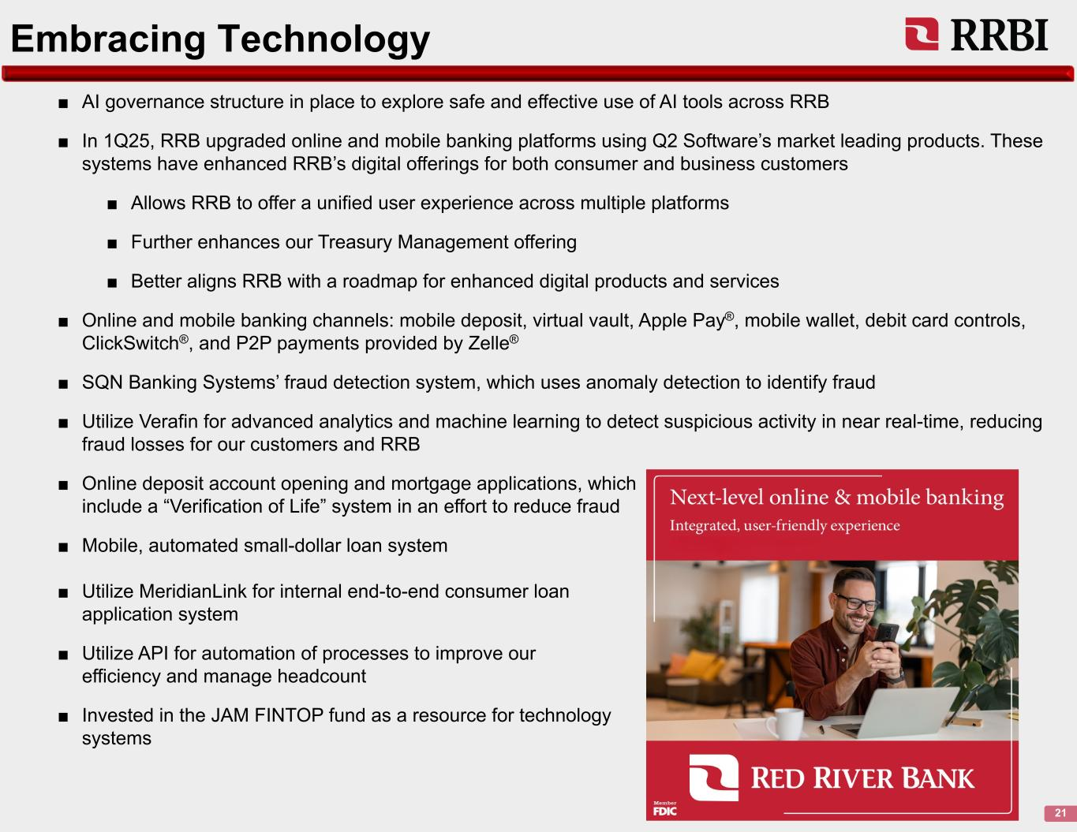
Embracing Technology 21 ■ AI governance structure in place to explore safe and effective use of AI tools across RRB ■ In 1Q25, RRB upgraded online and mobile banking platforms using Q2 Software’s market leading products. These systems have enhanced RRB’s digital offerings for both consumer and business customers ■ Allows RRB to offer a unified user experience across multiple platforms ■ Further enhances our Treasury Management offering ■ Better aligns RRB with a roadmap for enhanced digital products and services ■ Online and mobile banking channels: mobile deposit, virtual vault, Apple Pay®, mobile wallet, debit card controls, ClickSwitch®, and P2P payments provided by Zelle® ■ SQN Banking Systems’ fraud detection system, which uses anomaly detection to identify fraud ■ Utilize Verafin for advanced analytics and machine learning to detect suspicious activity in near real-time, reducing fraud losses for our customers and RRB ■ Online deposit account opening and mortgage applications, which include a “Verification of Life” system in an effort to reduce fraud ■ Mobile, automated small-dollar loan system ■ Utilize MeridianLink for internal end-to-end consumer loan application system ■ Utilize API for automation of processes to improve our efficiency and manage headcount ■ Invested in the JAM FINTOP fund as a resource for technology systems

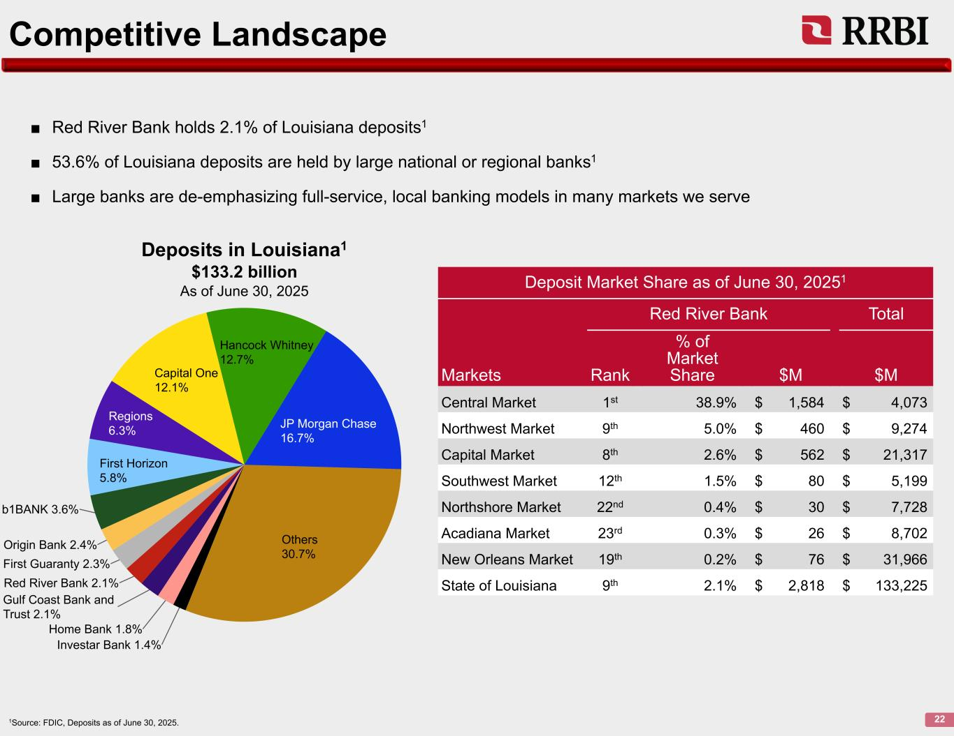
Competitive Landscape 221Source: FDIC, Deposits as of June 30, 2025. Investar Bank 1.4% Home Bank 1.8% Gulf Coast Bank and Trust 2.1% Red River Bank 2.1% First Guaranty 2.3% Origin Bank 2.4% b1BANK 3.6% First Horizon 5.8% Regions 6.3% Capital One 12.1% Hancock Whitney 12.7% JP Morgan Chase 16.7% Others 30.7% ■ Red River Bank holds 2.1% of Louisiana deposits1 ■ 53.6% of Louisiana deposits are held by large national or regional banks1 ■ Large banks are de-emphasizing full-service, local banking models in many markets we serve Deposit Market Share as of June 30, 20251 Red River Bank Total % of Market Share $M $MMarkets Rank Central Market 1st 38.9% $ 1,584 $ 4,073 Northwest Market 9th 5.0% $ 460 $ 9,274 Capital Market 8th 2.6% $ 562 $ 21,317 Southwest Market 12th 1.5% $ 80 $ 5,199 Northshore Market 22nd 0.4% $ 30 $ 7,728 Acadiana Market 23rd 0.3% $ 26 $ 8,702 New Orleans Market 19th 0.2% $ 76 $ 31,966 State of Louisiana 9th 2.1% $ 2,818 $ 133,225 Deposits in Louisiana1 $133.2 billion As of June 30, 2025

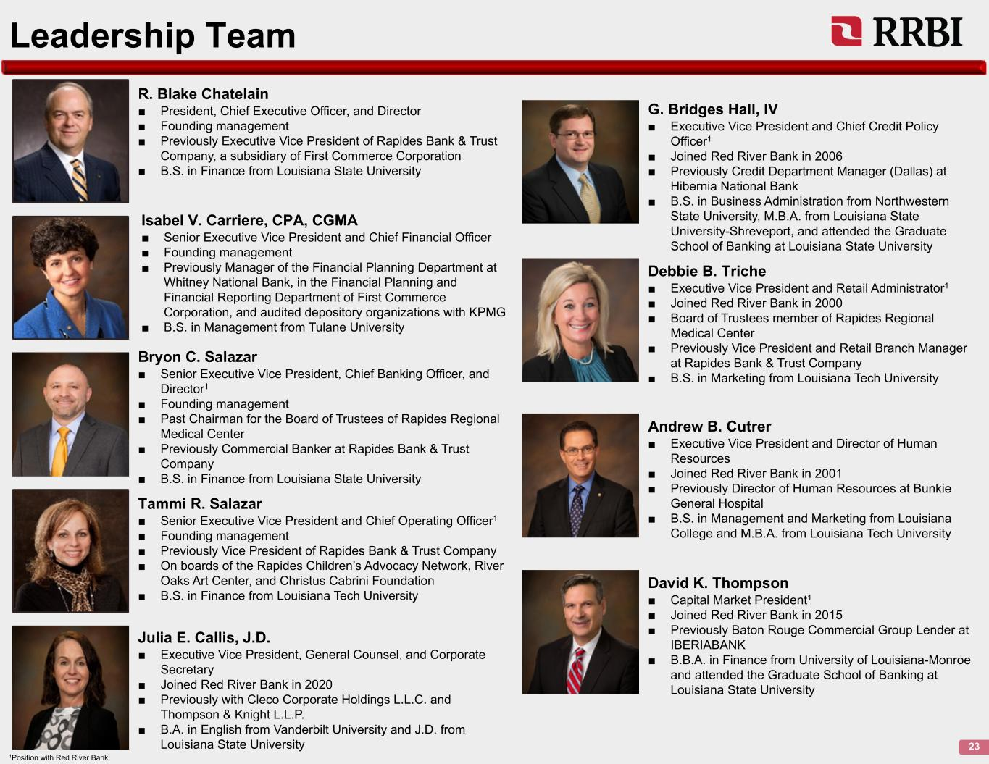
Leadership Team 23 R. Blake Chatelain ■ President, Chief Executive Officer, and Director ■ Founding management ■ Previously Executive Vice President of Rapides Bank & Trust Company, a subsidiary of First Commerce Corporation ■ B.S. in Finance from Louisiana State University Isabel V. Carriere, CPA, CGMA ■ Senior Executive Vice President and Chief Financial Officer ■ Founding management ■ Previously Manager of the Financial Planning Department at Whitney National Bank, in the Financial Planning and Financial Reporting Department of First Commerce Corporation, and audited depository organizations with KPMG ■ B.S. in Management from Tulane University Bryon C. Salazar ■ Senior Executive Vice President, Chief Banking Officer, and Director1 ■ Founding management ■ Past Chairman for the Board of Trustees of Rapides Regional Medical Center ■ Previously Commercial Banker at Rapides Bank & Trust Company ■ B.S. in Finance from Louisiana State University Tammi R. Salazar ■ Senior Executive Vice President and Chief Operating Officer1 ■ Founding management ■ Previously Vice President of Rapides Bank & Trust Company ■ On boards of the Rapides Children’s Advocacy Network, River Oaks Art Center, and Christus Cabrini Foundation ■ B.S. in Finance from Louisiana Tech University Julia E. Callis, J.D. ■ Executive Vice President, General Counsel, and Corporate Secretary ■ Joined Red River Bank in 2020 ■ Previously with Cleco Corporate Holdings L.L.C. and Thompson & Knight L.L.P. ■ B.A. in English from Vanderbilt University and J.D. from Louisiana State University 1Position with Red River Bank. G. Bridges Hall, IV ■ Executive Vice President and Chief Credit Policy Officer1 ■ Joined Red River Bank in 2006 ■ Previously Credit Department Manager (Dallas) at Hibernia National Bank ■ B.S. in Business Administration from Northwestern State University, M.B.A. from Louisiana State University-Shreveport, and attended the Graduate School of Banking at Louisiana State University Debbie B. Triche ■ Executive Vice President and Retail Administrator1 ■ Joined Red River Bank in 2000 ■ Board of Trustees member of Rapides Regional Medical Center ■ Previously Vice President and Retail Branch Manager at Rapides Bank & Trust Company ■ B.S. in Marketing from Louisiana Tech University Andrew B. Cutrer ■ Executive Vice President and Director of Human Resources ■ Joined Red River Bank in 2001 ■ Previously Director of Human Resources at Bunkie General Hospital ■ B.S. in Management and Marketing from Louisiana College and M.B.A. from Louisiana Tech University David K. Thompson ■ Capital Market President1 ■ Joined Red River Bank in 2015 ■ Previously Baton Rouge Commercial Group Lender at IBERIABANK ■ B.B.A. in Finance from University of Louisiana-Monroe and attended the Graduate School of Banking at Louisiana State University


2Q26 Overview

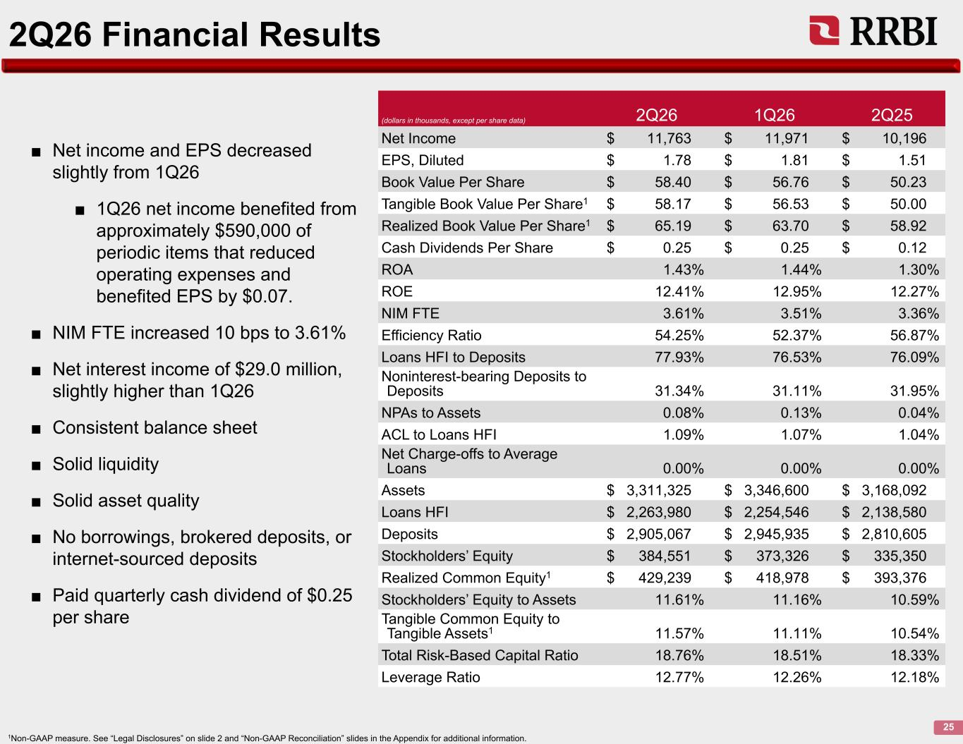
2Q26 Financial Results 25 ■ Net income and EPS decreased slightly from 1Q26 ■ 1Q26 net income benefited from approximately $590,000 of periodic items that reduced operating expenses and benefited EPS by $0.07. ■ NIM FTE increased 10 bps to 3.61% ■ Net interest income of $29.0 million, slightly higher than 1Q26 ■ Consistent balance sheet ■ Solid liquidity ■ Solid asset quality ■ No borrowings, brokered deposits, or internet-sourced deposits ■ Paid quarterly cash dividend of $0.25 per share (dollars in thousands, except per share data) 2Q26 1Q26 2Q25 Net Income $ 11,763 $ 11,971 $ 10,196 EPS, Diluted $ 1.78 $ 1.81 $ 1.51 Book Value Per Share $ 58.40 $ 56.76 $ 50.23 Tangible Book Value Per Share1 $ 58.17 $ 56.53 $ 50.00 Realized Book Value Per Share1 $ 65.19 $ 63.70 $ 58.92 Cash Dividends Per Share $ 0.25 $ 0.25 $ 0.12 ROA 1.43% 1.44% 1.30% ROE 12.41% 12.95% 12.27% NIM FTE 3.61% 3.51% 3.36% Efficiency Ratio 54.25% 52.37% 56.87% Loans HFI to Deposits 77.93% 76.53% 76.09% Noninterest-bearing Deposits to Deposits 31.34% 31.11% 31.95% NPAs to Assets 0.08% 0.13% 0.04% ACL to Loans HFI 1.09% 1.07% 1.04% Net Charge-offs to Average Loans 0.00% 0.00% 0.00% Assets $ 3,311,325 $ 3,346,600 $ 3,168,092 Loans HFI $ 2,263,980 $ 2,254,546 $ 2,138,580 Deposits $ 2,905,067 $ 2,945,935 $ 2,810,605 Stockholders’ Equity $ 384,551 $ 373,326 $ 335,350 Realized Common Equity1 $ 429,239 $ 418,978 $ 393,376 Stockholders’ Equity to Assets 11.61% 11.16% 10.59% Tangible Common Equity to Tangible Assets1 11.57% 11.11% 10.54% Total Risk-Based Capital Ratio 18.76% 18.51% 18.33% Leverage Ratio 12.77% 12.26% 12.18% 1Non-GAAP measure. See “Legal Disclosures” on slide 2 and “Non-GAAP Reconciliation” slides in the Appendix for additional information.

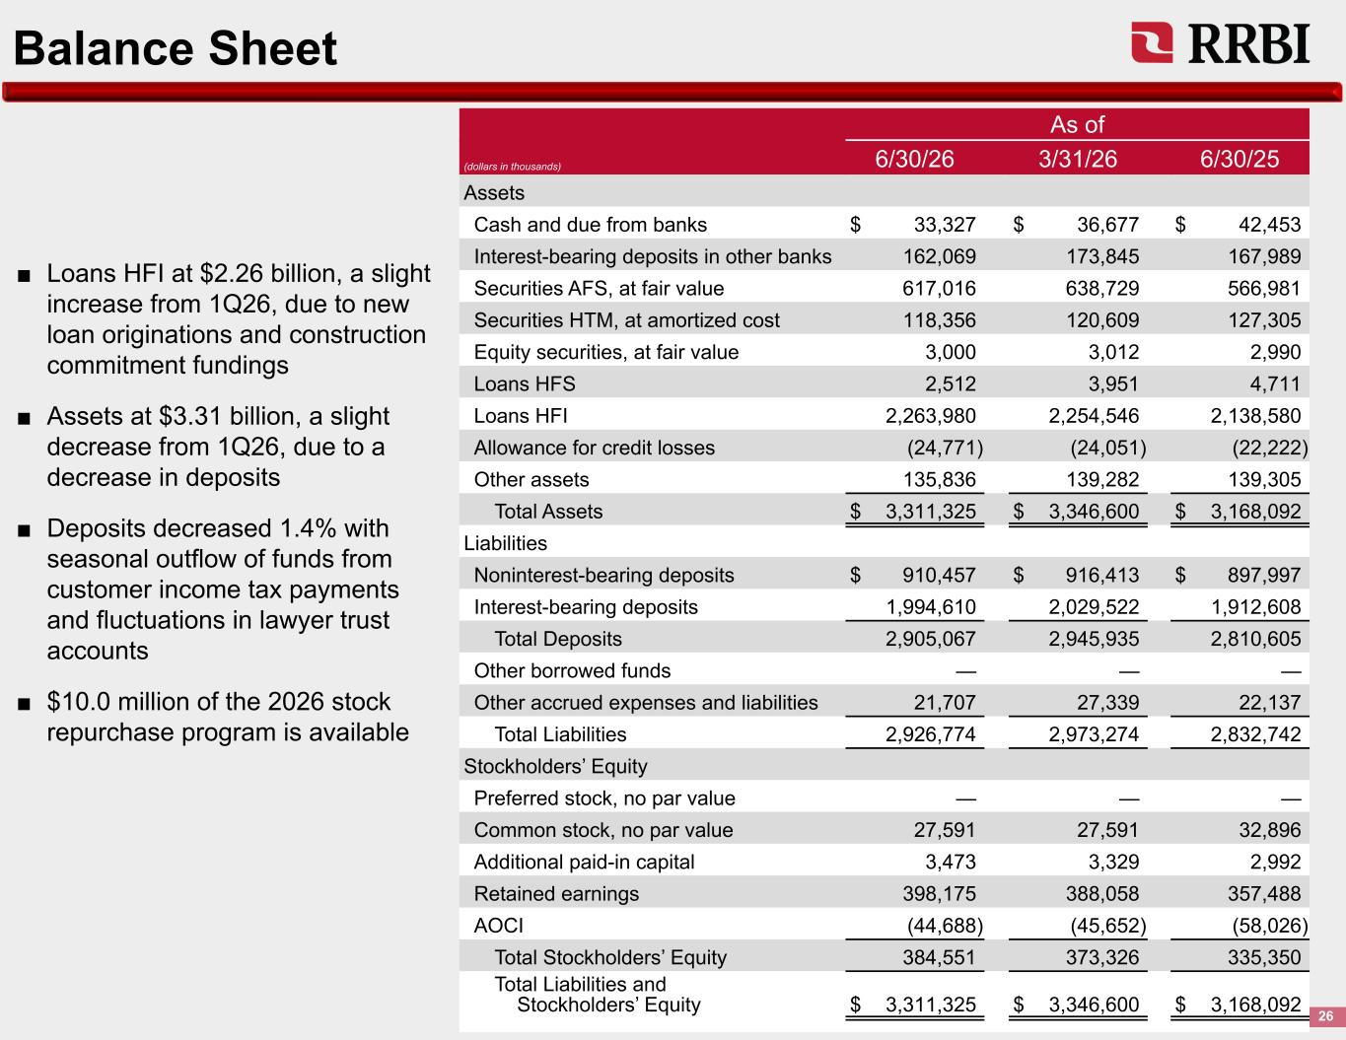
Balance Sheet 26 As of (dollars in thousands) 6/30/26 3/31/26 6/30/25 Assets Cash and due from banks $ 33,327 $ 36,677 $ 42,453 Interest-bearing deposits in other banks 162,069 173,845 167,989 Securities AFS, at fair value 617,016 638,729 566,981 Securities HTM, at amortized cost 118,356 120,609 127,305 Equity securities, at fair value 3,000 3,012 2,990 Loans HFS 2,512 3,951 4,711 Loans HFI 2,263,980 2,254,546 2,138,580 Allowance for credit losses (24,771) (24,051) (22,222) Other assets 135,836 139,282 139,305 Total Assets $ 3,311,325 $ 3,346,600 $ 3,168,092 Liabilities Noninterest-bearing deposits $ 910,457 $ 916,413 $ 897,997 Interest-bearing deposits 1,994,610 2,029,522 1,912,608 Total Deposits 2,905,067 2,945,935 2,810,605 Other borrowed funds — — — Other accrued expenses and liabilities 21,707 27,339 22,137 Total Liabilities 2,926,774 2,973,274 2,832,742 Stockholders’ Equity Preferred stock, no par value — — — Common stock, no par value 27,591 27,591 32,896 Additional paid-in capital 3,473 3,329 2,992 Retained earnings 398,175 388,058 357,488 AOCI (44,688) (45,652) (58,026) Total Stockholders’ Equity 384,551 373,326 335,350 Total Liabilities and Stockholders’ Equity $ 3,311,325 $ 3,346,600 $ 3,168,092 ■ Loans HFI at $2.26 billion, a slight increase from 1Q26, due to new loan originations and construction commitment fundings ■ Assets at $3.31 billion, a slight decrease from 1Q26, due to a decrease in deposits ■ Deposits decreased 1.4% with seasonal outflow of funds from customer income tax payments and fluctuations in lawyer trust accounts ■ $10.0 million of the 2026 stock repurchase program is available

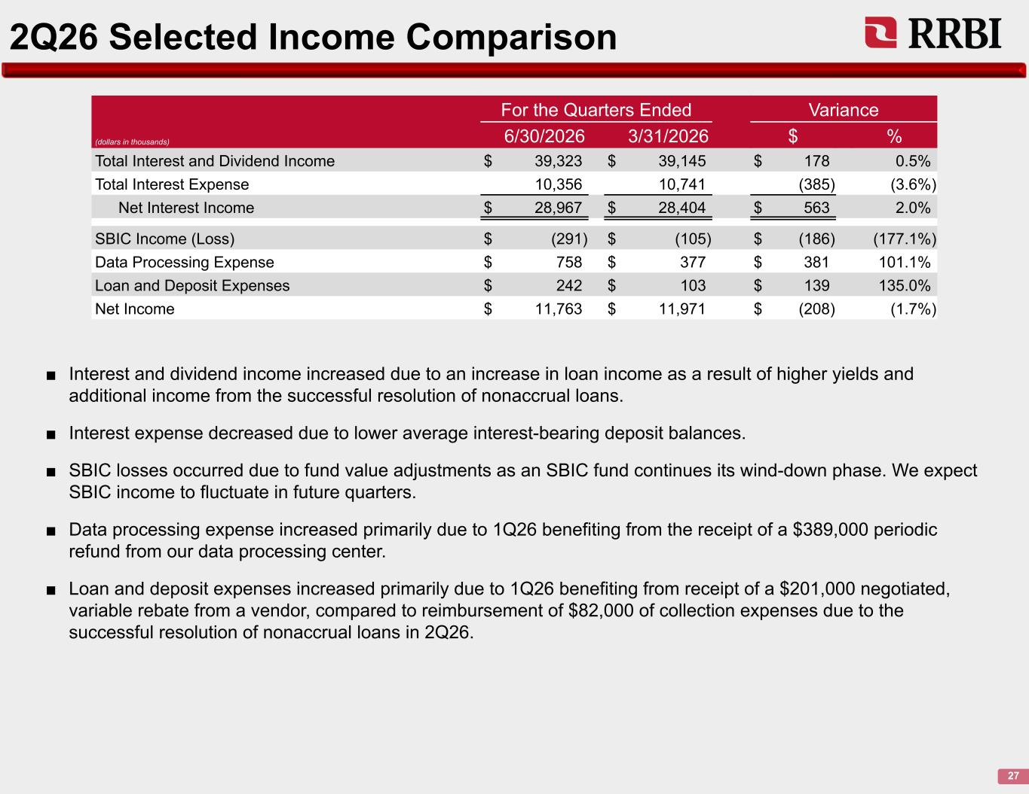
2Q26 Selected Income Comparison 27 ■ Interest and dividend income increased due to an increase in loan income as a result of higher yields and additional income from the successful resolution of nonaccrual loans. ■ Interest expense decreased due to lower average interest-bearing deposit balances. ■ SBIC losses occurred due to fund value adjustments as an SBIC fund continues its wind-down phase. We expect SBIC income to fluctuate in future quarters. ■ Data processing expense increased primarily due to 1Q26 benefiting from the receipt of a $389,000 periodic refund from our data processing center. ■ Loan and deposit expenses increased primarily due to 1Q26 benefiting from receipt of a $201,000 negotiated, variable rebate from a vendor, compared to reimbursement of $82,000 of collection expenses due to the successful resolution of nonaccrual loans in 2Q26. (dollars in thousands) For the Quarters Ended Variance 6/30/2026 3/31/2026 $ % Total Interest and Dividend Income $ 39,323 $ 39,145 $ 178 0.5% Total Interest Expense 10,356 10,741 (385) (3.6%) Net Interest Income $ 28,967 $ 28,404 $ 563 2.0% SBIC Income (Loss) $ (291) $ (105) $ (186) (177.1%) Data Processing Expense $ 758 $ 377 $ 381 101.1% Loan and Deposit Expenses $ 242 $ 103 $ 139 135.0% Net Income $ 11,763 $ 11,971 $ (208) (1.7%)

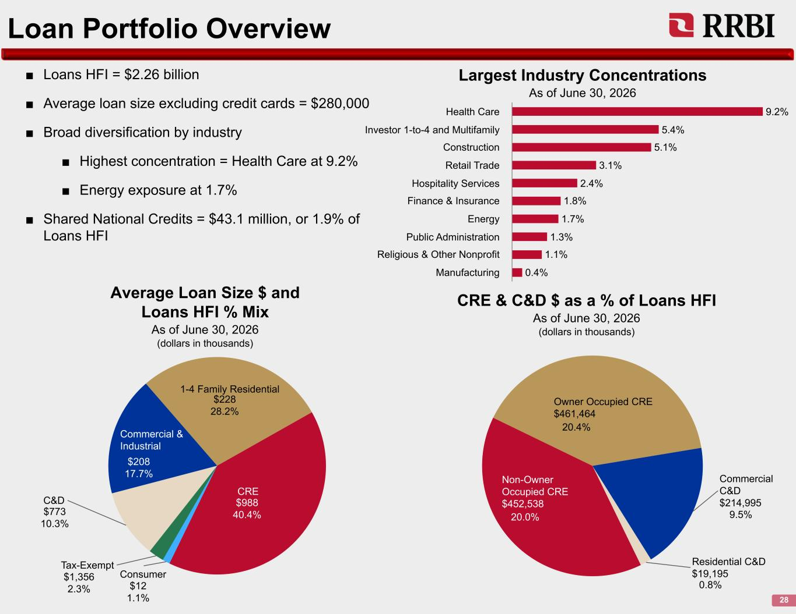
Loan Portfolio Overview 28 ■ Loans HFI = $2.26 billion ■ Average loan size excluding credit cards = $280,000 ■ Broad diversification by industry ■ Highest concentration = Health Care at 9.2% ■ Energy exposure at 1.7% ■ Shared National Credits = $43.1 million, or 1.9% of Loans HFI 9.2% 5.4% 5.1% 3.1% 2.4% 1.8% 1.7% 1.3% 1.1% 0.4% Health Care Investor 1-to-4 and Multifamily Construction Retail Trade Hospitality Services Finance & Insurance Energy Public Administration Religious & Other Nonprofit Manufacturing Consumer Tax-Exempt C&D Commercial & Industrial 1-4 Family Residential CRE Average Loan Size $ and Loans HFI % Mix As of June 30, 2026 (dollars in thousands) Largest Industry Concentrations As of June 30, 2026 Non-Owner Occupied CRE $452,538 Owner Occupied CRE $461,464 Commercial C&D $214,995 Residential C&D $19,195 CRE & C&D $ as a % of Loans HFI As of June 30, 2026 (dollars in thousands) 20.0% 20.4% 9.5% 0.8%$12 1.1% $1,356 2.3% $773 10.3% $208 17.7% $228 28.2% $988 40.4%

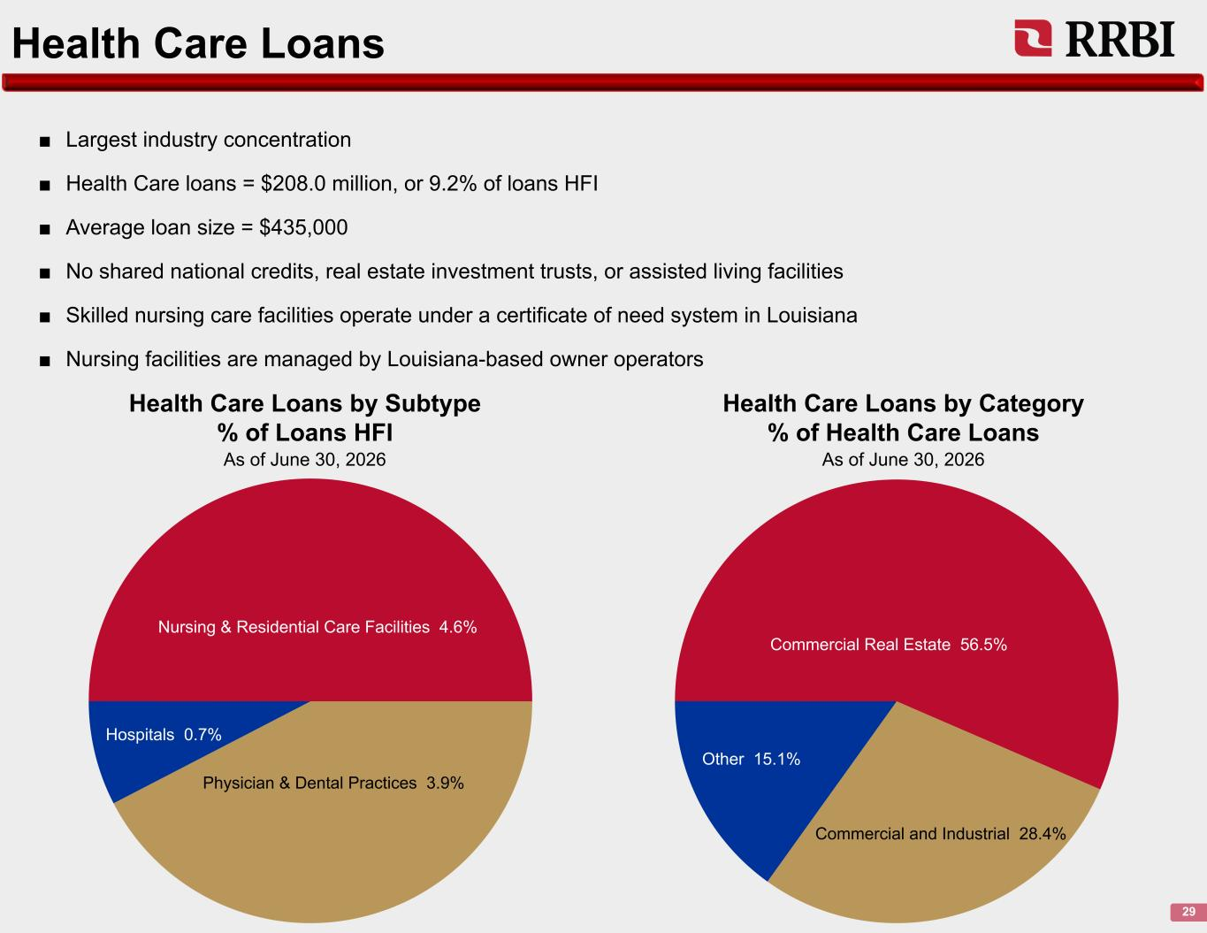
Health Care Loans 29 Nursing & Residential Care Facilities 4.6% Physician & Dental Practices 3.9% Hospitals 0.7% ■ Largest industry concentration ■ Health Care loans = $208.0 million, or 9.2% of loans HFI ■ Average loan size = $435,000 ■ No shared national credits, real estate investment trusts, or assisted living facilities ■ Skilled nursing care facilities operate under a certificate of need system in Louisiana ■ Nursing facilities are managed by Louisiana-based owner operators Health Care Loans by Subtype % of Loans HFI As of June 30, 2026 Health Care Loans by Category % of Health Care Loans As of June 30, 2026 Commercial Real Estate 56.5% Commercial and Industrial 28.4% Other 15.1%

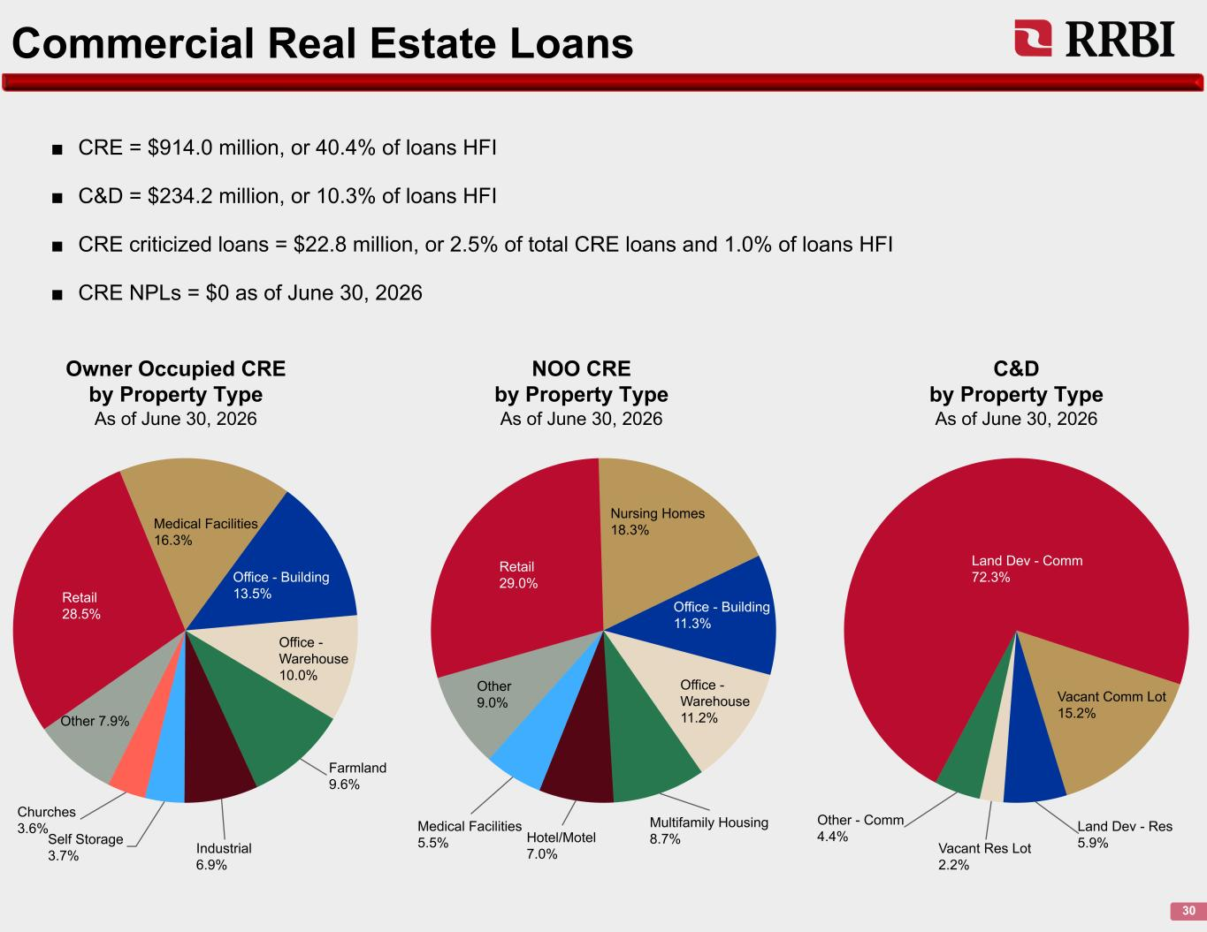
Commercial Real Estate Loans 30 Retail 28.5% Medical Facilities 16.3% Office - Building 13.5% Office - Warehouse 10.0% Farmland 9.6% Industrial 6.9% Self Storage 3.7% Churches 3.6% Other 7.9% Owner Occupied CRE by Property Type As of June 30, 2026 Retail 29.0% Nursing Homes 18.3% Office - Building 11.3% Office - Warehouse 11.2% Multifamily Housing 8.7%Hotel/Motel 7.0% Medical Facilities 5.5% Other 9.0% NOO CRE by Property Type As of June 30, 2026 Land Dev - Comm 72.3% Vacant Comm Lot 15.2% Land Dev - Res 5.9%Vacant Res Lot 2.2% Other - Comm 4.4% C&D by Property Type As of June 30, 2026 ■ CRE = $914.0 million, or 40.4% of loans HFI ■ C&D = $234.2 million, or 10.3% of loans HFI ■ CRE criticized loans = $22.8 million, or 2.5% of total CRE loans and 1.0% of loans HFI ■ CRE NPLs = $0 as of June 30, 2026

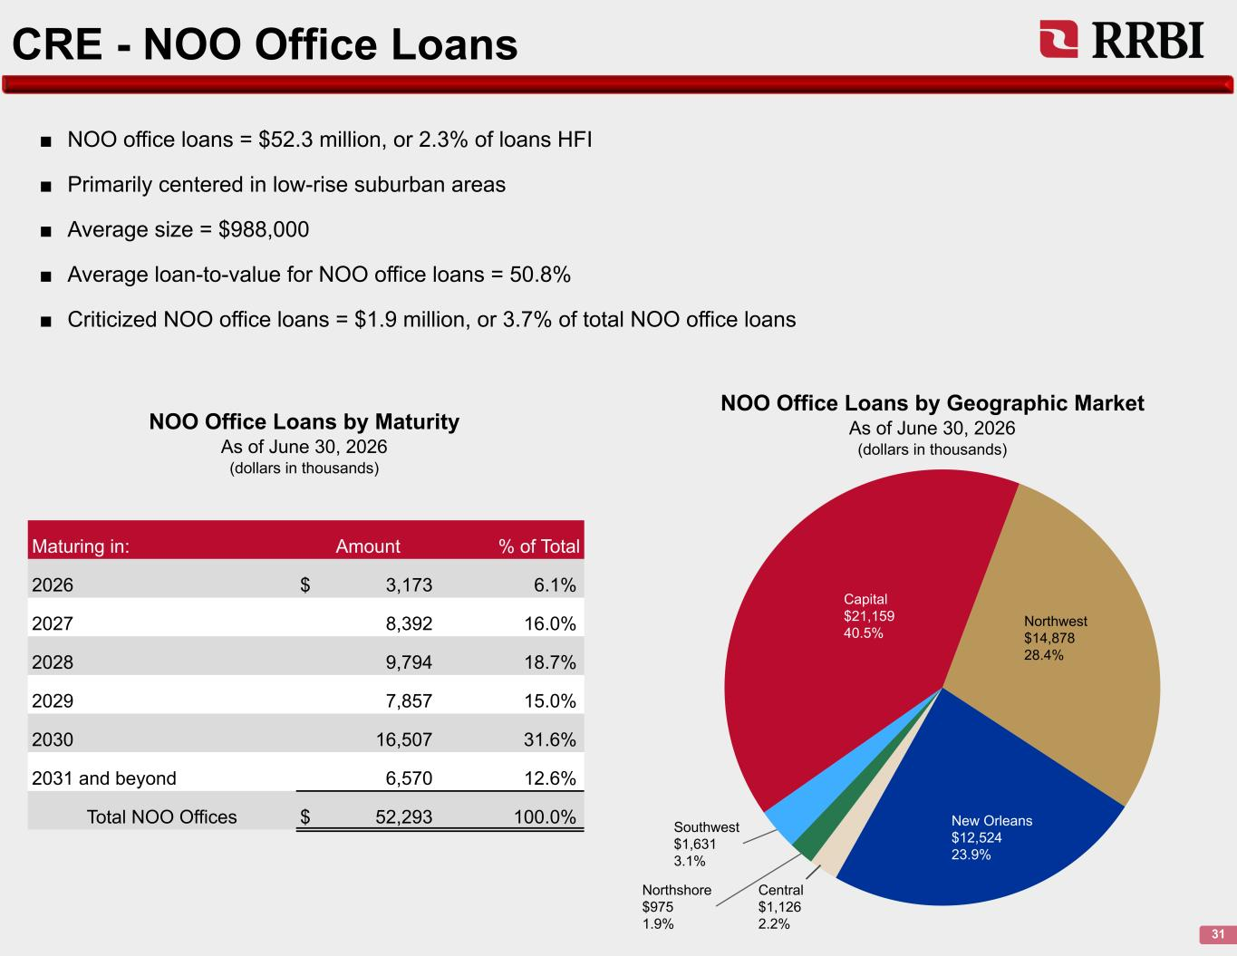
CRE - NOO Office Loans 31 Capital $21,159 40.5% Northwest $14,878 28.4% New Orleans $12,524 23.9% Central $1,126 2.2% Northshore $975 1.9% Southwest $1,631 3.1% ■ NOO office loans = $52.3 million, or 2.3% of loans HFI ■ Primarily centered in low-rise suburban areas ■ Average size = $988,000 ■ Average loan-to-value for NOO office loans = 50.8% ■ Criticized NOO office loans = $1.9 million, or 3.7% of total NOO office loans NOO Office Loans by Geographic Market As of June 30, 2026 (dollars in thousands) NOO Office Loans by Maturity As of June 30, 2026 (dollars in thousands) Maturing in: Amount % of Total 2026 $ 3,173 6.1% 2027 8,392 16.0% 2028 9,794 18.7% 2029 7,857 15.0% 2030 16,507 31.6% 2031 and beyond 6,570 12.6% Total NOO Offices $ 52,293 100.0%

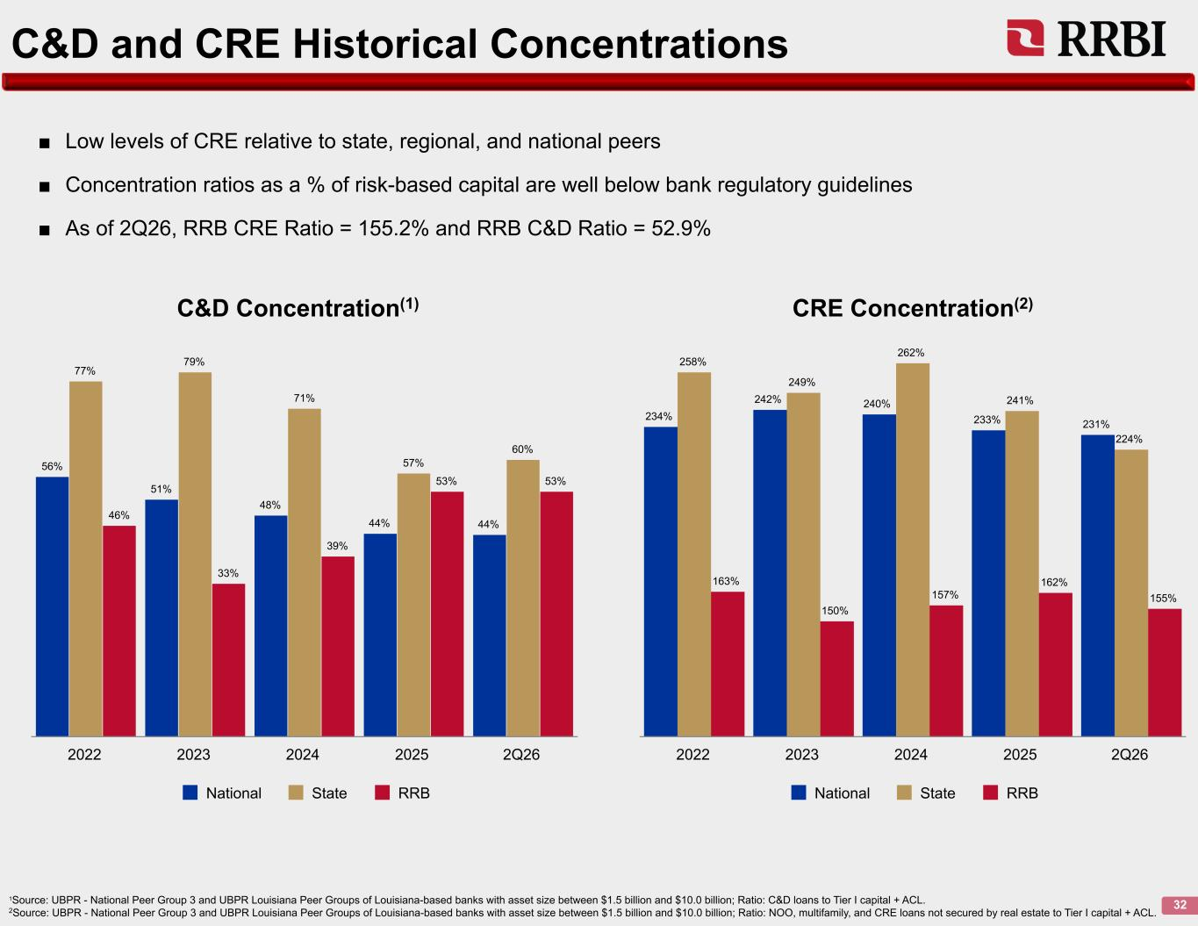
C&D and CRE Historical Concentrations 32 56% 51% 48% 44% 44% 77% 79% 71% 57% 60% 46% 33% 39% 53% 53% National State RRB 2022 2023 2024 2025 2Q26 234% 242% 240% 233% 231% 258% 249% 262% 241% 224% 163% 150% 157% 162% 155% National State RRB 2022 2023 2024 2025 2Q26 1Source: UBPR - National Peer Group 3 and UBPR Louisiana Peer Groups of Louisiana-based banks with asset size between $1.5 billion and $10.0 billion; Ratio: C&D loans to Tier I capital + ACL. 2Source: UBPR - National Peer Group 3 and UBPR Louisiana Peer Groups of Louisiana-based banks with asset size between $1.5 billion and $10.0 billion; Ratio: NOO, multifamily, and CRE loans not secured by real estate to Tier I capital + ACL. C&D Concentration(1) CRE Concentration(2) ■ Low levels of CRE relative to state, regional, and national peers ■ Concentration ratios as a % of risk-based capital are well below bank regulatory guidelines ■ As of 2Q26, RRB CRE Ratio = 155.2% and RRB C&D Ratio = 52.9%

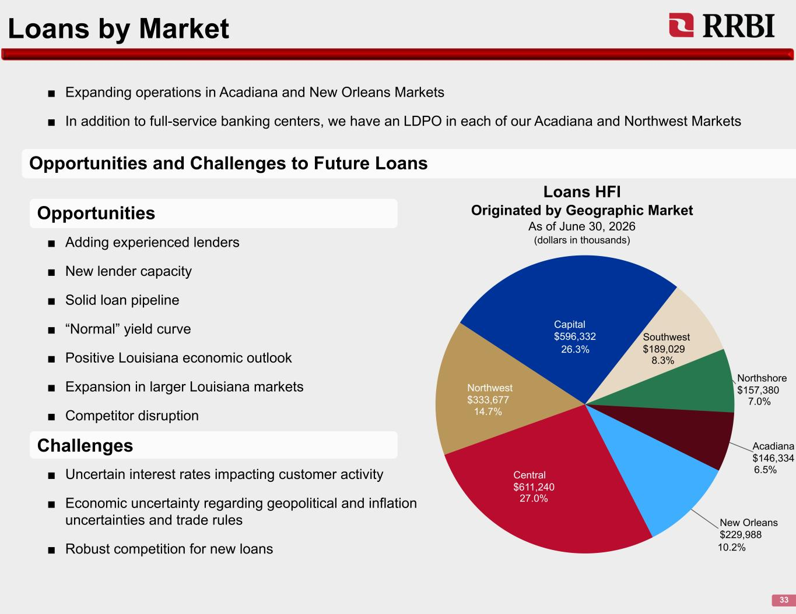
Loans by Market 33 ■ Uncertain interest rates impacting customer activity ■ Economic uncertainty regarding geopolitical and inflation uncertainties and trade rules ■ Robust competition for new loans Central $611,240 Northwest $333,677 Capital $596,332 Southwest $189,029 Northshore $157,380 Acadiana $146,334 New Orleans $229,988 Loans HFI Originated by Geographic Market As of June 30, 2026 (dollars in thousands) Opportunities and Challenges to Future Loans ■ Adding experienced lenders ■ New lender capacity ■ Solid loan pipeline ■ “Normal” yield curve ■ Positive Louisiana economic outlook ■ Expansion in larger Louisiana markets ■ Competitor disruption ■ Expanding operations in Acadiana and New Orleans Markets ■ In addition to full-service banking centers, we have an LDPO in each of our Acadiana and Northwest Markets Opportunities Challenges 26.3% 8.3% 14.7% 27.0% 7.0% 6.5% 10.2%

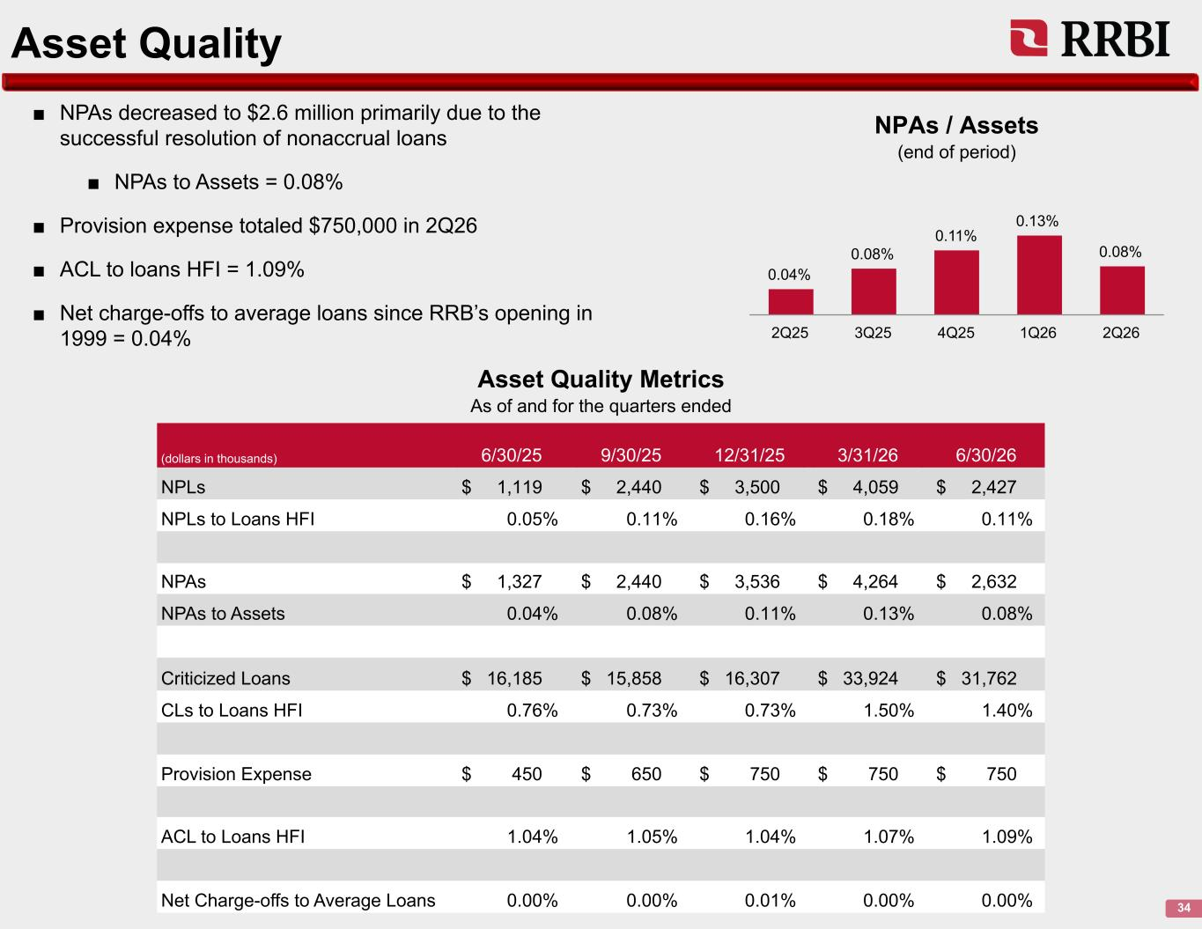
Asset Quality 34 ■ NPAs decreased to $2.6 million primarily due to the successful resolution of nonaccrual loans ■ NPAs to Assets = 0.08% ■ Provision expense totaled $750,000 in 2Q26 ■ ACL to loans HFI = 1.09% ■ Net charge-offs to average loans since RRB’s opening in 1999 = 0.04% 0.04% 0.08% 0.11% 0.13% 0.08% 2Q25 3Q25 4Q25 1Q26 2Q26 (dollars in thousands) 6/30/25 9/30/25 12/31/25 3/31/26 6/30/26 NPLs $ 1,119 $ 2,440 $ 3,500 $ 4,059 $ 2,427 NPLs to Loans HFI 0.05% 0.11% 0.16% 0.18% 0.11% NPAs $ 1,327 $ 2,440 $ 3,536 $ 4,264 $ 2,632 NPAs to Assets 0.04% 0.08% 0.11% 0.13% 0.08% Criticized Loans $ 16,185 $ 15,858 $ 16,307 $ 33,924 $ 31,762 CLs to Loans HFI 0.76% 0.73% 0.73% 1.50% 1.40% Provision Expense $ 450 $ 650 $ 750 $ 750 $ 750 ACL to Loans HFI 1.04% 1.05% 1.04% 1.07% 1.09% Net Charge-offs to Average Loans 0.00% 0.00% 0.01% 0.00% 0.00% NPAs / Assets (end of period) Asset Quality Metrics As of and for the quarters ended

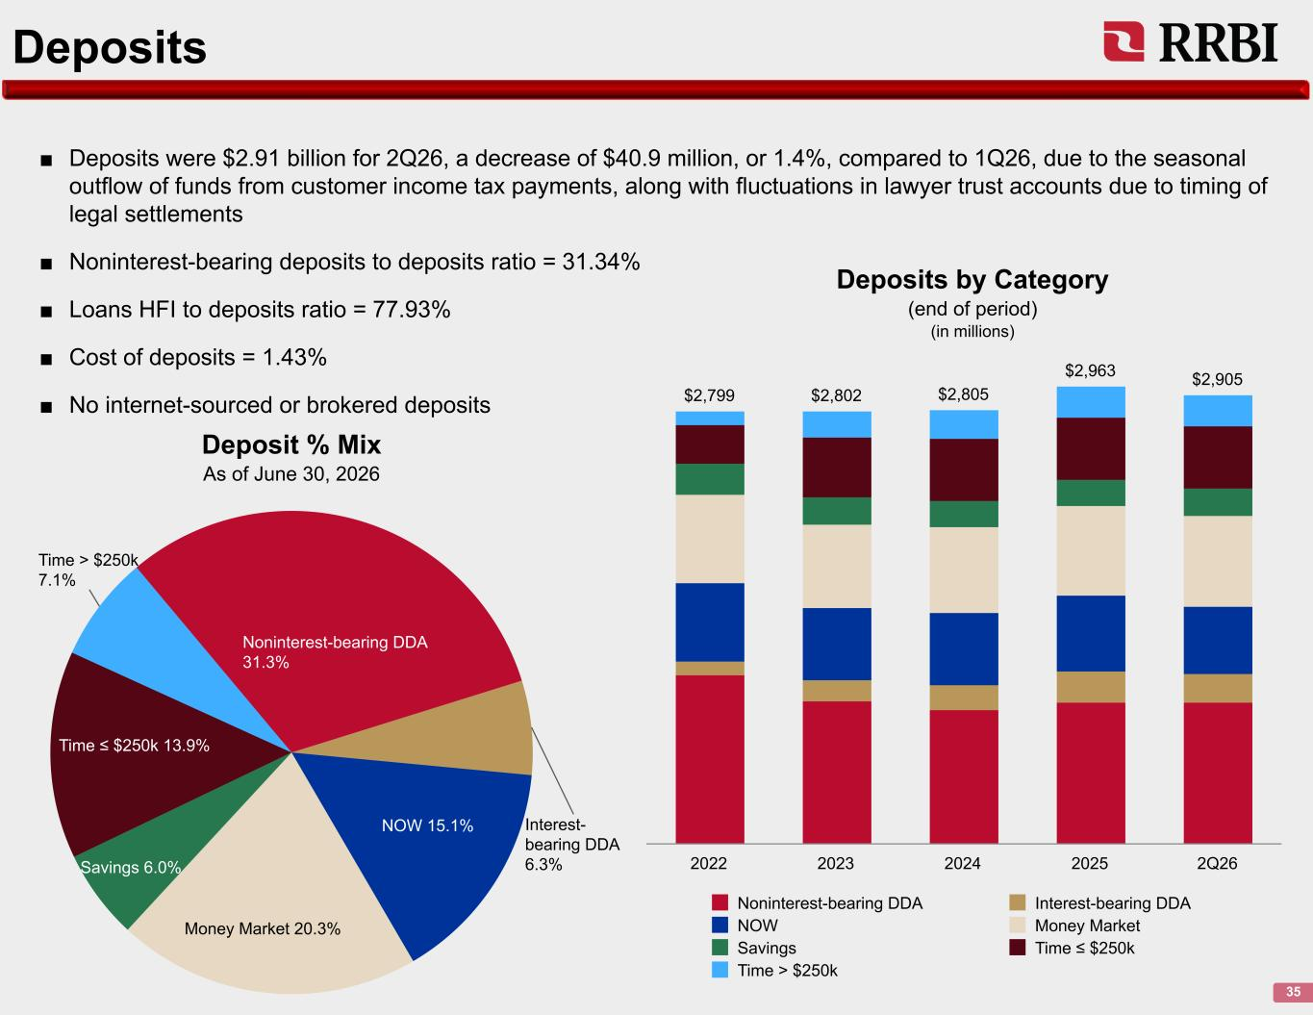
Deposits 35 ■ Deposits were $2.91 billion for 2Q26, a decrease of $40.9 million, or 1.4%, compared to 1Q26, due to the seasonal outflow of funds from customer income tax payments, along with fluctuations in lawyer trust accounts due to timing of legal settlements ■ Noninterest-bearing deposits to deposits ratio = 31.34% ■ Loans HFI to deposits ratio = 77.93% ■ Cost of deposits = 1.43% ■ No internet-sourced or brokered deposits Noninterest-bearing DDA 31.3% Interest- bearing DDA 6.3% NOW 15.1% Money Market 20.3% Savings 6.0% Time ≤ $250k 13.9% Time > $250k 7.1% $2,799 $2,802 $2,805 $2,963 $2,905 Noninterest-bearing DDA Interest-bearing DDA NOW Money Market Savings Time ≤ $250k Time > $250k 2022 2023 2024 2025 2Q26 Deposit % Mix As of June 30, 2026 Deposits by Category (end of period) (in millions)

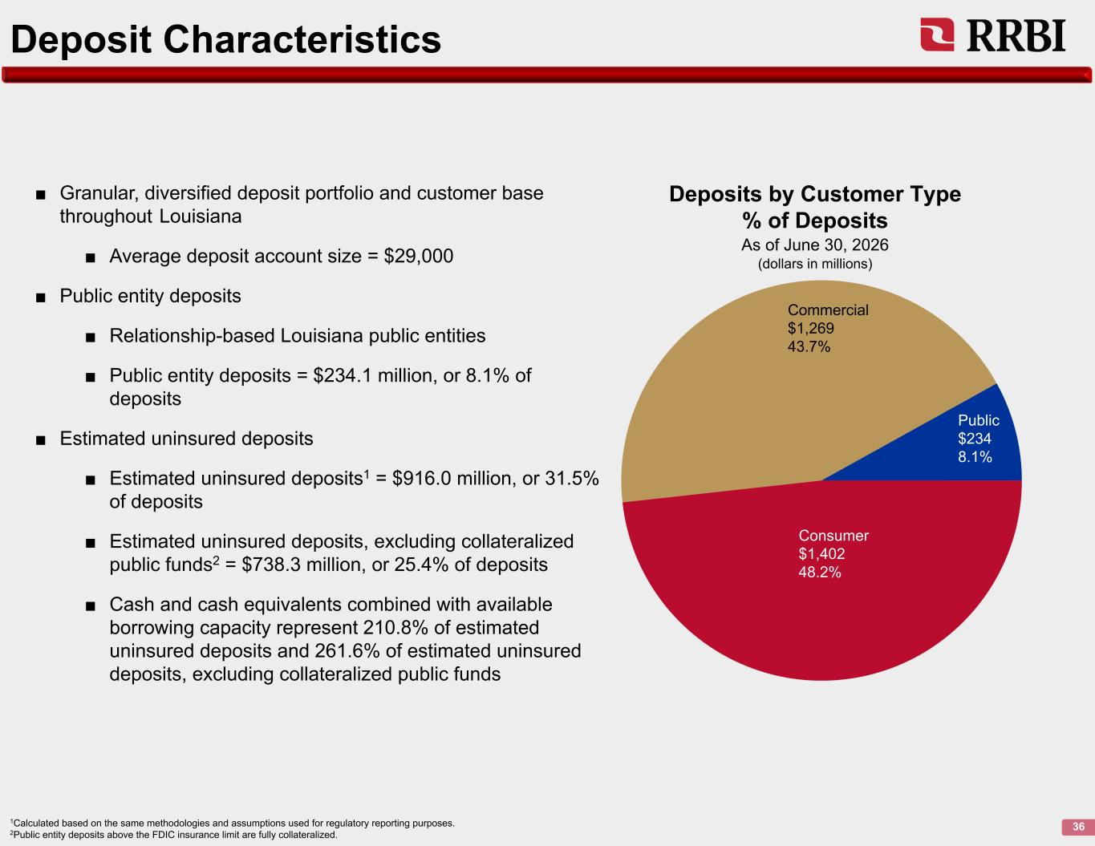
Deposit Characteristics 36 ■ Granular, diversified deposit portfolio and customer base throughout Louisiana ■ Average deposit account size = $29,000 ■ Public entity deposits ■ Relationship-based Louisiana public entities ■ Public entity deposits = $234.1 million, or 8.1% of deposits ■ Estimated uninsured deposits ■ Estimated uninsured deposits1 = $916.0 million, or 31.5% of deposits ■ Estimated uninsured deposits, excluding collateralized public funds2 = $738.3 million, or 25.4% of deposits ■ Cash and cash equivalents combined with available borrowing capacity represent 210.8% of estimated uninsured deposits and 261.6% of estimated uninsured deposits, excluding collateralized public funds 1Calculated based on the same methodologies and assumptions used for regulatory reporting purposes. 2Public entity deposits above the FDIC insurance limit are fully collateralized. Deposits by Customer Type % of Deposits As of June 30, 2026 (dollars in millions) Public $234 8.1% Consumer $1,402 48.2% Commercial $1,269 43.7%

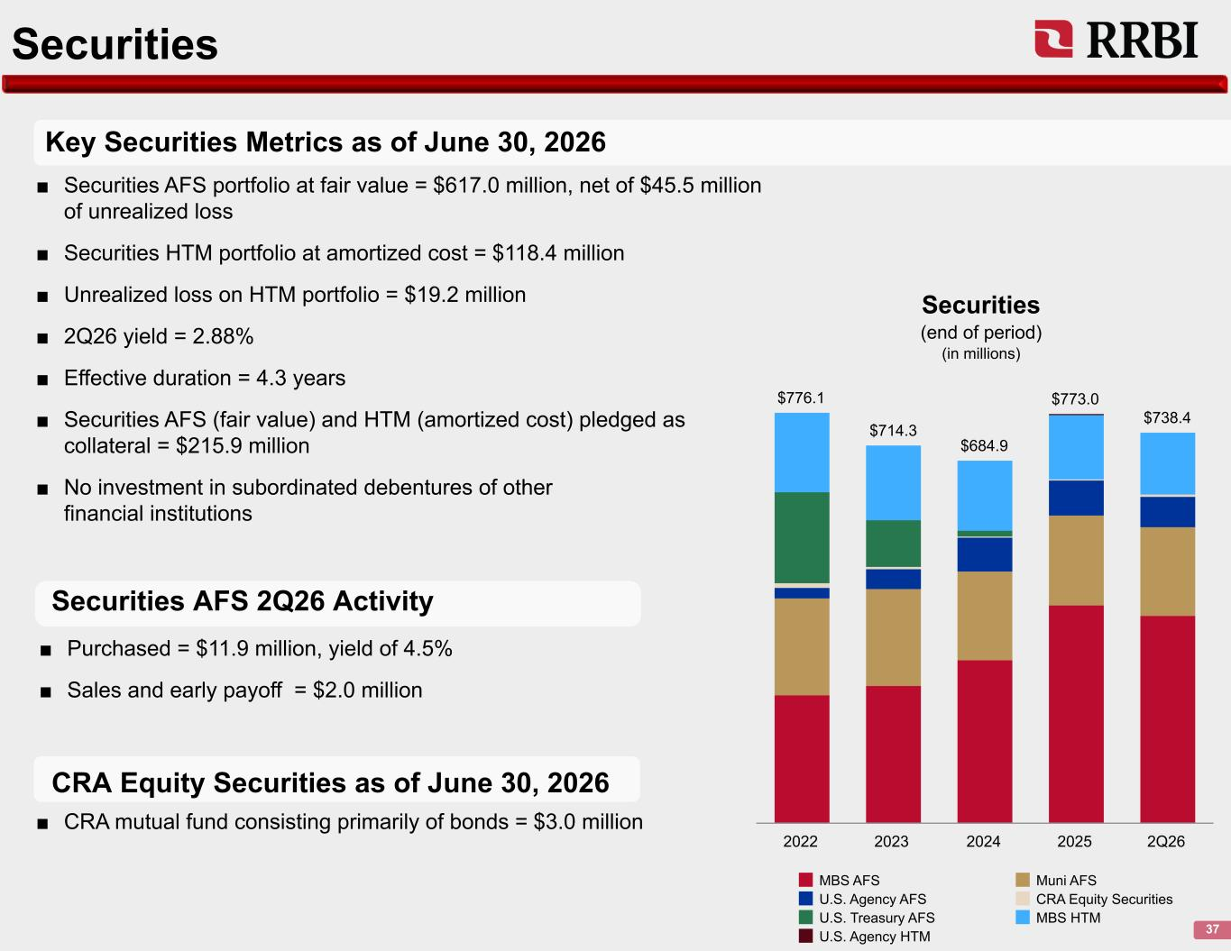
Securities 37 Key Securities Metrics as of June 30, 2026 Securities AFS 2Q26 Activity ■ Securities AFS portfolio at fair value = $617.0 million, net of $45.5 million of unrealized loss ■ Securities HTM portfolio at amortized cost = $118.4 million ■ Unrealized loss on HTM portfolio = $19.2 million ■ 2Q26 yield = 2.88% ■ Effective duration = 4.3 years ■ Securities AFS (fair value) and HTM (amortized cost) pledged as collateral = $215.9 million ■ No investment in subordinated debentures of other financial institutions $776.1 $714.3 $684.9 $773.0 $738.4 MBS AFS Muni AFS U.S. Agency AFS CRA Equity Securities U.S. Treasury AFS MBS HTM U.S. Agency HTM 2022 2023 2024 2025 2Q26 Securities (end of period) (in millions) CRA Equity Securities as of June 30, 2026 ■ Purchased = $11.9 million, yield of 4.5% ■ Sales and early payoff = $2.0 million ■ CRA mutual fund consisting primarily of bonds = $3.0 million

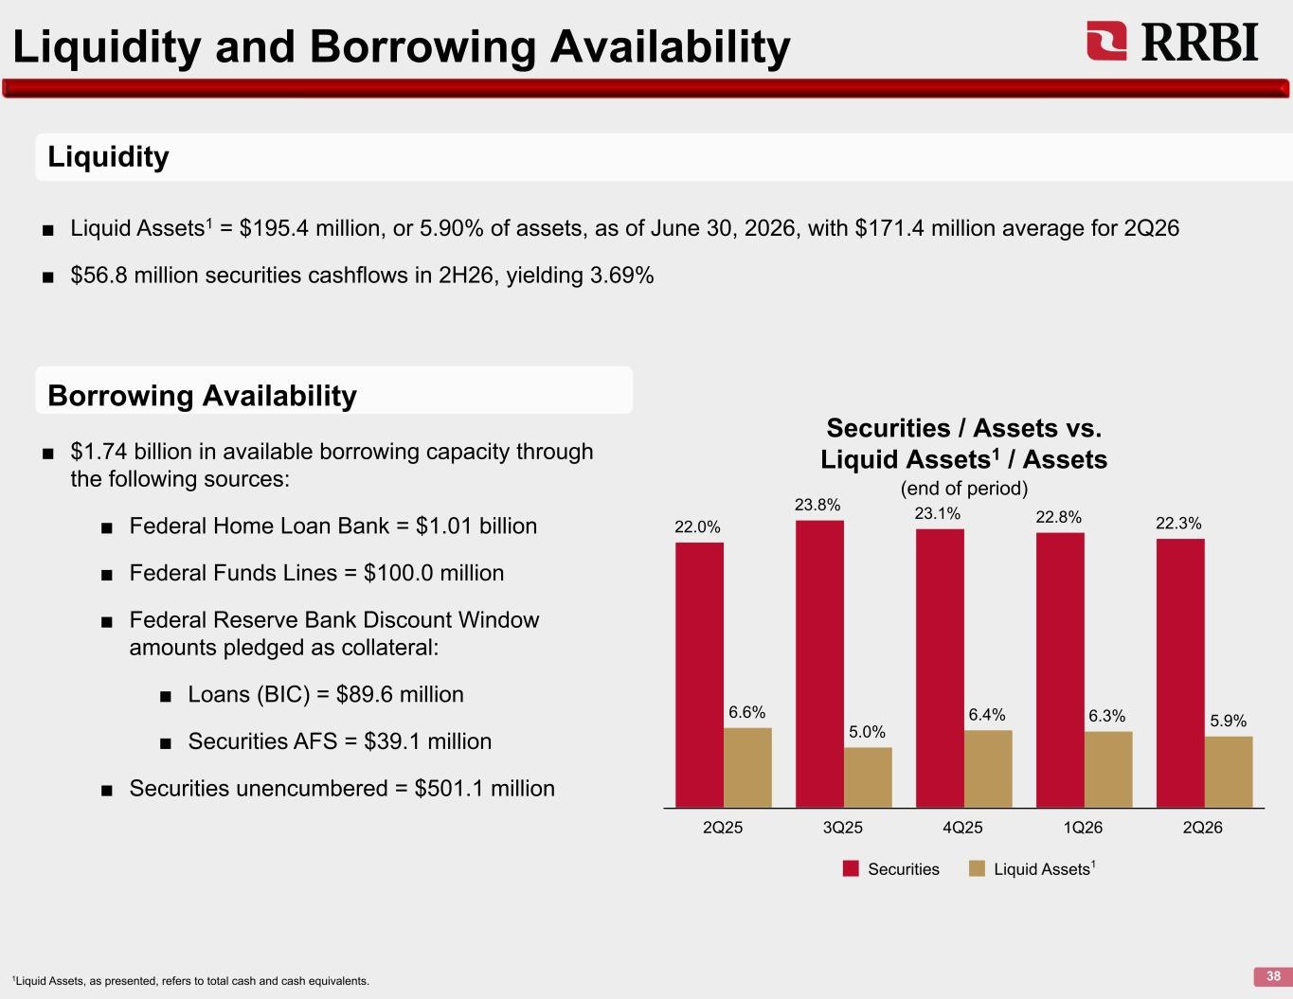
Liquidity and Borrowing Availability 38 22.0% 23.8% 23.1% 22.8% 22.3% 6.6% 5.0% 6.4% 6.3% 5.9% Securities Liquid Assets 2Q25 3Q25 4Q25 1Q26 2Q26 Securities / Assets vs. Liquid Assets1 / Assets (end of period) 1Liquid Assets, as presented, refers to total cash and cash equivalents. Liquidity Borrowing Availability ■ Liquid Assets1 = $195.4 million, or 5.90% of assets, as of June 30, 2026, with $171.4 million average for 2Q26 ■ $56.8 million securities cashflows in 2H26, yielding 3.69% ■ $1.74 billion in available borrowing capacity through the following sources: ■ Federal Home Loan Bank = $1.01 billion ■ Federal Funds Lines = $100.0 million ■ Federal Reserve Bank Discount Window amounts pledged as collateral: ■ Loans (BIC) = $89.6 million ■ Securities AFS = $39.1 million ■ Securities unencumbered = $501.1 million 1

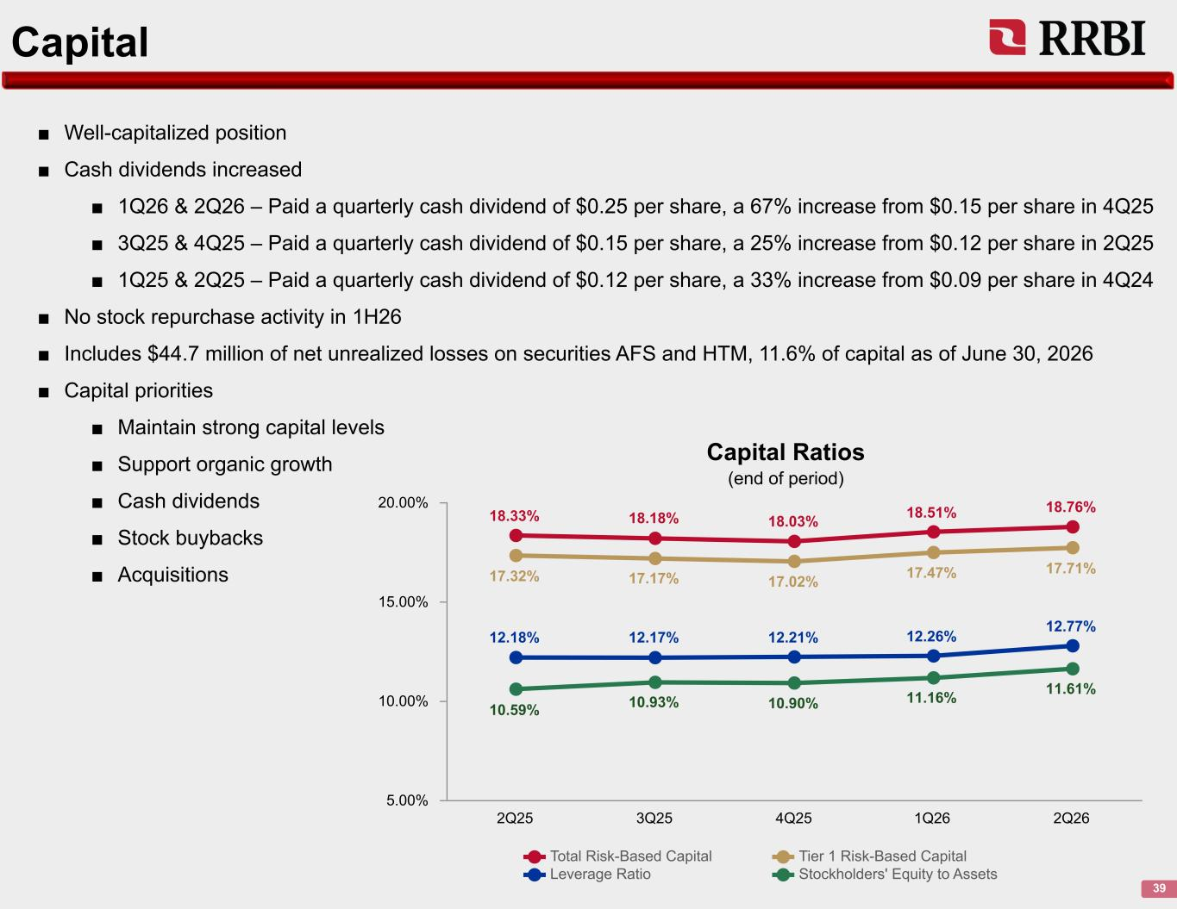
Capital 39 ■ Well-capitalized position ■ Cash dividends increased ■ 1Q26 & 2Q26 – Paid a quarterly cash dividend of $0.25 per share, a 67% increase from $0.15 per share in 4Q25 ■ 3Q25 & 4Q25 – Paid a quarterly cash dividend of $0.15 per share, a 25% increase from $0.12 per share in 2Q25 ■ 1Q25 & 2Q25 – Paid a quarterly cash dividend of $0.12 per share, a 33% increase from $0.09 per share in 4Q24 ■ No stock repurchase activity in 1H26 ■ Includes $44.7 million of net unrealized losses on securities AFS and HTM, 11.6% of capital as of June 30, 2026 ■ Capital priorities ■ Maintain strong capital levels ■ Support organic growth ■ Cash dividends ■ Stock buybacks ■ Acquisitions 18.33% 18.18% 18.03% 18.51% 18.76% 17.32% 17.17% 17.02% 17.47% 17.71% 12.18% 12.17% 12.21% 12.26% 12.77% 10.59% 10.93% 10.90% 11.16% 11.61% Total Risk-Based Capital Tier 1 Risk-Based Capital Leverage Ratio Stockholders' Equity to Assets 2Q25 3Q25 4Q25 1Q26 2Q26 5.00% 10.00% 15.00% 20.00% Capital Ratios (end of period)

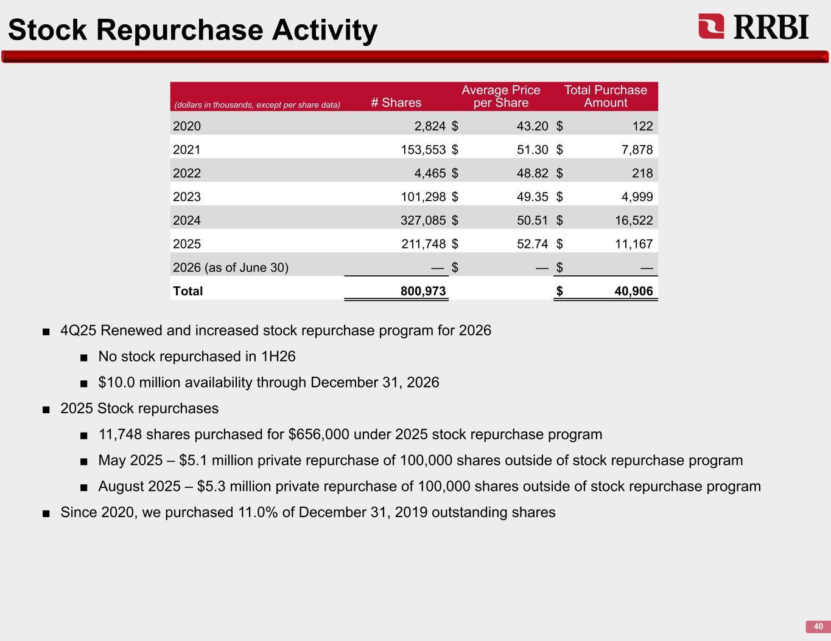
Stock Repurchase Activity 40 (dollars in thousands, except per share data) # Shares Average Price per Share Total Purchase Amount 2020 2,824 $ 43.20 $ 122 2021 153,553 $ 51.30 $ 7,878 2022 4,465 $ 48.82 $ 218 2023 101,298 $ 49.35 $ 4,999 2024 327,085 $ 50.51 $ 16,522 2025 211,748 $ 52.74 $ 11,167 2026 (as of June 30) — $ — $ — Total 800,973 $ 40,906 ■ 4Q25 Renewed and increased stock repurchase program for 2026 ■ No stock repurchased in 1H26 ■ $10.0 million availability through December 31, 2026 ■ 2025 Stock repurchases ■ 11,748 shares purchased for $656,000 under 2025 stock repurchase program ■ May 2025 – $5.1 million private repurchase of 100,000 shares outside of stock repurchase program ■ August 2025 – $5.3 million private repurchase of 100,000 shares outside of stock repurchase program ■ Since 2020, we purchased 11.0% of December 31, 2019 outstanding shares

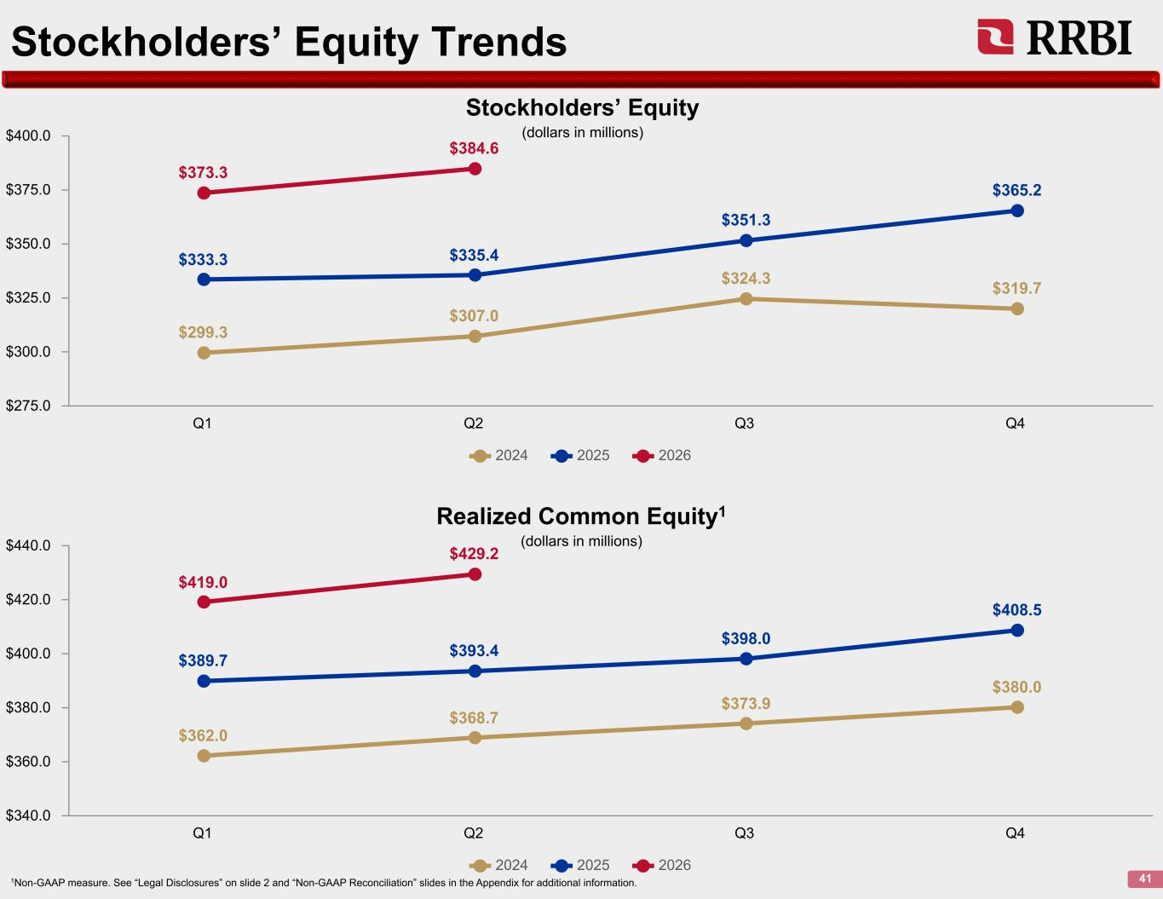
Stockholders’ Equity Trends 41 $299.3 $307.0 $324.3 $319.7 $333.3 $335.4 $351.3 $365.2 $373.3 $384.6 2024 2025 2026 Q1 Q2 Q3 Q4 $275.0 $300.0 $325.0 $350.0 $375.0 $400.0 Stockholders’ Equity (dollars in millions) $362.0 $368.7 $373.9 $380.0 $389.7 $393.4 $398.0 $408.5 $419.0 $429.2 2024 2025 2026 Q1 Q2 Q3 Q4 $340.0 $360.0 $380.0 $400.0 $420.0 $440.0 Realized Common Equity1 (dollars in millions) 1Non-GAAP measure. See “Legal Disclosures” on slide 2 and “Non-GAAP Reconciliation” slides in the Appendix for additional information.

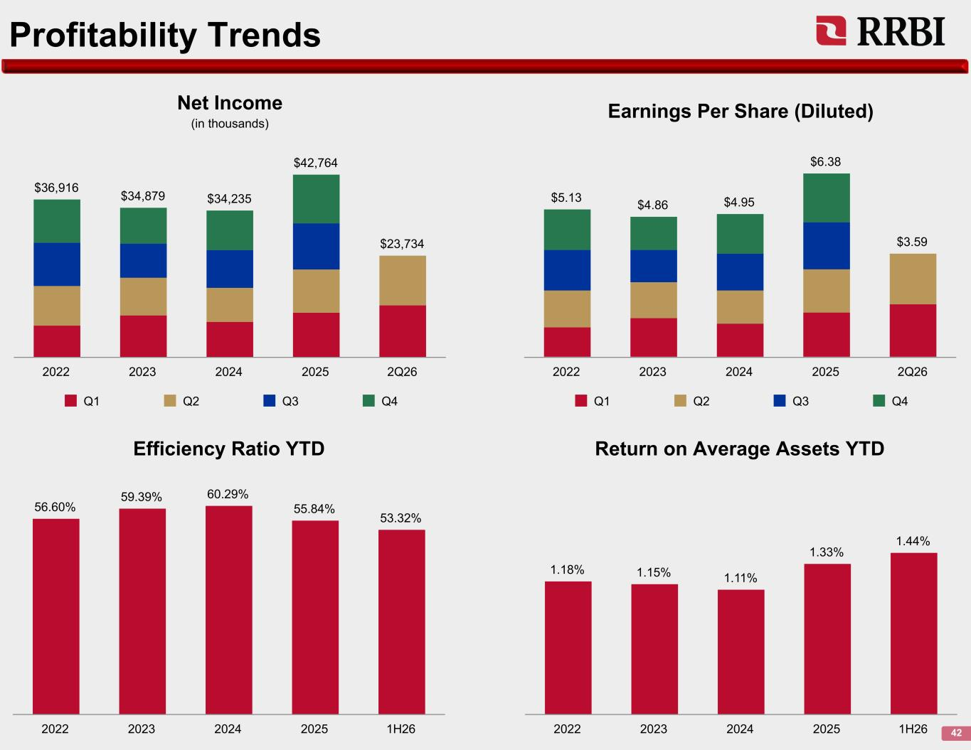
Profitability Trends 42 $36,916 $34,879 $34,235 $42,764 $23,734 Q1 Q2 Q3 Q4 2022 2023 2024 2025 2Q26 Net Income (in thousands) $5.13 $4.86 $4.95 $6.38 $3.59 Q1 Q2 Q3 Q4 2022 2023 2024 2025 2Q26 Earnings Per Share (Diluted) 56.60% 59.39% 60.29% 55.84% 53.32% 2022 2023 2024 2025 1H26 Efficiency Ratio YTD Return on Average Assets YTD 1.18% 1.15% 1.11% 1.33% 1.44% 2022 2023 2024 2025 1H26

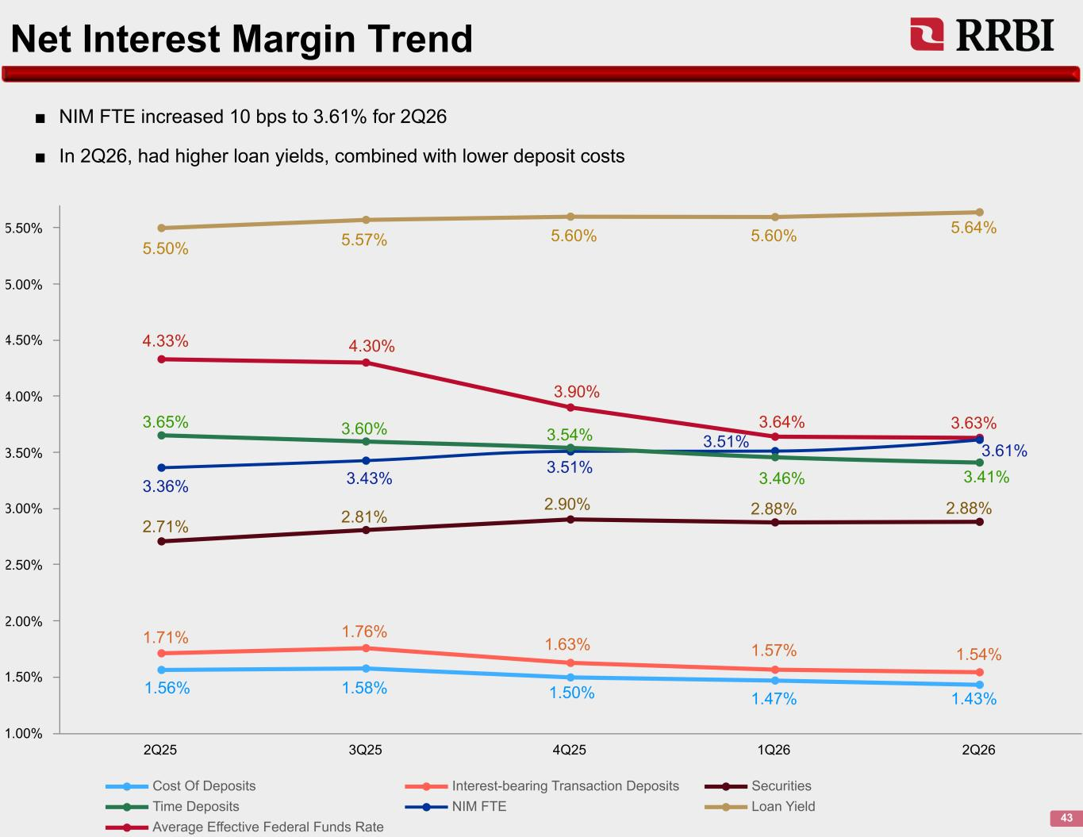
Net Interest Margin Trend 43 ■ NIM FTE increased 10 bps to 3.61% for 2Q26 ■ In 2Q26, had higher loan yields, combined with lower deposit costs Cost Of Deposits Interest-bearing Transaction Deposits Securities Time Deposits NIM FTE Loan Yield Average Effective Federal Funds Rate 2Q25 3Q25 4Q25 1Q26 2Q26 1.00% 1.50% 2.00% 2.50% 3.00% 3.50% 4.00% 4.50% 5.00% 5.50% 5.50% 5.57% 5.60% 5.60% 5.64% 4.33% 4.30% 3.90% 3.64% 3.63%3.65% 3.60% 3.54% 3.46% 3.41%3.36% 3.43% 3.51% 3.51% 3.61% 2.71% 2.81% 2.90% 2.88% 2.88% 1.71% 1.76% 1.63% 1.57% 1.54% 1.56% 1.58% 1.50% 1.47% 1.43%

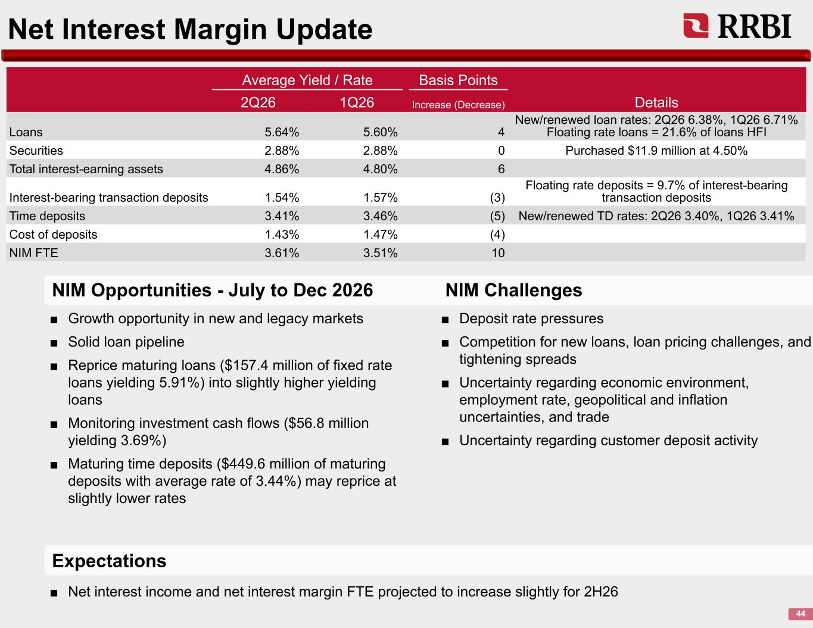
Net Interest Margin Update 44 ■ Growth opportunity in new and legacy markets ■ Solid loan pipeline ■ Reprice maturing loans ($157.4 million of fixed rate loans yielding 5.91%) into slightly higher yielding loans ■ Monitoring investment cash flows ($56.8 million yielding 3.69%) ■ Maturing time deposits ($449.6 million of maturing deposits with average rate of 3.44%) may reprice at slightly lower rates Average Yield / Rate Basis Points Details2Q26 1Q26 Increase (Decrease) Loans 5.64% 5.60% 4 New/renewed loan rates: 2Q26 6.38%, 1Q26 6.71% Floating rate loans = 21.6% of loans HFI Securities 2.88% 2.88% 0 Purchased $11.9 million at 4.50% Total interest-earning assets 4.86% 4.80% 6 Interest-bearing transaction deposits 1.54% 1.57% (3) Floating rate deposits = 9.7% of interest-bearing transaction deposits Time deposits 3.41% 3.46% (5) New/renewed TD rates: 2Q26 3.40%, 1Q26 3.41% Cost of deposits 1.43% 1.47% (4) NIM FTE 3.61% 3.51% 10 ■ Deposit rate pressures ■ Competition for new loans, loan pricing challenges, and tightening spreads ■ Uncertainty regarding economic environment, employment rate, geopolitical and inflation uncertainties, and trade ■ Uncertainty regarding customer deposit activity ■ Net interest income and net interest margin FTE projected to increase slightly for 2H26 Expectations NIM Opportunities - July to Dec 2026 NIM Challenges

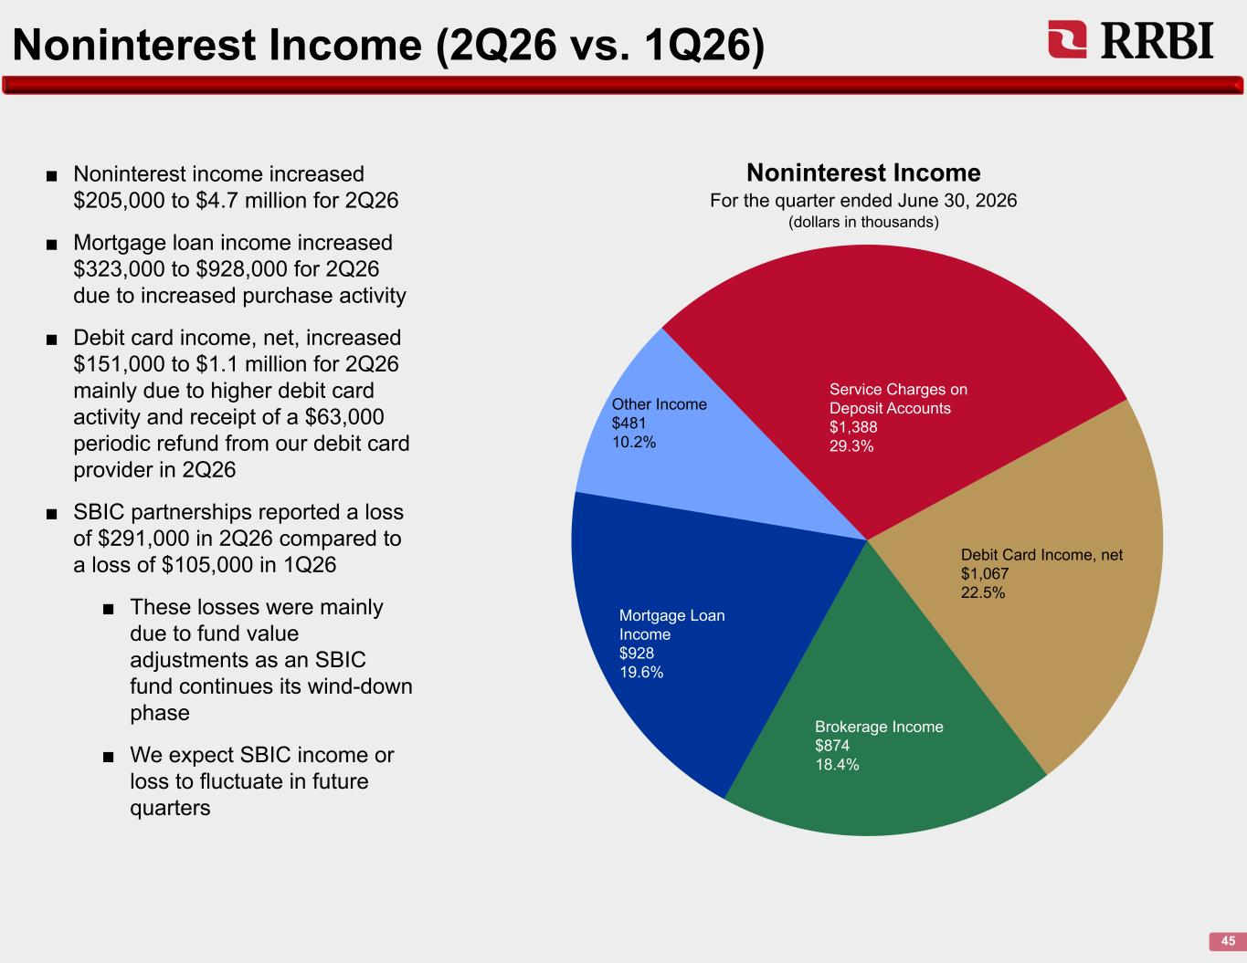
Noninterest Income (2Q26 vs. 1Q26) 45 ■ Noninterest income increased $205,000 to $4.7 million for 2Q26 ■ Mortgage loan income increased $323,000 to $928,000 for 2Q26 due to increased purchase activity ■ Debit card income, net, increased $151,000 to $1.1 million for 2Q26 mainly due to higher debit card activity and receipt of a $63,000 periodic refund from our debit card provider in 2Q26 ■ SBIC partnerships reported a loss of $291,000 in 2Q26 compared to a loss of $105,000 in 1Q26 ■ These losses were mainly due to fund value adjustments as an SBIC fund continues its wind-down phase ■ We expect SBIC income or loss to fluctuate in future quarters Service Charges on Deposit Accounts $1,388 29.3% Debit Card Income, net $1,067 22.5% Brokerage Income $874 18.4% Mortgage Loan Income $928 19.6% Other Income $481 10.2% Noninterest Income For the quarter ended June 30, 2026 (dollars in thousands)

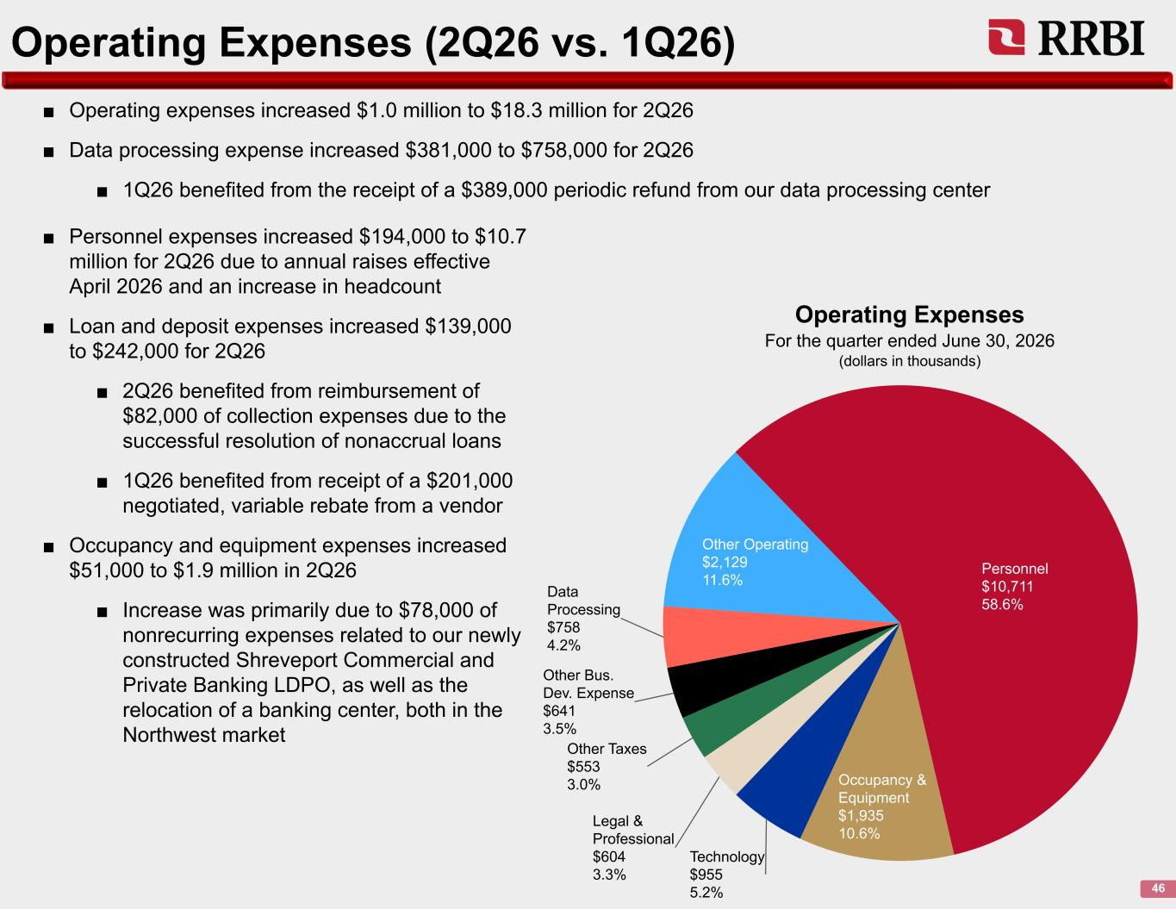
Operating Expenses (2Q26 vs. 1Q26) 46 ■ Operating expenses increased $1.0 million to $18.3 million for 2Q26 ■ Data processing expense increased $381,000 to $758,000 for 2Q26 ■ 1Q26 benefited from the receipt of a $389,000 periodic refund from our data processing center Personnel $10,711 58.6% Occupancy & Equipment $1,935 10.6% Technology $955 5.2% Legal & Professional $604 3.3% Other Taxes $553 3.0% Other Bus. Dev. Expense $641 3.5% Data Processing $758 4.2% Other Operating $2,129 11.6% Operating Expenses For the quarter ended June 30, 2026 (dollars in thousands) ■ Personnel expenses increased $194,000 to $10.7 million for 2Q26 due to annual raises effective April 2026 and an increase in headcount ■ Loan and deposit expenses increased $139,000 to $242,000 for 2Q26 ■ 2Q26 benefited from reimbursement of $82,000 of collection expenses due to the successful resolution of nonaccrual loans ■ 1Q26 benefited from receipt of a $201,000 negotiated, variable rebate from a vendor ■ Occupancy and equipment expenses increased $51,000 to $1.9 million in 2Q26 ■ Increase was primarily due to $78,000 of nonrecurring expenses related to our newly constructed Shreveport Commercial and Private Banking LDPO, as well as the relocation of a banking center, both in the Northwest market

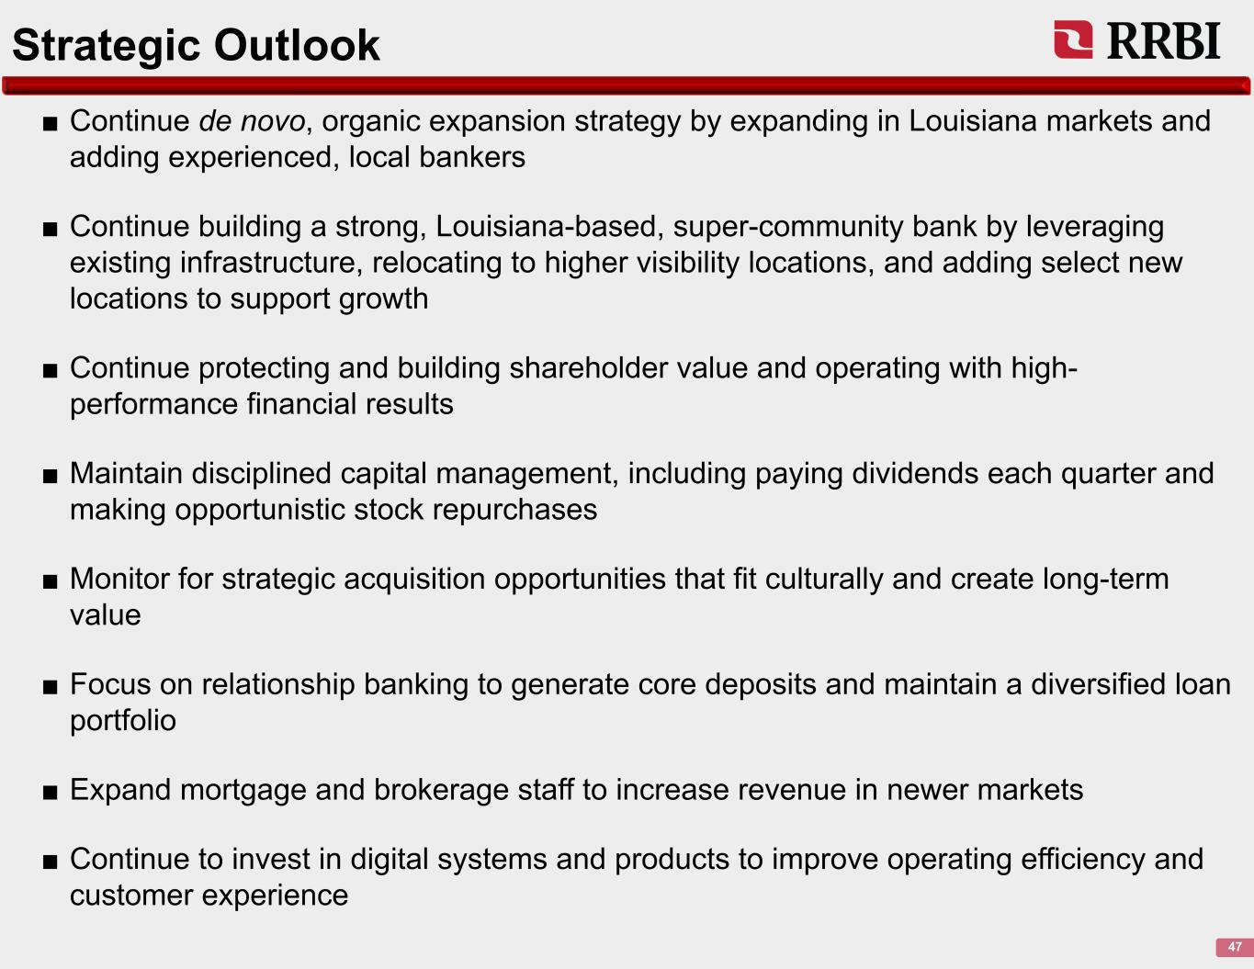
Strategic Outlook 47 ■ Continue de novo, organic expansion strategy by expanding in Louisiana markets and adding experienced, local bankers ■ Continue building a strong, Louisiana-based, super-community bank by leveraging existing infrastructure, relocating to higher visibility locations, and adding select new locations to support growth ■ Continue protecting and building shareholder value and operating with high- performance financial results ■ Maintain disciplined capital management, including paying dividends each quarter and making opportunistic stock repurchases ■ Monitor for strategic acquisition opportunities that fit culturally and create long-term value ■ Focus on relationship banking to generate core deposits and maintain a diversified loan portfolio ■ Expand mortgage and brokerage staff to increase revenue in newer markets ■ Continue to invest in digital systems and products to improve operating efficiency and customer experience

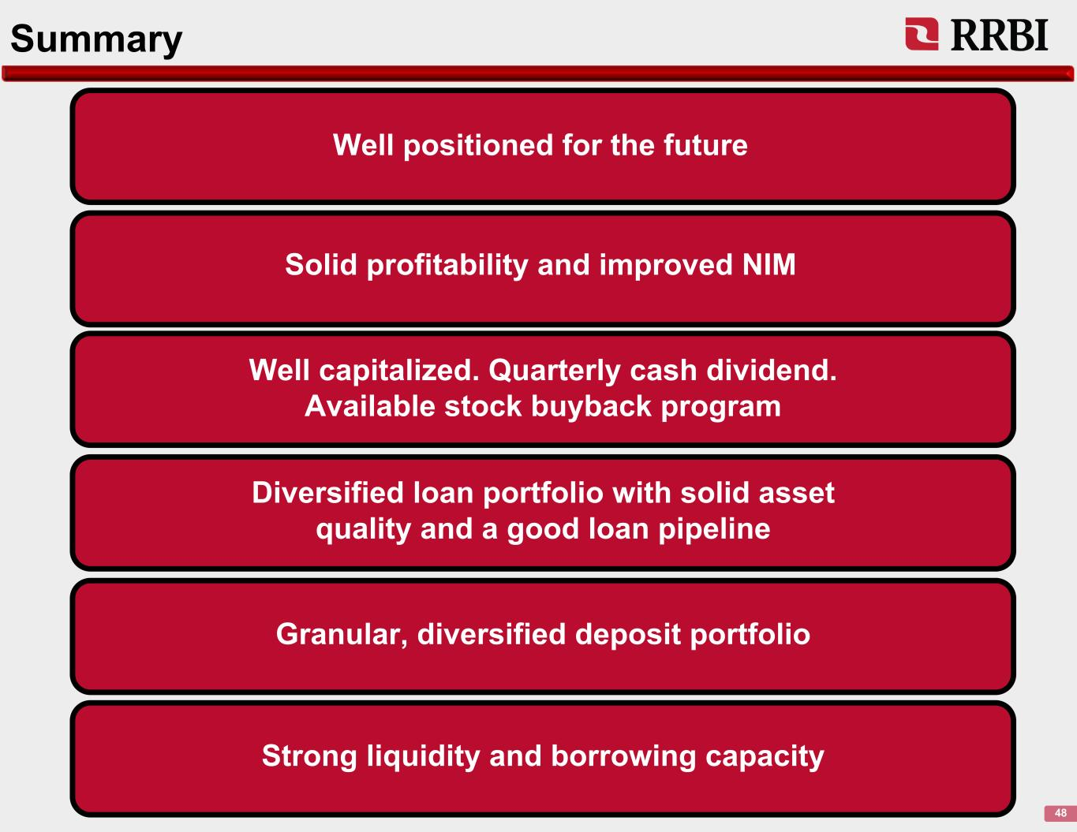
Summary 48 Solid profitability and improved NIM Well positioned for the future Well capitalized. Quarterly cash dividend. Available stock buyback program Diversified loan portfolio with solid asset quality and a good loan pipeline Granular, diversified deposit portfolio Strong liquidity and borrowing capacity


Appendix

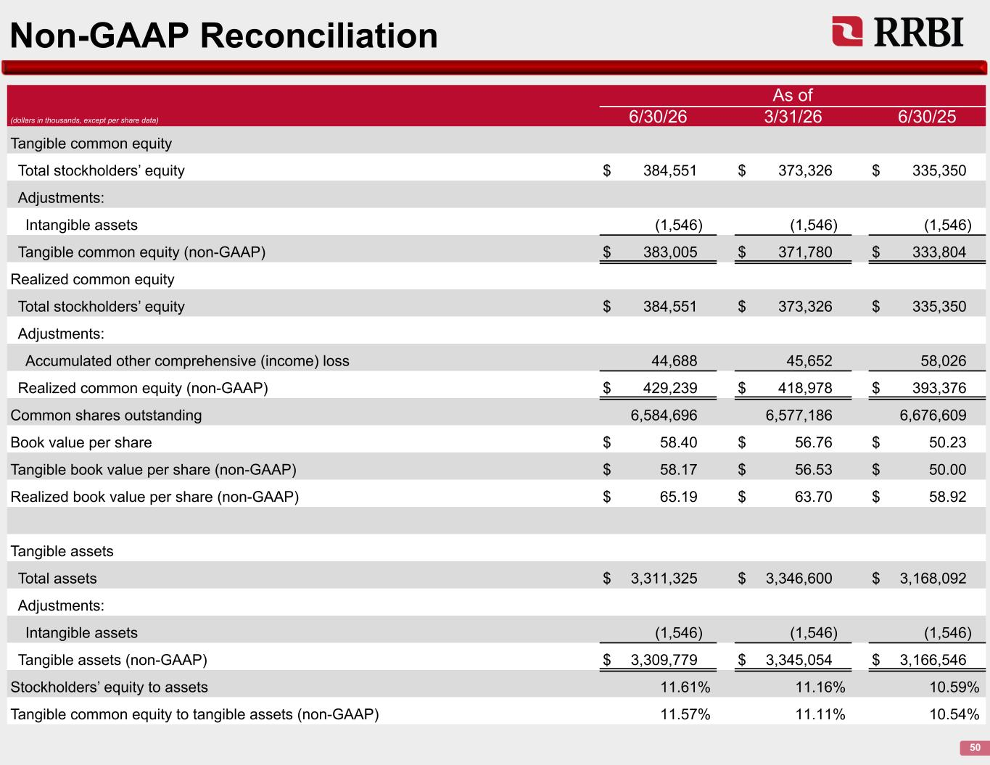
Non-GAAP Reconciliation 50 As of (dollars in thousands, except per share data) 6/30/26 3/31/26 6/30/25 Tangible common equity Total stockholders’ equity $ 384,551 $ 373,326 $ 335,350 Adjustments: Intangible assets (1,546) (1,546) (1,546) Tangible common equity (non-GAAP) $ 383,005 $ 371,780 $ 333,804 Realized common equity Total stockholders’ equity $ 384,551 $ 373,326 $ 335,350 Adjustments: Accumulated other comprehensive (income) loss 44,688 45,652 58,026 Realized common equity (non-GAAP) $ 429,239 $ 418,978 $ 393,376 Common shares outstanding 6,584,696 6,577,186 6,676,609 Book value per share $ 58.40 $ 56.76 $ 50.23 Tangible book value per share (non-GAAP) $ 58.17 $ 56.53 $ 50.00 Realized book value per share (non-GAAP) $ 65.19 $ 63.70 $ 58.92 Tangible assets Total assets $ 3,311,325 $ 3,346,600 $ 3,168,092 Adjustments: Intangible assets (1,546) (1,546) (1,546) Tangible assets (non-GAAP) $ 3,309,779 $ 3,345,054 $ 3,166,546 Stockholders’ equity to assets 11.61% 11.16% 10.59% Tangible common equity to tangible assets (non-GAAP) 11.57% 11.11% 10.54%

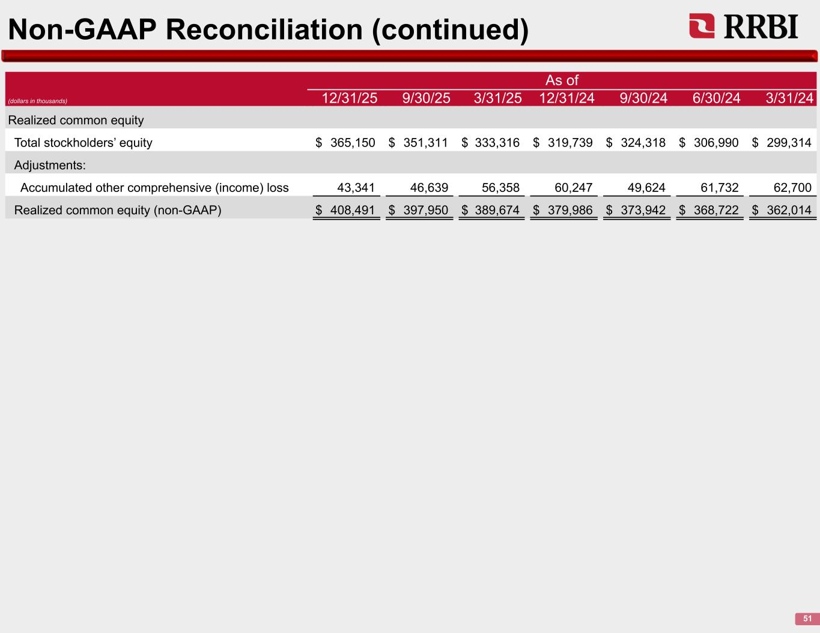
Non-GAAP Reconciliation (continued) 51 As of (dollars in thousands) 12/31/25 9/30/25 3/31/25 12/31/24 9/30/24 6/30/24 3/31/24 Realized common equity Total stockholders’ equity $ 365,150 $ 351,311 $ 333,316 $ 319,739 $ 324,318 $ 306,990 $ 299,314 Adjustments: Accumulated other comprehensive (income) loss 43,341 46,639 56,358 60,247 49,624 61,732 62,700 Realized common equity (non-GAAP) $ 408,491 $ 397,950 $ 389,674 $ 379,986 $ 373,942 $ 368,722 $ 362,014

