UNITED STATES
SECURITIES AND EXCHANGE COMMISSION
WASHINGTON, D.C. 20549
FORM 8-K
CURRENT REPORT
Pursuant to Section 13 or 15(d) of The Securities Exchange Act of 1934

May 14, 2026
Date of Report (Date of earliest event reported)

Red River Bancshares, Inc.
(Exact Name of Registrant as Specified in its Charter)
Louisiana |  |  | 001-38888 |  |  | 72-1412058
(State or Other Jurisdiction  of Incorporation) |  |  | (Commission  File Number) |  |  | (IRS Employer  Identification No.)
1412 Centre Court Drive, Suite 301, Alexandria, Louisiana |  |  |  |  |  | 71301
(Address of Principal Executive Offices) |  |  |  |  |  | (Zip Code)
(318) 561-4000
Registrant’s telephone number, including area code

Check the appropriate box below if the Form 8-K filing is intended to simultaneously satisfy the filing obligation of the registrant under any of the following provisions:

☐ Written communications pursuant to Rule 425 under the Securities Act (17 CFR 230.425)

☐ Soliciting material pursuant to Rule 14a-12 under the Exchange Act (17 CFR 240.14a-12)

☐ Pre-commencement communications pursuant to Rule 14d-2(b) under the Exchange Act (17 CFR 240.14d-2(b))

☐ Pre-commencement communications pursuant to Rule 13e-4(c) under the Exchange Act (17 CFR 240.13e-4(c))

Securities registered pursuant to Section 12(b) of the Act:
Title of each class |  |  | Trading  Symbol(s) |  |  | Name of each exchange  on which registered
Common Stock, no par value |  |  | RRBI |  |  | The Nasdaq Stock Market, LLC

Indicate by check mark whether the registrant is an emerging growth company as defined in Rule 405 of the Securities Act of 1933 (§230.405 of this chapter) or Rule 12b-2 of the Securities Exchange Act of 1934 (§240.12b-2 of this chapter).

Emerging growth company ☐

If an emerging growth company, indicate by check mark if the registrant has elected not to use the extended transition period for complying with any new or revised financial accounting standards provided pursuant to Section 13(a) of the Exchange Act. ☐

Item. 7.01 Regulation FD Disclosure.
Red River Bancshares, Inc. (the “Company”) intends to participate in the 2026 Gulf South Bank Conference, which will be held on May 18-19, 2026. During this conference, members of the Company’s executive management team will meet with investors and analysts. Attached as Exhibit 99.1 to this Current Report on Form 8-K is the presentation the Company’s executive management team will present. The presentation is also available on the Investor Relations page of the Company’s website at www.redriverbank.net.
All information included in the presentation is presented as of the dates indicated, and the Company does not assume any obligation to correct or update such information in the future. In addition, the Company disclaims any inferences regarding the materiality of such information that may arise as a result of it furnishing such information under Item 7.01 of this Current Report on Form 8-K.
As provided in General Instruction B.2. to Form 8-K, the information furnished in Item 7.01 and Exhibit 99.1 of this Current Report on Form 8-K shall not be deemed “filed” for purposes of Section 18 of the Securities Exchange Act of 1934, as amended (the “Exchange Act”), or otherwise subject to the liabilities of that section, and such information shall not be deemed incorporated by reference in any filing under the Securities Act of 1933, as amended, or the Exchange Act, except as shall be expressly set forth by specific reference in such filing.
Item. 9.01 Financial Statements and Exhibits.
(d) Exhibits. The following are furnished as exhibits to this Current Report on Form 8-K.
Exhibit Number |  |  |  |  |  | Description of Exhibit
99.1 |  |  |  |  |  | Red River Bancshares, Inc. Investor Presentation for 2026 Gulf South Bank Conference
104 |  |  |  |  |  | Cover Page Interactive Data File (embedded within the Inline XBRL document)

SIGNATURES

Pursuant to the requirements of the Securities Exchange Act of 1934, the registrant has duly caused this report to be signed on its behalf by the undersigned hereunto duly authorized.

Dated: May 14, 2026
 |  |  | RED RIVER BANCSHARES, INC.
 |  |  | By: |  |  | /s/ Isabel V. Carriere
 |  |  |  |  |  | Isabel V. Carriere, CPA, CGMA
 |  |  |  |  |  | Senior Executive Vice President, Chief Financial Officer, and Assistant Corporate Secretary
 |  |  |  |  |  | (Principal Financial Officer and Principal Accounting Officer)
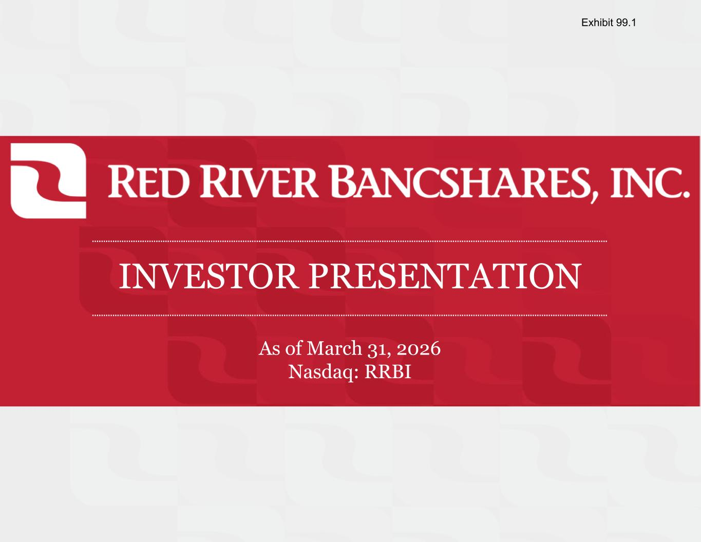

INVESTOR PRESENTATION As of March 31, 2026 Nasdaq: RRBI Exhibit 99.1

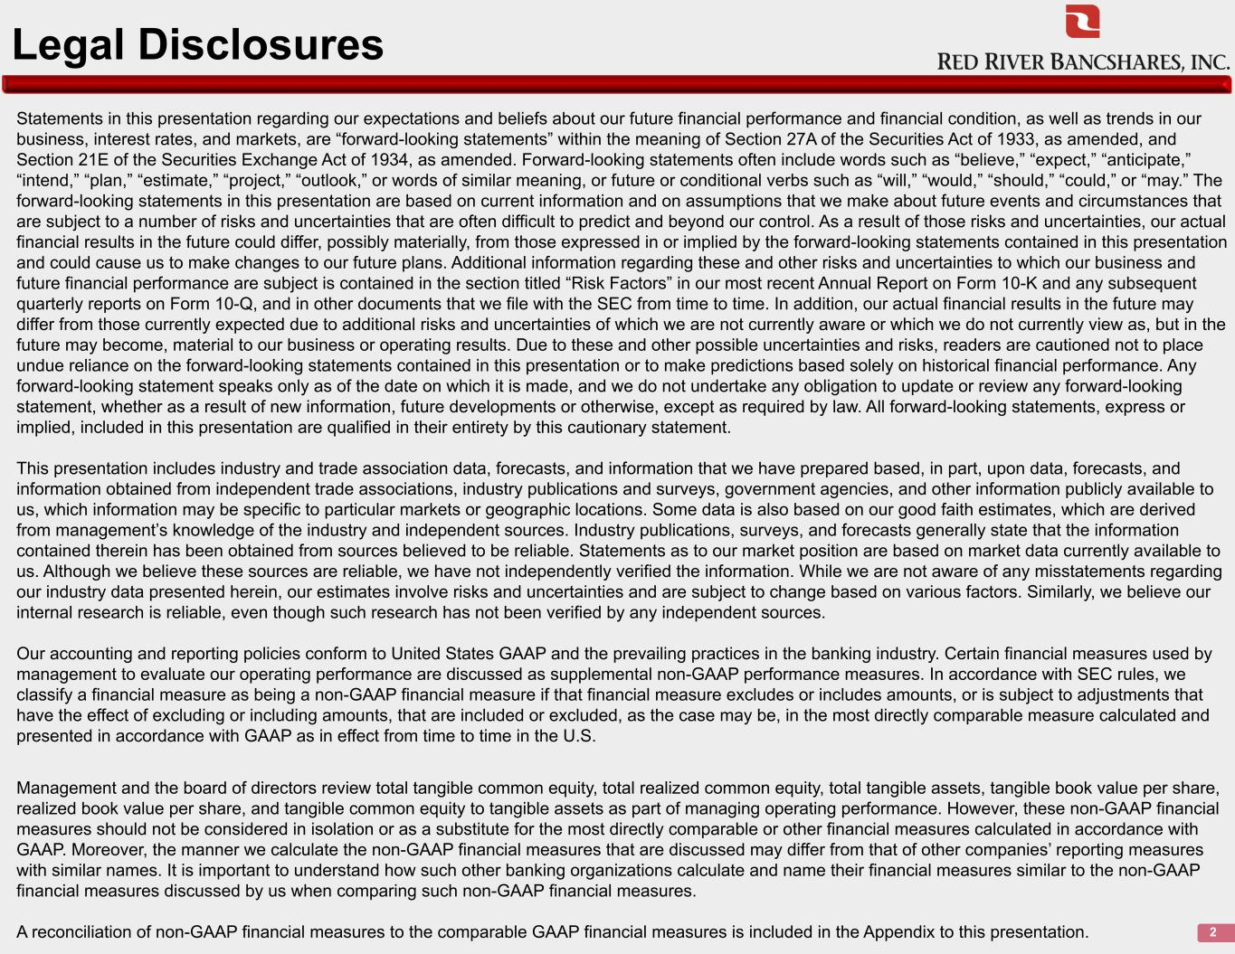
Legal Disclosures Statements in this presentation regarding our expectations and beliefs about our future financial performance and financial condition, as well as trends in our business, interest rates, and markets, are “forward-looking statements” within the meaning of Section 27A of the Securities Act of 1933, as amended, and Section 21E of the Securities Exchange Act of 1934, as amended. Forward-looking statements often include words such as “believe,” “expect,” “anticipate,” “intend,” “plan,” “estimate,” “project,” “outlook,” or words of similar meaning, or future or conditional verbs such as “will,” “would,” “should,” “could,” or “may.” The forward-looking statements in this presentation are based on current information and on assumptions that we make about future events and circumstances that are subject to a number of risks and uncertainties that are often difficult to predict and beyond our control. As a result of those risks and uncertainties, our actual financial results in the future could differ, possibly materially, from those expressed in or implied by the forward-looking statements contained in this presentation and could cause us to make changes to our future plans. Additional information regarding these and other risks and uncertainties to which our business and future financial performance are subject is contained in the section titled “Risk Factors” in our most recent Annual Report on Form 10-K and any subsequent quarterly reports on Form 10-Q, and in other documents that we file with the SEC from time to time. In addition, our actual financial results in the future may differ from those currently expected due to additional risks and uncertainties of which we are not currently aware or which we do not currently view as, but in the future may become, material to our business or operating results. Due to these and other possible uncertainties and risks, readers are cautioned not to place undue reliance on the forward-looking statements contained in this presentation or to make predictions based solely on historical financial performance. Any forward-looking statement speaks only as of the date on which it is made, and we do not undertake any obligation to update or review any forward-looking statement, whether as a result of new information, future developments or otherwise, except as required by law. All forward-looking statements, express or implied, included in this presentation are qualified in their entirety by this cautionary statement. This presentation includes industry and trade association data, forecasts, and information that we have prepared based, in part, upon data, forecasts, and information obtained from independent trade associations, industry publications and surveys, government agencies, and other information publicly available to us, which information may be specific to particular markets or geographic locations. Some data is also based on our good faith estimates, which are derived from management’s knowledge of the industry and independent sources. Industry publications, surveys, and forecasts generally state that the information contained therein has been obtained from sources believed to be reliable. Statements as to our market position are based on market data currently available to us. Although we believe these sources are reliable, we have not independently verified the information. While we are not aware of any misstatements regarding our industry data presented herein, our estimates involve risks and uncertainties and are subject to change based on various factors. Similarly, we believe our internal research is reliable, even though such research has not been verified by any independent sources. Our accounting and reporting policies conform to United States GAAP and the prevailing practices in the banking industry. Certain financial measures used by management to evaluate our operating performance are discussed as supplemental non-GAAP performance measures. In accordance with SEC rules, we classify a financial measure as being a non-GAAP financial measure if that financial measure excludes or includes amounts, or is subject to adjustments that have the effect of excluding or including amounts, that are included or excluded, as the case may be, in the most directly comparable measure calculated and presented in accordance with GAAP as in effect from time to time in the U.S. Management and the board of directors review total tangible common equity, total realized common equity, total tangible assets, tangible book value per share, realized book value per share, and tangible common equity to tangible assets as part of managing operating performance. However, these non-GAAP financial measures should not be considered in isolation or as a substitute for the most directly comparable or other financial measures calculated in accordance with GAAP. Moreover, the manner we calculate the non-GAAP financial measures that are discussed may differ from that of other companies’ reporting measures with similar names. It is important to understand how such other banking organizations calculate and name their financial measures similar to the non-GAAP financial measures discussed by us when comparing such non-GAAP financial measures. A reconciliation of non-GAAP financial measures to the comparable GAAP financial measures is included in the Appendix to this presentation. 2

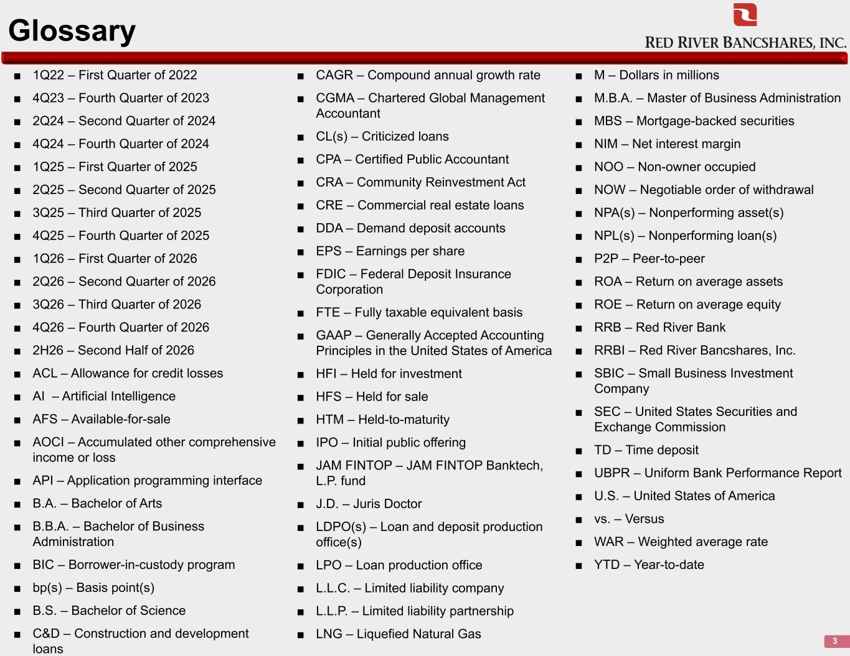
Glossary 3 ■ 1Q22 – First Quarter of 2022 ■ 4Q23 – Fourth Quarter of 2023 ■ 2Q24 – Second Quarter of 2024 ■ 4Q24 – Fourth Quarter of 2024 ■ 1Q25 – First Quarter of 2025 ■ 2Q25 – Second Quarter of 2025 ■ 3Q25 – Third Quarter of 2025 ■ 4Q25 – Fourth Quarter of 2025 ■ 1Q26 – First Quarter of 2026 ■ 2Q26 – Second Quarter of 2026 ■ 3Q26 – Third Quarter of 2026 ■ 4Q26 – Fourth Quarter of 2026 ■ 2H26 – Second Half of 2026 ■ ACL – Allowance for credit losses ■ AI – Artificial Intelligence ■ AFS – Available-for-sale ■ AOCI – Accumulated other comprehensive income or loss ■ API – Application programming interface ■ B.A. – Bachelor of Arts ■ B.B.A. – Bachelor of Business Administration ■ BIC – Borrower-in-custody program ■ bp(s) – Basis point(s) ■ B.S. – Bachelor of Science ■ C&D – Construction and development loans ■ CAGR – Compound annual growth rate ■ CGMA – Chartered Global Management Accountant ■ CL(s) – Criticized loans ■ CPA – Certified Public Accountant ■ CRA – Community Reinvestment Act ■ CRE – Commercial real estate loans ■ DDA – Demand deposit accounts ■ EPS – Earnings per share ■ FDIC – Federal Deposit Insurance Corporation ■ FTE – Fully taxable equivalent basis ■ GAAP – Generally Accepted Accounting Principles in the United States of America ■ HFI – Held for investment ■ HFS – Held for sale ■ HTM – Held-to-maturity ■ IPO – Initial public offering ■ JAM FINTOP – JAM FINTOP Banktech, L.P. fund ■ J.D. – Juris Doctor ■ LDPO(s) – Loan and deposit production office(s) ■ LPO – Loan production office ■ L.L.C. – Limited liability company ■ L.L.P. – Limited liability partnership ■ LNG – Liquefied Natural Gas ■ M – Dollars in millions ■ M.B.A. – Master of Business Administration ■ MBS – Mortgage-backed securities ■ NIM – Net interest margin ■ NOO – Non-owner occupied ■ NOW – Negotiable order of withdrawal ■ NPA(s) – Nonperforming asset(s) ■ NPL(s) – Nonperforming loan(s) ■ P2P – Peer-to-peer ■ ROA – Return on average assets ■ ROE – Return on average equity ■ RRB – Red River Bank ■ RRBI – Red River Bancshares, Inc. ■ SBIC – Small Business Investment Company ■ SEC – United States Securities and Exchange Commission ■ TD – Time deposit ■ UBPR – Uniform Bank Performance Report ■ U.S. – United States of America ■ vs. – Versus ■ WAR – Weighted average rate ■ YTD – Year-to-date



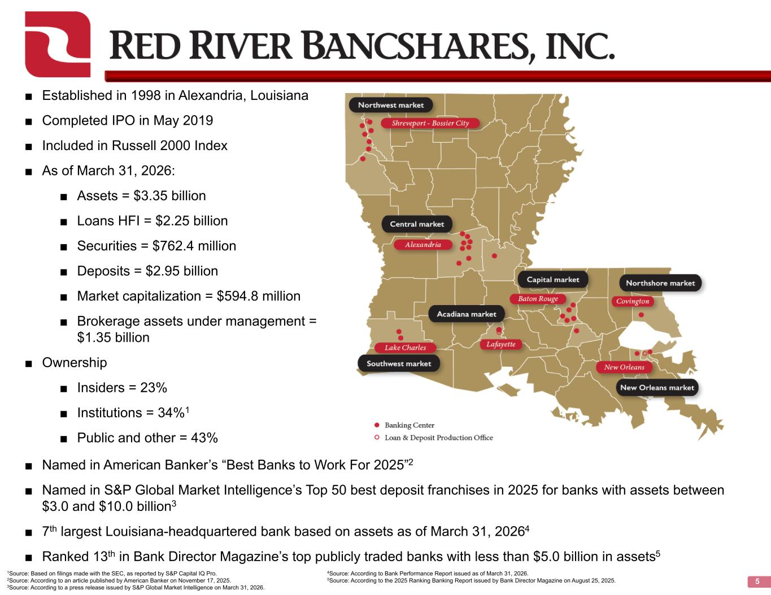
5 ■ Established in 1998 in Alexandria, Louisiana ■ Completed IPO in May 2019 ■ Included in Russell 2000 Index ■ As of March 31, 2026: ■ Assets = $3.35 billion ■ Loans HFI = $2.25 billion ■ Securities = $762.4 million ■ Deposits = $2.95 billion ■ Market capitalization = $594.8 million ■ Brokerage assets under management = $1.35 billion ■ Ownership ■ Insiders = 23% ■ Institutions = 34%1 ■ Public and other = 43% ■ Named in American Banker’s “Best Banks to Work For 2025”2 ■ Named in S&P Global Market Intelligence’s Top 50 best deposit franchises in 2025 for banks with assets between $3.0 and $10.0 billion3 ■ 7th largest Louisiana-headquartered bank based on assets as of March 31, 20264 ■ Ranked 13th in Bank Director Magazine’s top publicly traded banks with less than $5.0 billion in assets5 1Source: Based on filings made with the SEC, as reported by S&P Capital IQ Pro. 2Source: According to an article published by American Banker on November 17, 2025. 3Source: According to a press release issued by S&P Global Market Intelligence on March 31, 2026. 4Source: According to Bank Performance Report issued as of March 31, 2026. 5Source: According to the 2025 Ranking Banking Report issued by Bank Director Magazine on August 25, 2025.

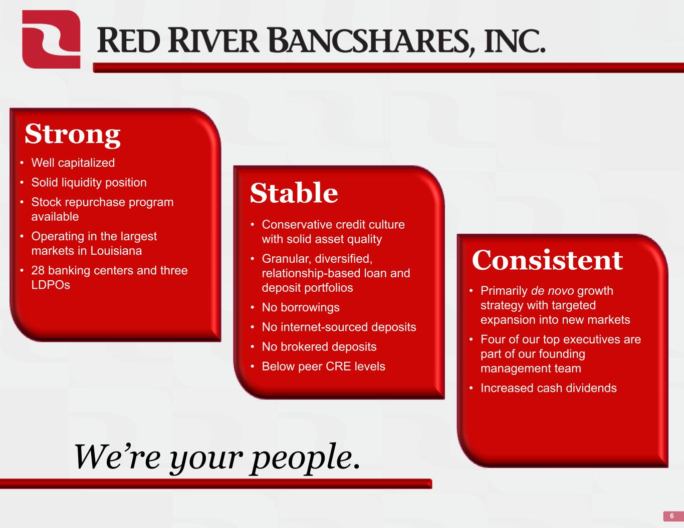
6 Strong • Well capitalized • Solid liquidity position • Stock repurchase program available • Operating in the largest markets in Louisiana • 28 banking centers and three LDPOs Stable • Conservative credit culture with solid asset quality • Granular, diversified, relationship-based loan and deposit portfolios • No borrowings • No internet-sourced deposits • No brokered deposits • Below peer CRE levels Consistent • Primarily de novo growth strategy with targeted expansion into new markets • Four of our top executives are part of our founding management team • Increased cash dividends We’re your people.


History & Strategy

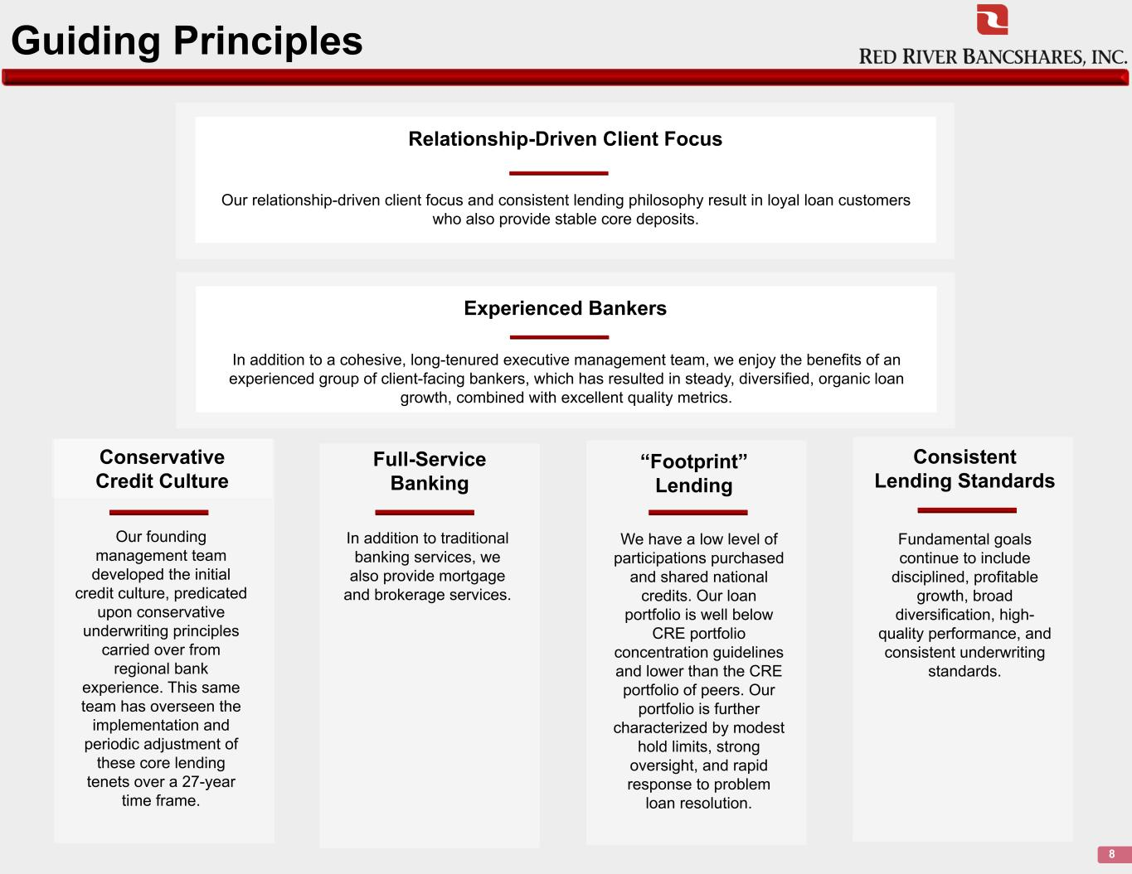
Guiding Principles 8 Conservative Credit Culture Our founding management team developed the initial credit culture, predicated upon conservative underwriting principles carried over from regional bank experience. This same team has overseen the implementation and periodic adjustment of these core lending tenets over a 27-year time frame. “Footprint” Lending We have a low level of participations purchased and shared national credits. Our loan portfolio is well below CRE portfolio concentration guidelines and lower than the CRE portfolio of peers. Our portfolio is further characterized by modest hold limits, strong oversight, and rapid response to problem loan resolution. Relationship-Driven Client Focus Our relationship-driven client focus and consistent lending philosophy result in loyal loan customers who also provide stable core deposits. Experienced Bankers In addition to a cohesive, long-tenured executive management team, we enjoy the benefits of an experienced group of client-facing bankers, which has resulted in steady, diversified, organic loan growth, combined with excellent quality metrics. Consistent Lending Standards Fundamental goals continue to include disciplined, profitable growth, broad diversification, high- quality performance, and consistent underwriting standards. Full-Service Banking In addition to traditional banking services, we also provide mortgage and brokerage services.

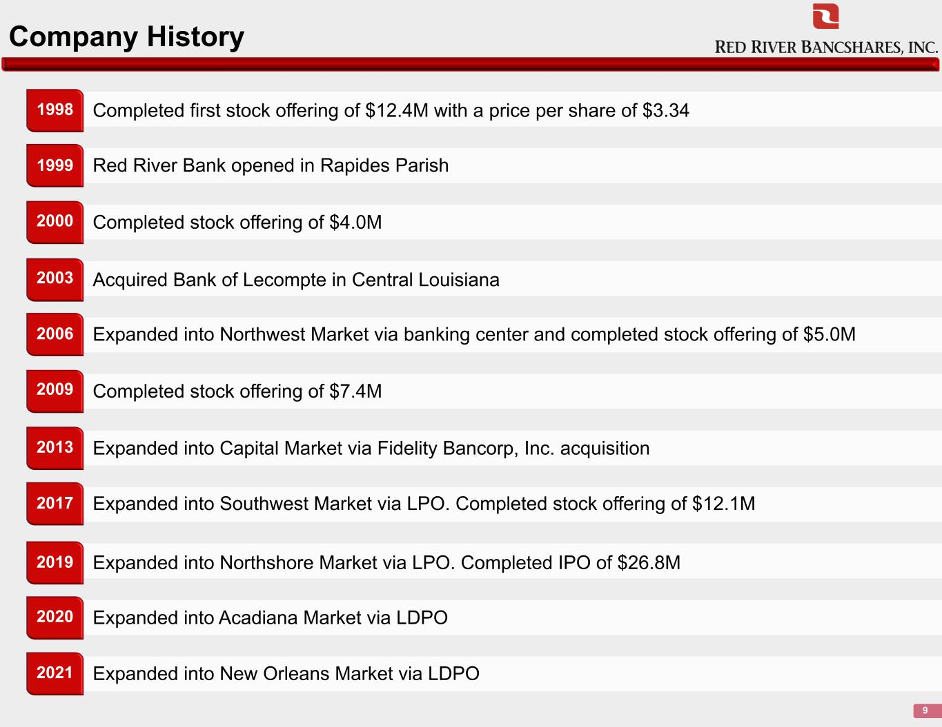
Company History 9 Completed first stock offering of $12.4M with a price per share of $3.341998 Red River Bank opened in Rapides Parish Completed stock offering of $4.0M Acquired Bank of Lecompte in Central Louisiana Expanded into Northwest Market via banking center and completed stock offering of $5.0M Completed stock offering of $7.4M Expanded into Capital Market via Fidelity Bancorp, Inc. acquisition Expanded into Southwest Market via LPO. Completed stock offering of $12.1M Expanded into Northshore Market via LPO. Completed IPO of $26.8M Expanded into Acadiana Market via LDPO Expanded into New Orleans Market via LDPO 1999 2000 2003 2006 2009 2013 2017 2019 2020 2021

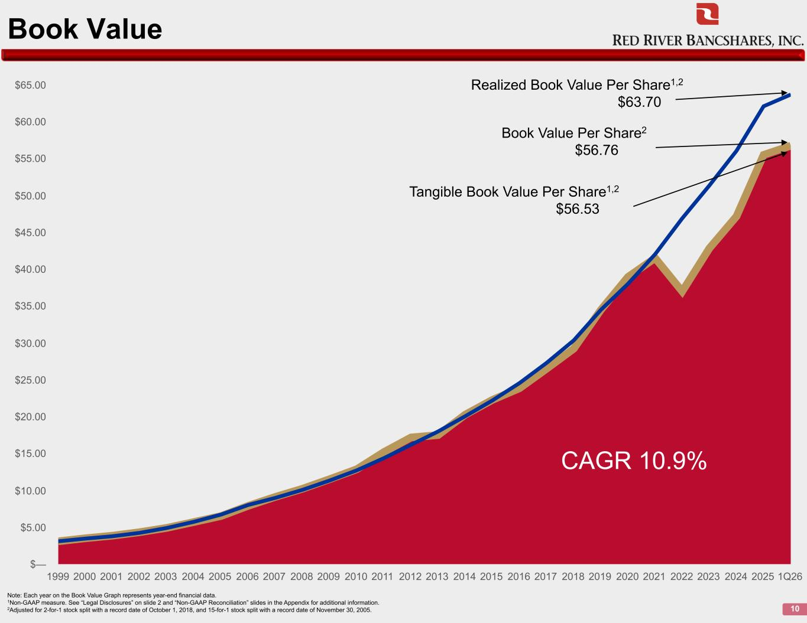
Book Value 10 Note: Each year on the Book Value Graph represents year-end financial data. 1Non-GAAP measure. See “Legal Disclosures” on slide 2 and “Non-GAAP Reconciliation” slides in the Appendix for additional information. 2Adjusted for 2-for-1 stock split with a record date of October 1, 2018, and 15-for-1 stock split with a record date of November 30, 2005. 1999 2000 2001 2002 2003 2004 2005 2006 2007 2008 2009 2010 2011 2012 2013 2014 2015 2016 2017 2018 2019 2020 2021 2022 2023 2024 2025 1Q26 $— $5.00 $10.00 $15.00 $20.00 $25.00 $30.00 $35.00 $40.00 $45.00 $50.00 $55.00 $60.00 $65.00 Realized Book Value Per Share1,2 $63.70 Book Value Per Share2 $56.76 Tangible Book Value Per Share1,2 $56.53 CAGR 10.9%

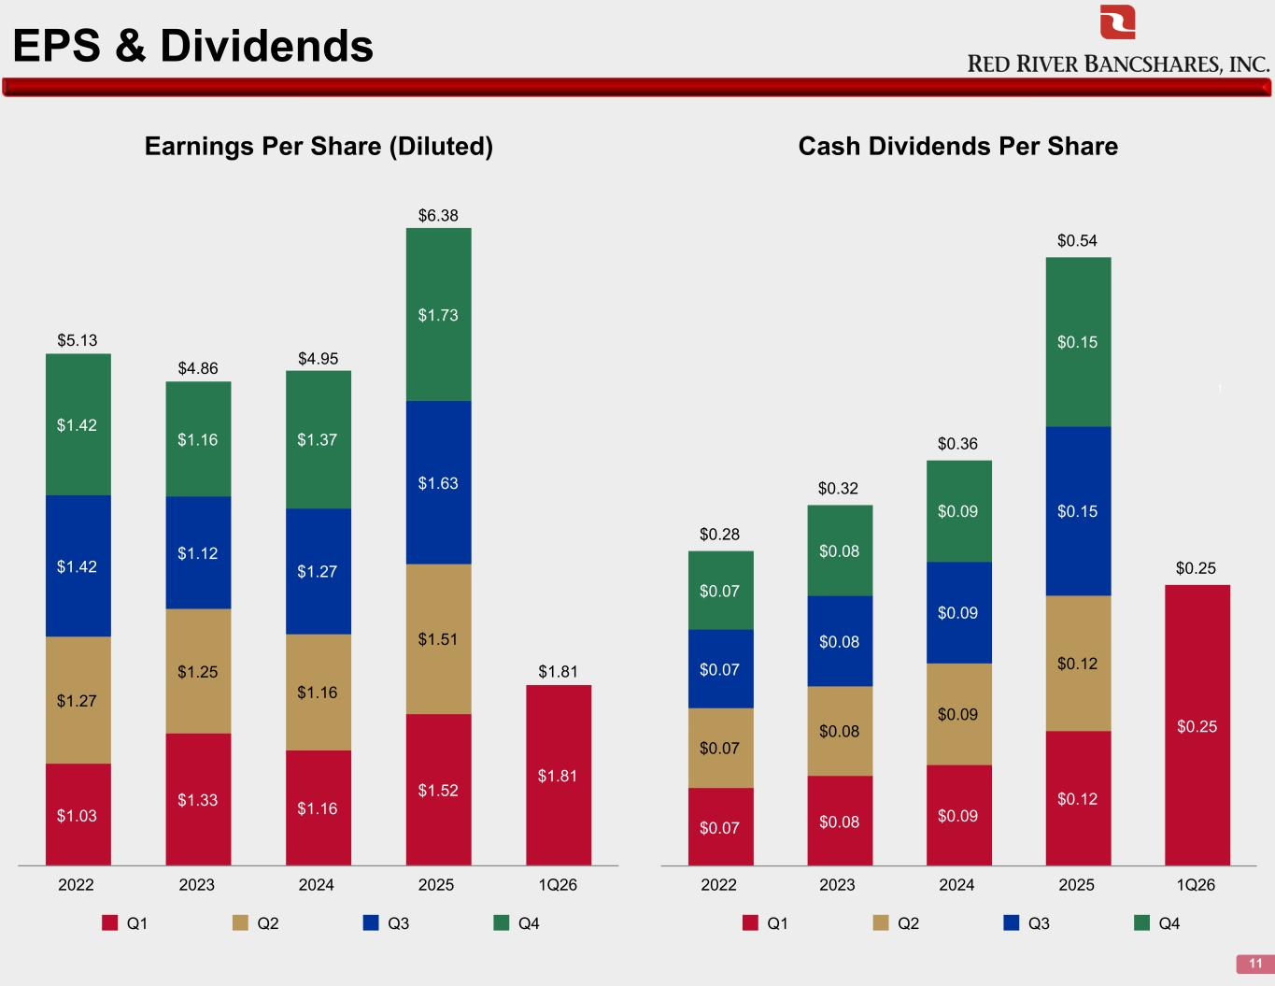
EPS & Dividends 11 $1.03 $1.33 $1.16 $1.52 $1.81 $1.27 $1.25 $1.16 $1.51 $1.42 $1.12 $1.27 $1.63 $1.42 $1.16 $1.37 $1.73 Q1 Q2 Q3 Q4 2022 2023 2024 2025 1Q26 $0.28 $0.32 $0.36 $0.54 $0.25 $0.07 $0.08 $0.09 $0.12 $0.25 $0.07 $0.08 $0.09 $0.12$0.07 $0.08 $0.09 $0.15 $0.07 $0.08 $0.09 $0.15 Q1 Q2 Q3 Q4 2022 2023 2024 2025 1Q26 Cash Dividends Per ShareEarnings Per Share (Diluted) 1 $5.13 $4.86 $4.95 $6.38 $1.81

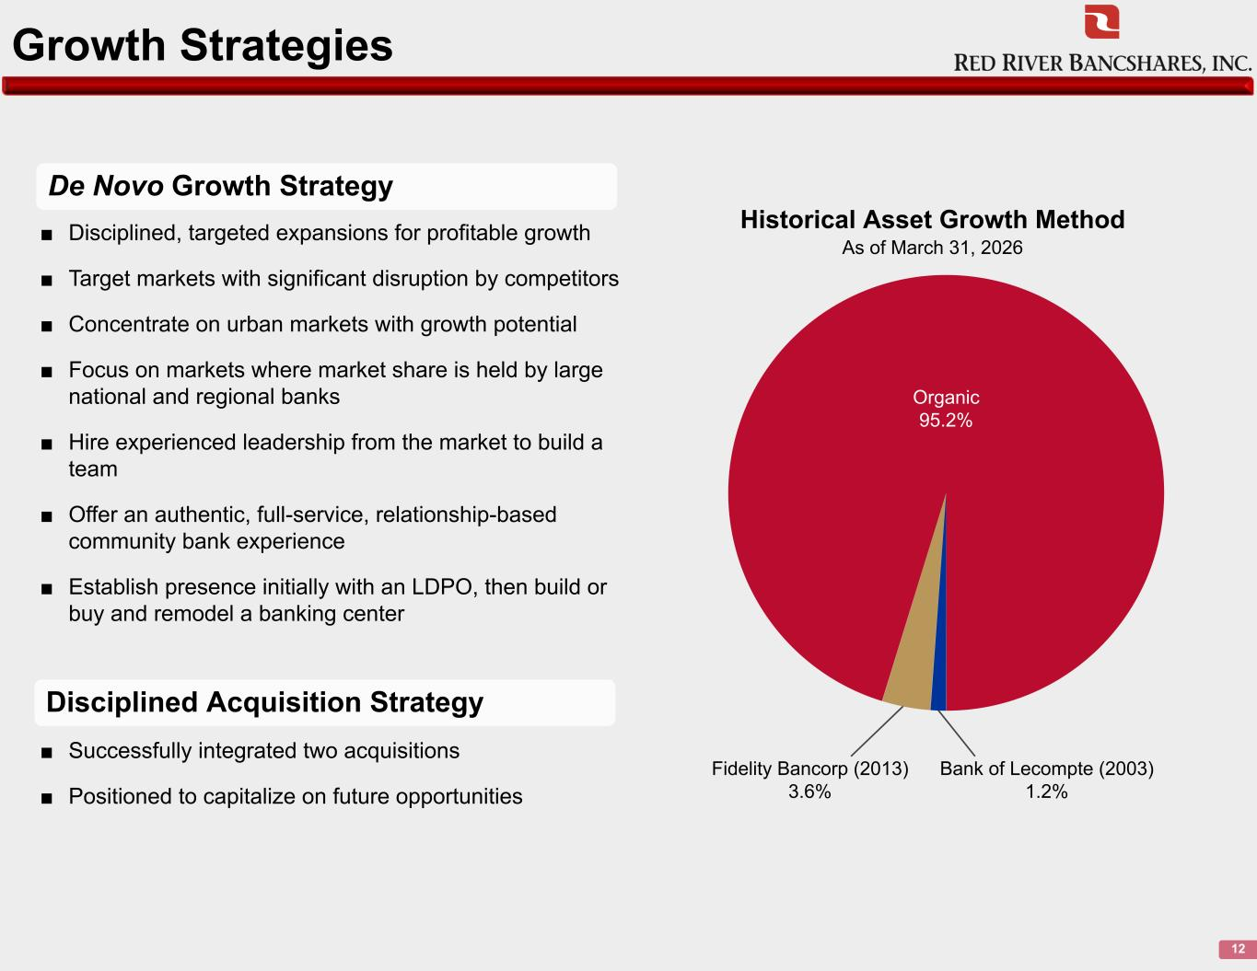
Growth Strategies 12 De Novo Growth Strategy ■ Disciplined, targeted expansions for profitable growth ■ Target markets with significant disruption by competitors ■ Concentrate on urban markets with growth potential ■ Focus on markets where market share is held by large national and regional banks ■ Hire experienced leadership from the market to build a team ■ Offer an authentic, full-service, relationship-based community bank experience ■ Establish presence initially with an LDPO, then build or buy and remodel a banking center ■ Successfully integrated two acquisitions ■ Positioned to capitalize on future opportunities Fidelity Bancorp (2013) 3.6% Bank of Lecompte (2003) 1.2% Historical Asset Growth Method As of March 31, 2026 Organic 95.2% Disciplined Acquisition Strategy

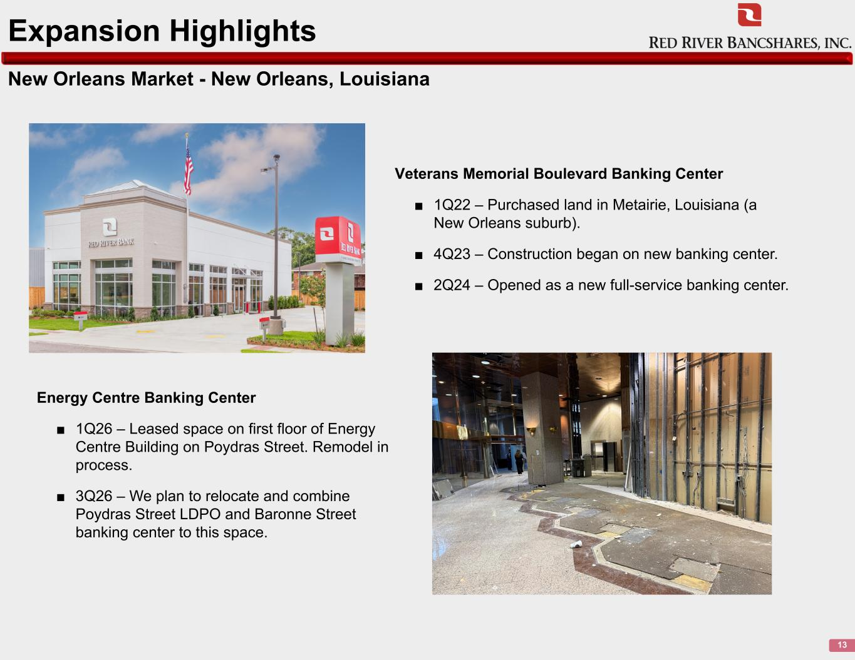
New Orleans Market - New Orleans, Louisiana 13 Expansion Highlights Veterans Memorial Boulevard Banking Center ■ 1Q22 – Purchased land in Metairie, Louisiana (a New Orleans suburb). ■ 4Q23 – Construction began on new banking center. ■ 2Q24 – Opened as a new full-service banking center. Energy Centre Banking Center ■ 1Q26 – Leased space on first floor of Energy Centre Building on Poydras Street. Remodel in process. ■ 3Q26 – We plan to relocate and combine Poydras Street LDPO and Baronne Street banking center to this space.

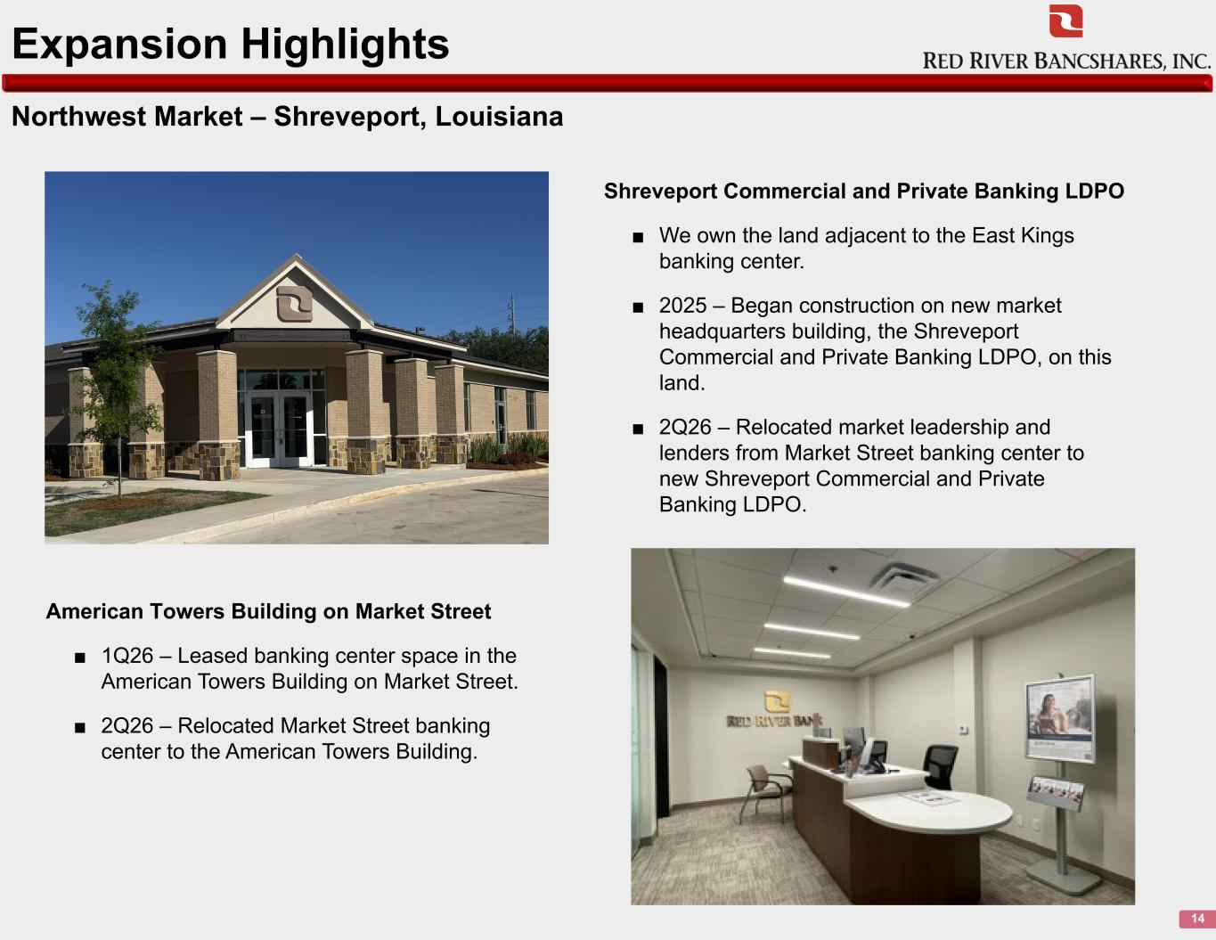
Northwest Market – Shreveport, Louisiana 14 Expansion Highlights Shreveport Commercial and Private Banking LDPO ■ We own the land adjacent to the East Kings banking center. ■ 2025 – Began construction on new market headquarters building, the Shreveport Commercial and Private Banking LDPO, on this land. ■ 2Q26 – Relocated market leadership and lenders from Market Street banking center to new Shreveport Commercial and Private Banking LDPO. American Towers Building on Market Street ■ 1Q26 – Leased banking center space in the American Towers Building on Market Street. ■ 2Q26 – Relocated Market Street banking center to the American Towers Building.

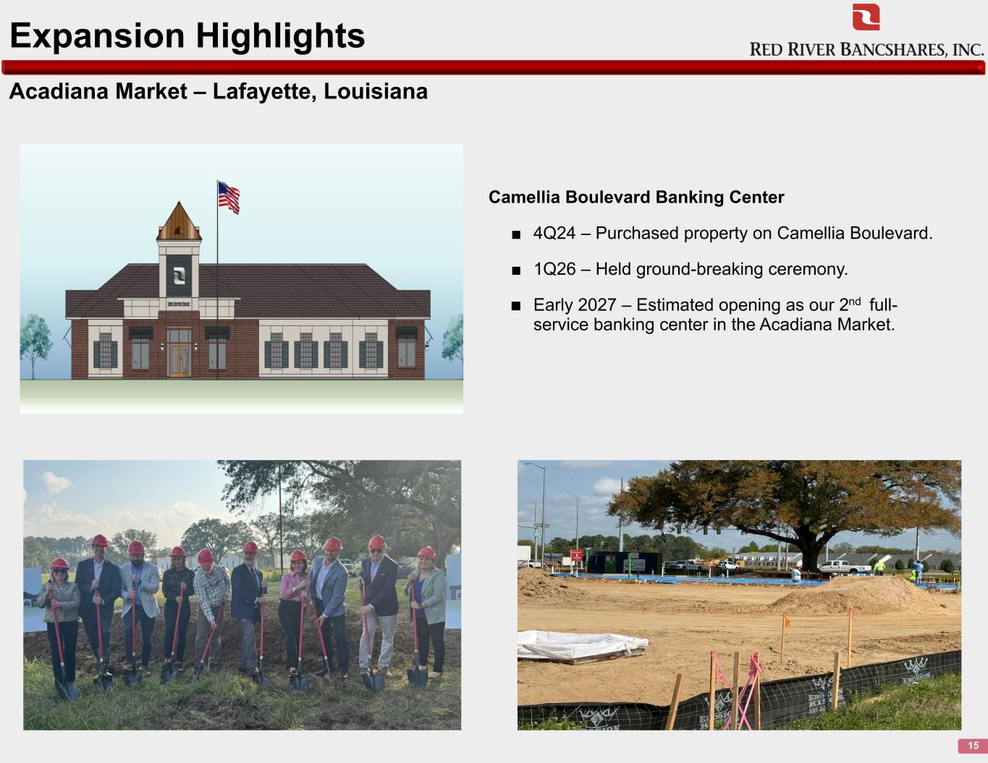
Acadiana Market – Lafayette, Louisiana 15 Expansion Highlights Camellia Boulevard Banking Center ■ 4Q24 – Purchased property on Camellia Boulevard. ■ 1Q26 – Held ground-breaking ceremony. ■ Early 2027 – Estimated opening as our 2nd full- service banking center in the Acadiana Market.

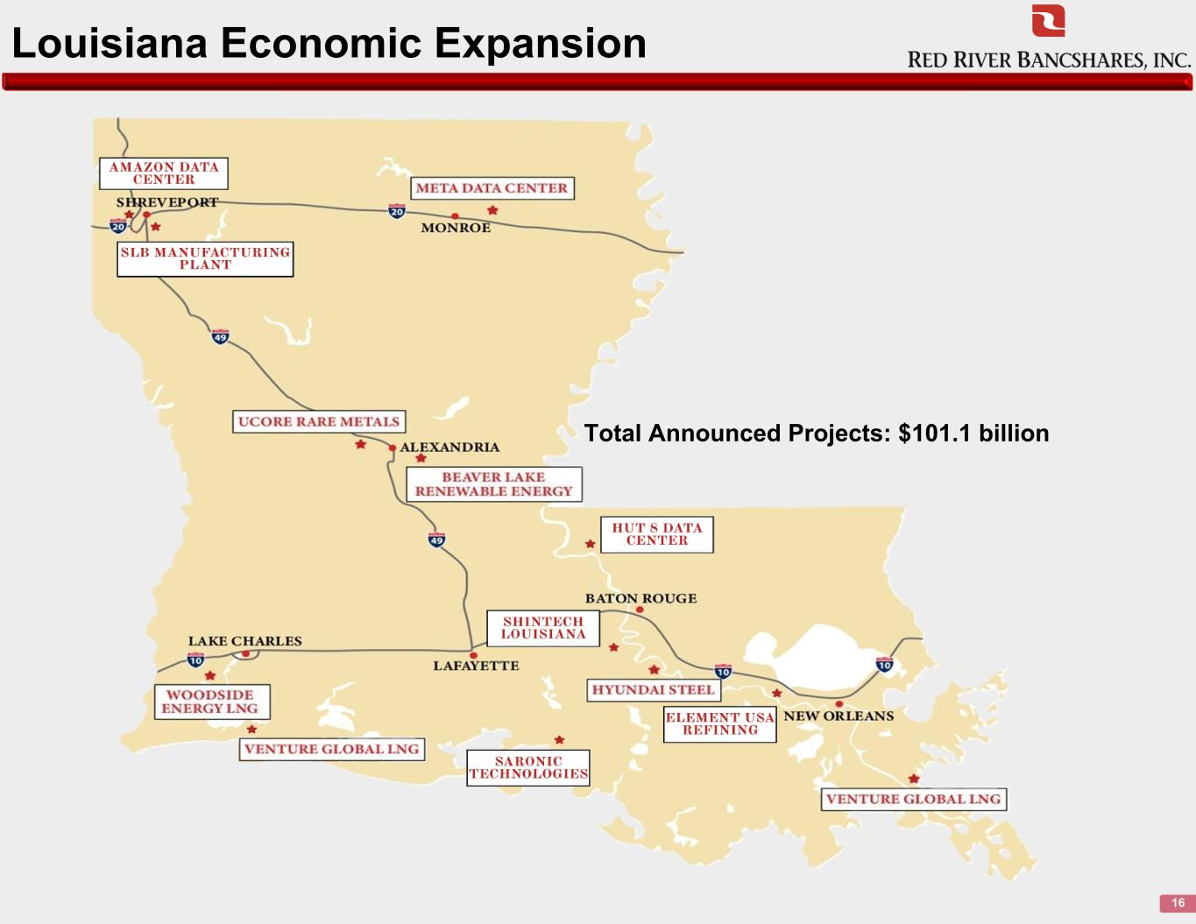
Louisiana Economic Expansion Total Announced Projects: $101.1 billion 16

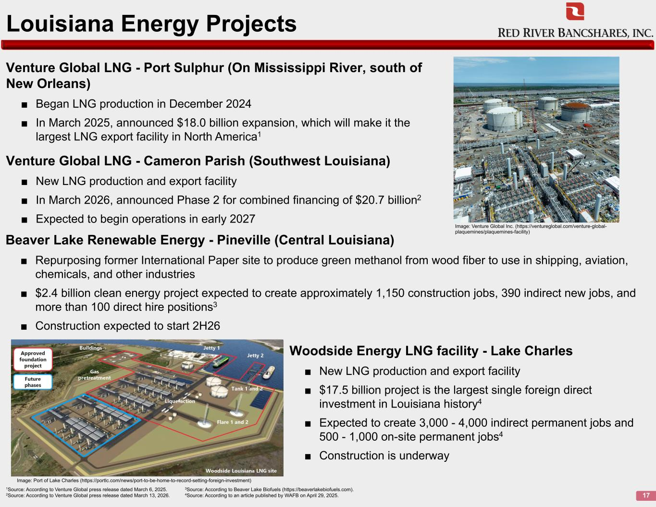
Beaver Lake Renewable Energy - Pineville (Central Louisiana) ■ Repurposing former International Paper site to produce green methanol from wood fiber to use in shipping, aviation, chemicals, and other industries ■ $2.4 billion clean energy project expected to create approximately 1,150 construction jobs, 390 indirect new jobs, and more than 100 direct hire positions3 ■ Construction expected to start 2H26 17 Louisiana Energy Projects Woodside Energy LNG facility - Lake Charles ■ New LNG production and export facility ■ $17.5 billion project is the largest single foreign direct investment in Louisiana history4 ■ Expected to create 3,000 - 4,000 indirect permanent jobs and 500 - 1,000 on-site permanent jobs4 ■ Construction is underway Venture Global LNG - Port Sulphur (On Mississippi River, south of New Orleans) ■ Began LNG production in December 2024 ■ In March 2025, announced $18.0 billion expansion, which will make it the largest LNG export facility in North America1 1Source: According to Venture Global press release dated March 6, 2025. 3Source: According to Beaver Lake Biofuels (https://beaverlakebiofuels.com). 2Source: According to Venture Global press release dated March 13, 2026. 4Source: According to an article published by WAFB on April 29, 2025. Image: Venture Global Inc. (https://ventureglobal.com/venture-global- plaquemines/plaquemines-facility) Image: Port of Lake Charles (https://portlc.com/news/port-to-be-home-to-record-setting-foreign-investment) Venture Global LNG - Cameron Parish (Southwest Louisiana) ■ New LNG production and export facility ■ In March 2026, announced Phase 2 for combined financing of $20.7 billion2 ■ Expected to begin operations in early 2027

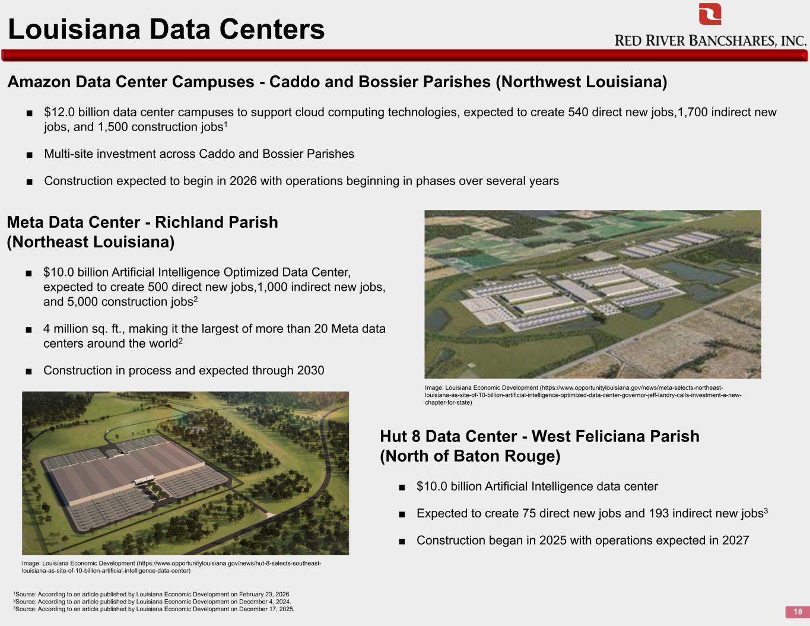
Amazon Data Center Campuses - Caddo and Bossier Parishes (Northwest Louisiana) ■ $12.0 billion data center campuses to support cloud computing technologies, expected to create 540 direct new jobs,1,700 indirect new jobs, and 1,500 construction jobs1 ■ Multi-site investment across Caddo and Bossier Parishes ■ Construction expected to begin in 2026 with operations beginning in phases over several years 18 Louisiana Data Centers 1Source: According to an article published by Louisiana Economic Development on February 23, 2026. 2Source: According to an article published by Louisiana Economic Development on December 4, 2024. 3Source: According to an article published by Louisiana Economic Development on December 17, 2025. Hut 8 Data Center - West Feliciana Parish (North of Baton Rouge) ■ $10.0 billion Artificial Intelligence data center ■ Expected to create 75 direct new jobs and 193 indirect new jobs3 ■ Construction began in 2025 with operations expected in 2027 Meta Data Center - Richland Parish (Northeast Louisiana) ■ $10.0 billion Artificial Intelligence Optimized Data Center, expected to create 500 direct new jobs,1,000 indirect new jobs, and 5,000 construction jobs2 ■ 4 million sq. ft., making it the largest of more than 20 Meta data centers around the world2 ■ Construction in process and expected through 2030 Image: Louisiana Economic Development (https://www.opportunitylouisiana.gov/news/meta-selects-northeast- louisiana-as-site-of-10-billion-artificial-intelligence-optimized-data-center-governor-jeff-landry-calls-investment-a-new- chapter-for-state) Image: Louisiana Economic Development (https://www.opportunitylouisiana.gov/news/hut-8-selects-southeast- louisiana-as-site-of-10-billion-artificial-intelligence-data-center)

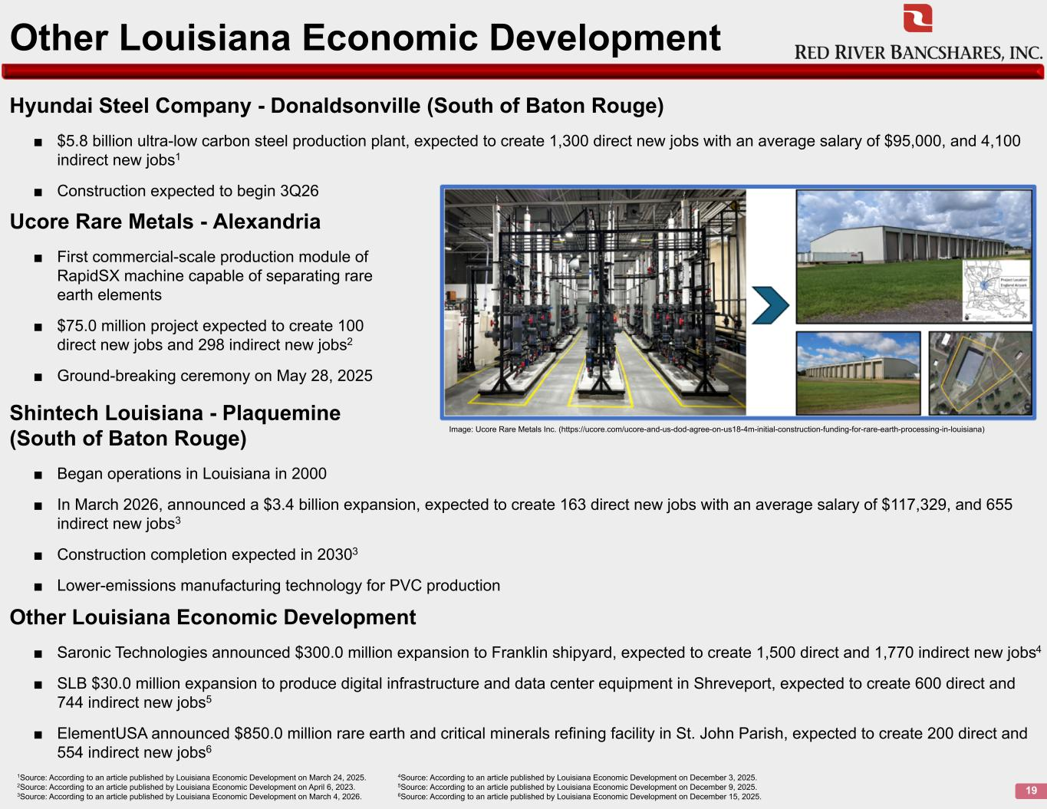
Hyundai Steel Company - Donaldsonville (South of Baton Rouge) ■ $5.8 billion ultra-low carbon steel production plant, expected to create 1,300 direct new jobs with an average salary of $95,000, and 4,100 indirect new jobs1 ■ Construction expected to begin 3Q26 19 Other Louisiana Economic Development 1Source: According to an article published by Louisiana Economic Development on March 24, 2025. 4Source: According to an article published by Louisiana Economic Development on December 3, 2025. 2Source: According to an article published by Louisiana Economic Development on April 6, 2023. 5Source: According to an article published by Louisiana Economic Development on December 9, 2025. 3Source: According to an article published by Louisiana Economic Development on March 4, 2026. 6Source: According to an article published by Louisiana Economic Development on December 15, 2025. Ucore Rare Metals - Alexandria ■ First commercial-scale production module of RapidSX machine capable of separating rare earth elements ■ $75.0 million project expected to create 100 direct new jobs and 298 indirect new jobs2 ■ Ground-breaking ceremony on May 28, 2025 Image: Ucore Rare Metals Inc. (https://ucore.com/ucore-and-us-dod-agree-on-us18-4m-initial-construction-funding-for-rare-earth-processing-in-louisiana) Shintech Louisiana - Plaquemine (South of Baton Rouge) ■ Began operations in Louisiana in 2000 ■ In March 2026, announced a $3.4 billion expansion, expected to create 163 direct new jobs with an average salary of $117,329, and 655 indirect new jobs3 ■ Construction completion expected in 20303 ■ Lower-emissions manufacturing technology for PVC production Other Louisiana Economic Development ■ Saronic Technologies announced $300.0 million expansion to Franklin shipyard, expected to create 1,500 direct and 1,770 indirect new jobs4 ■ SLB $30.0 million expansion to produce digital infrastructure and data center equipment in Shreveport, expected to create 600 direct and 744 indirect new jobs5 ■ ElementUSA announced $850.0 million rare earth and critical minerals refining facility in St. John Parish, expected to create 200 direct and 554 indirect new jobs6

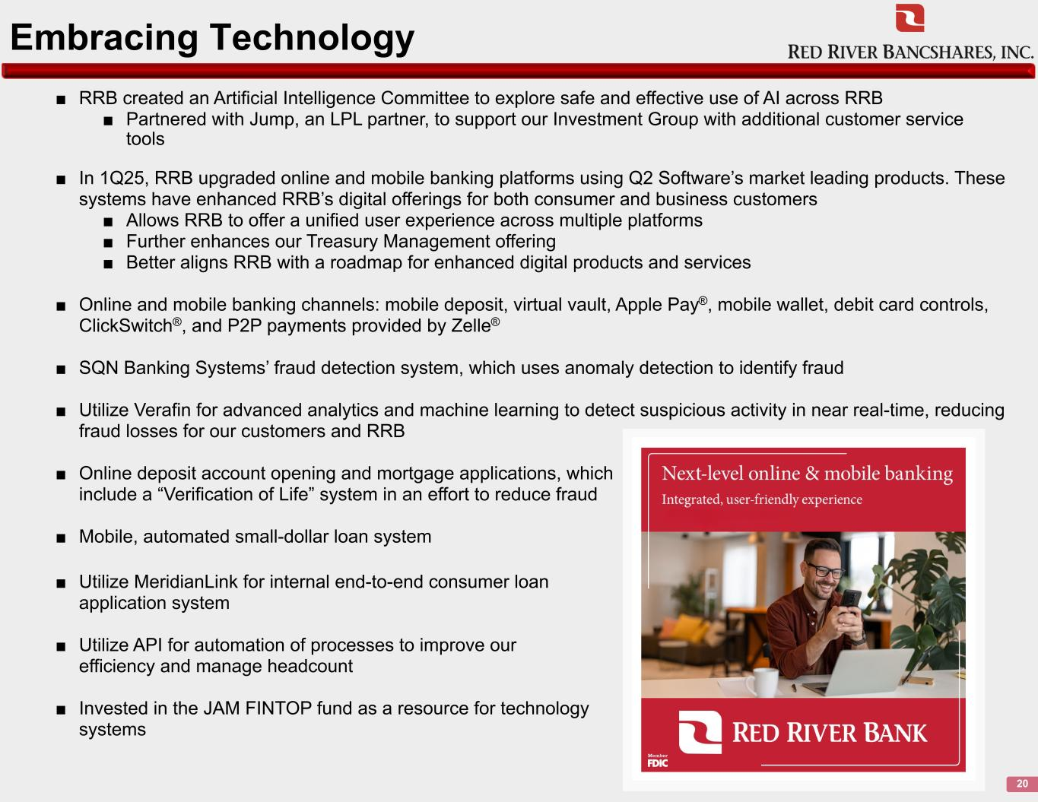
Embracing Technology 20 ■ RRB created an Artificial Intelligence Committee to explore safe and effective use of AI across RRB ■ Partnered with Jump, an LPL partner, to support our Investment Group with additional customer service tools ■ In 1Q25, RRB upgraded online and mobile banking platforms using Q2 Software’s market leading products. These systems have enhanced RRB’s digital offerings for both consumer and business customers ■ Allows RRB to offer a unified user experience across multiple platforms ■ Further enhances our Treasury Management offering ■ Better aligns RRB with a roadmap for enhanced digital products and services ■ Online and mobile banking channels: mobile deposit, virtual vault, Apple Pay®, mobile wallet, debit card controls, ClickSwitch®, and P2P payments provided by Zelle® ■ SQN Banking Systems’ fraud detection system, which uses anomaly detection to identify fraud ■ Utilize Verafin for advanced analytics and machine learning to detect suspicious activity in near real-time, reducing fraud losses for our customers and RRB ■ Online deposit account opening and mortgage applications, which include a “Verification of Life” system in an effort to reduce fraud ■ Mobile, automated small-dollar loan system ■ Utilize MeridianLink for internal end-to-end consumer loan application system ■ Utilize API for automation of processes to improve our efficiency and manage headcount ■ Invested in the JAM FINTOP fund as a resource for technology systems

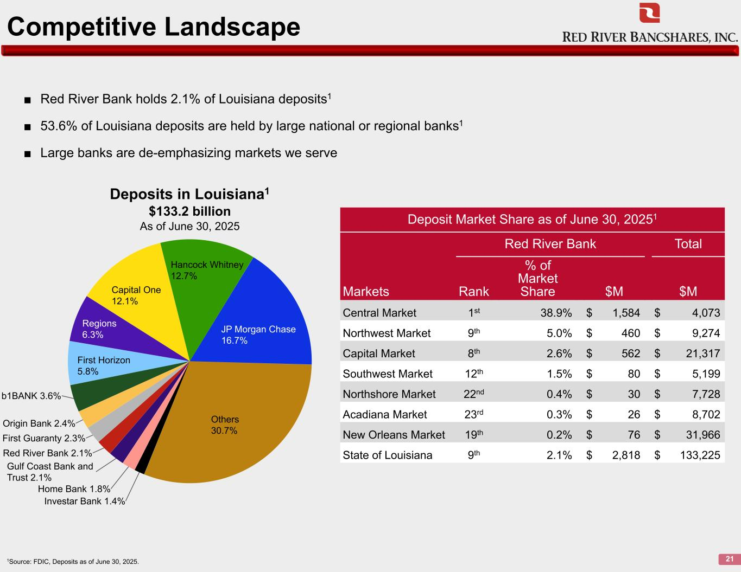
Competitive Landscape 211Source: FDIC, Deposits as of June 30, 2025. Investar Bank 1.4% Home Bank 1.8% Gulf Coast Bank and Trust 2.1% Red River Bank 2.1% First Guaranty 2.3% Origin Bank 2.4% b1BANK 3.6% First Horizon 5.8% Regions 6.3% Capital One 12.1% Hancock Whitney 12.7% JP Morgan Chase 16.7% Others 30.7% ■ Red River Bank holds 2.1% of Louisiana deposits1 ■ 53.6% of Louisiana deposits are held by large national or regional banks1 ■ Large banks are de-emphasizing markets we serve Deposit Market Share as of June 30, 20251 Red River Bank Total % of Market Share $M $MMarkets Rank Central Market 1st 38.9% $ 1,584 $ 4,073 Northwest Market 9th 5.0% $ 460 $ 9,274 Capital Market 8th 2.6% $ 562 $ 21,317 Southwest Market 12th 1.5% $ 80 $ 5,199 Northshore Market 22nd 0.4% $ 30 $ 7,728 Acadiana Market 23rd 0.3% $ 26 $ 8,702 New Orleans Market 19th 0.2% $ 76 $ 31,966 State of Louisiana 9th 2.1% $ 2,818 $ 133,225 Deposits in Louisiana1 $133.2 billion As of June 30, 2025

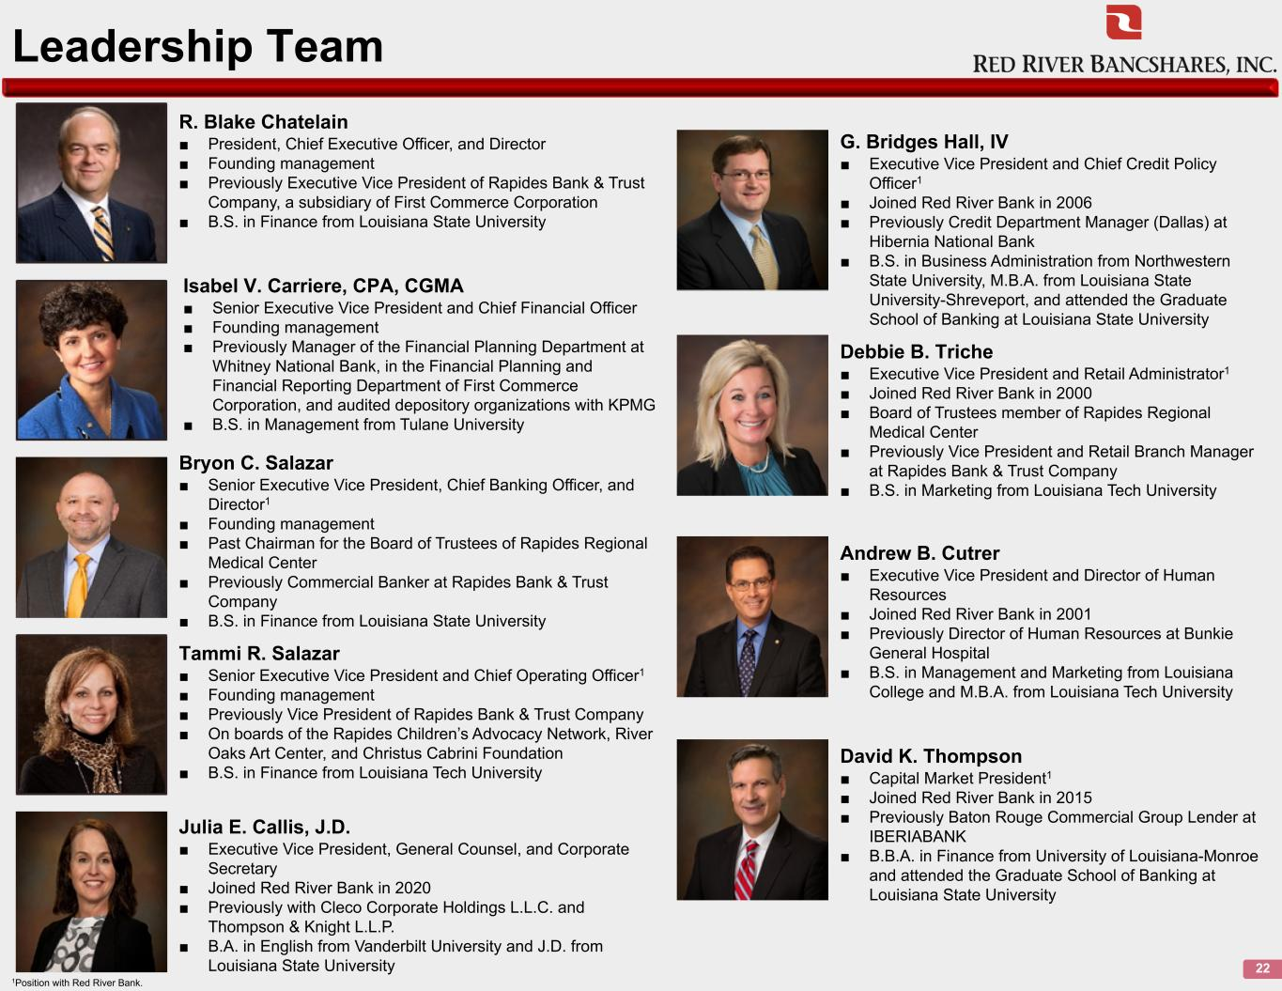
Leadership Team 22 R. Blake Chatelain ■ President, Chief Executive Officer, and Director ■ Founding management ■ Previously Executive Vice President of Rapides Bank & Trust Company, a subsidiary of First Commerce Corporation ■ B.S. in Finance from Louisiana State University Isabel V. Carriere, CPA, CGMA ■ Senior Executive Vice President and Chief Financial Officer ■ Founding management ■ Previously Manager of the Financial Planning Department at Whitney National Bank, in the Financial Planning and Financial Reporting Department of First Commerce Corporation, and audited depository organizations with KPMG ■ B.S. in Management from Tulane University Bryon C. Salazar ■ Senior Executive Vice President, Chief Banking Officer, and Director1 ■ Founding management ■ Past Chairman for the Board of Trustees of Rapides Regional Medical Center ■ Previously Commercial Banker at Rapides Bank & Trust Company ■ B.S. in Finance from Louisiana State University Tammi R. Salazar ■ Senior Executive Vice President and Chief Operating Officer1 ■ Founding management ■ Previously Vice President of Rapides Bank & Trust Company ■ On boards of the Rapides Children’s Advocacy Network, River Oaks Art Center, and Christus Cabrini Foundation ■ B.S. in Finance from Louisiana Tech University Julia E. Callis, J.D. ■ Executive Vice President, General Counsel, and Corporate Secretary ■ Joined Red River Bank in 2020 ■ Previously with Cleco Corporate Holdings L.L.C. and Thompson & Knight L.L.P. ■ B.A. in English from Vanderbilt University and J.D. from Louisiana State University 1Position with Red River Bank. G. Bridges Hall, IV ■ Executive Vice President and Chief Credit Policy Officer1 ■ Joined Red River Bank in 2006 ■ Previously Credit Department Manager (Dallas) at Hibernia National Bank ■ B.S. in Business Administration from Northwestern State University, M.B.A. from Louisiana State University-Shreveport, and attended the Graduate School of Banking at Louisiana State University Debbie B. Triche ■ Executive Vice President and Retail Administrator1 ■ Joined Red River Bank in 2000 ■ Board of Trustees member of Rapides Regional Medical Center ■ Previously Vice President and Retail Branch Manager at Rapides Bank & Trust Company ■ B.S. in Marketing from Louisiana Tech University Andrew B. Cutrer ■ Executive Vice President and Director of Human Resources ■ Joined Red River Bank in 2001 ■ Previously Director of Human Resources at Bunkie General Hospital ■ B.S. in Management and Marketing from Louisiana College and M.B.A. from Louisiana Tech University David K. Thompson ■ Capital Market President1 ■ Joined Red River Bank in 2015 ■ Previously Baton Rouge Commercial Group Lender at IBERIABANK ■ B.B.A. in Finance from University of Louisiana-Monroe and attended the Graduate School of Banking at Louisiana State University

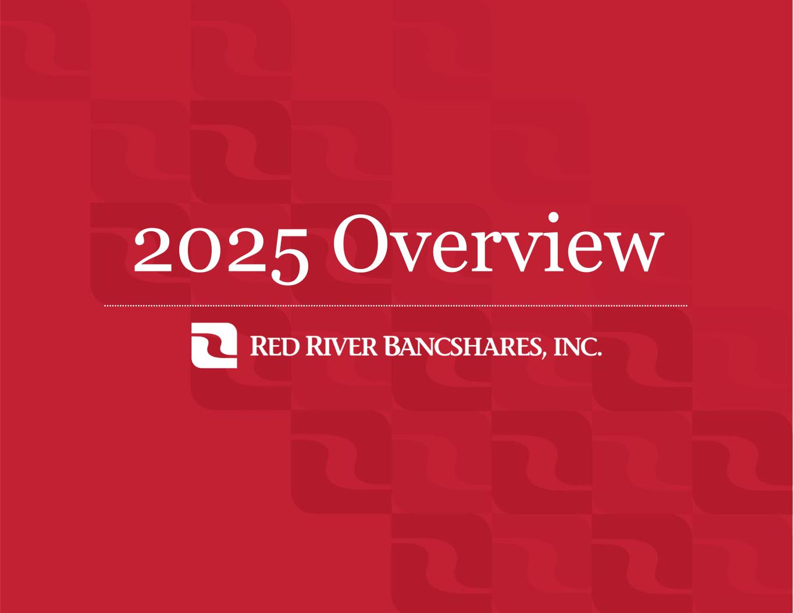
2025 Overview

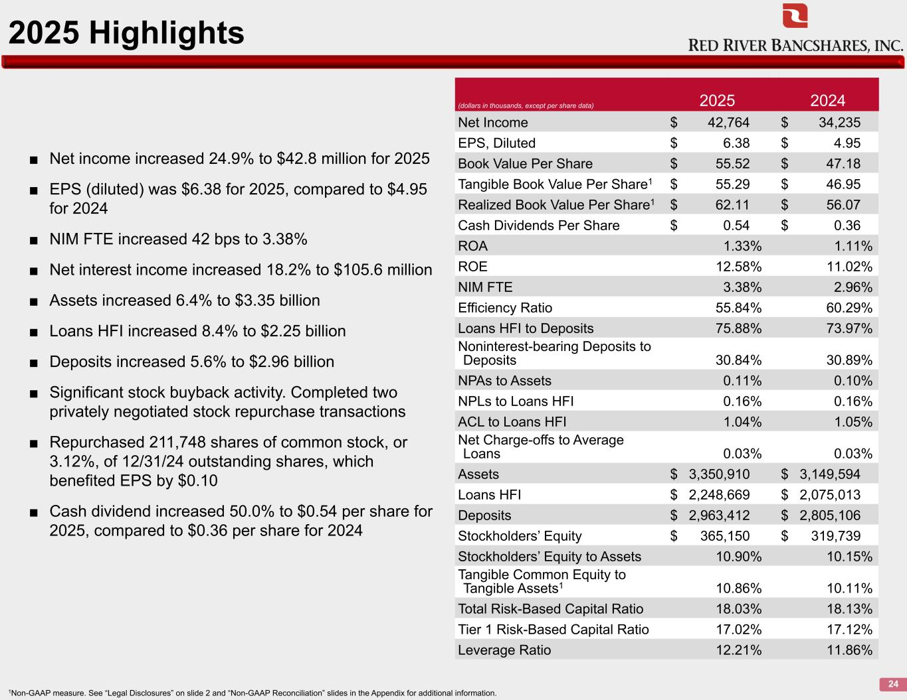
2025 Highlights 24 ■ Net income increased 24.9% to $42.8 million for 2025 ■ EPS (diluted) was $6.38 for 2025, compared to $4.95 for 2024 ■ NIM FTE increased 42 bps to 3.38% ■ Net interest income increased 18.2% to $105.6 million ■ Assets increased 6.4% to $3.35 billion ■ Loans HFI increased 8.4% to $2.25 billion ■ Deposits increased 5.6% to $2.96 billion ■ Significant stock buyback activity. Completed two privately negotiated stock repurchase transactions ■ Repurchased 211,748 shares of common stock, or 3.12%, of 12/31/24 outstanding shares, which benefited EPS by $0.10 ■ Cash dividend increased 50.0% to $0.54 per share for 2025, compared to $0.36 per share for 2024 (dollars in thousands, except per share data) 2025 2024 Net Income $ 42,764 $ 34,235 EPS, Diluted $ 6.38 $ 4.95 Book Value Per Share $ 55.52 $ 47.18 Tangible Book Value Per Share1 $ 55.29 $ 46.95 Realized Book Value Per Share1 $ 62.11 $ 56.07 Cash Dividends Per Share $ 0.54 $ 0.36 ROA 1.33% 1.11% ROE 12.58% 11.02% NIM FTE 3.38% 2.96% Efficiency Ratio 55.84% 60.29% Loans HFI to Deposits 75.88% 73.97% Noninterest-bearing Deposits to Deposits 30.84% 30.89% NPAs to Assets 0.11% 0.10% NPLs to Loans HFI 0.16% 0.16% ACL to Loans HFI 1.04% 1.05% Net Charge-offs to Average Loans 0.03% 0.03% Assets $ 3,350,910 $ 3,149,594 Loans HFI $ 2,248,669 $ 2,075,013 Deposits $ 2,963,412 $ 2,805,106 Stockholders’ Equity $ 365,150 $ 319,739 Stockholders’ Equity to Assets 10.90% 10.15% Tangible Common Equity to Tangible Assets1 10.86% 10.11% Total Risk-Based Capital Ratio 18.03% 18.13% Tier 1 Risk-Based Capital Ratio 17.02% 17.12% Leverage Ratio 12.21% 11.86% 1Non-GAAP measure. See “Legal Disclosures” on slide 2 and “Non-GAAP Reconciliation” slides in the Appendix for additional information.

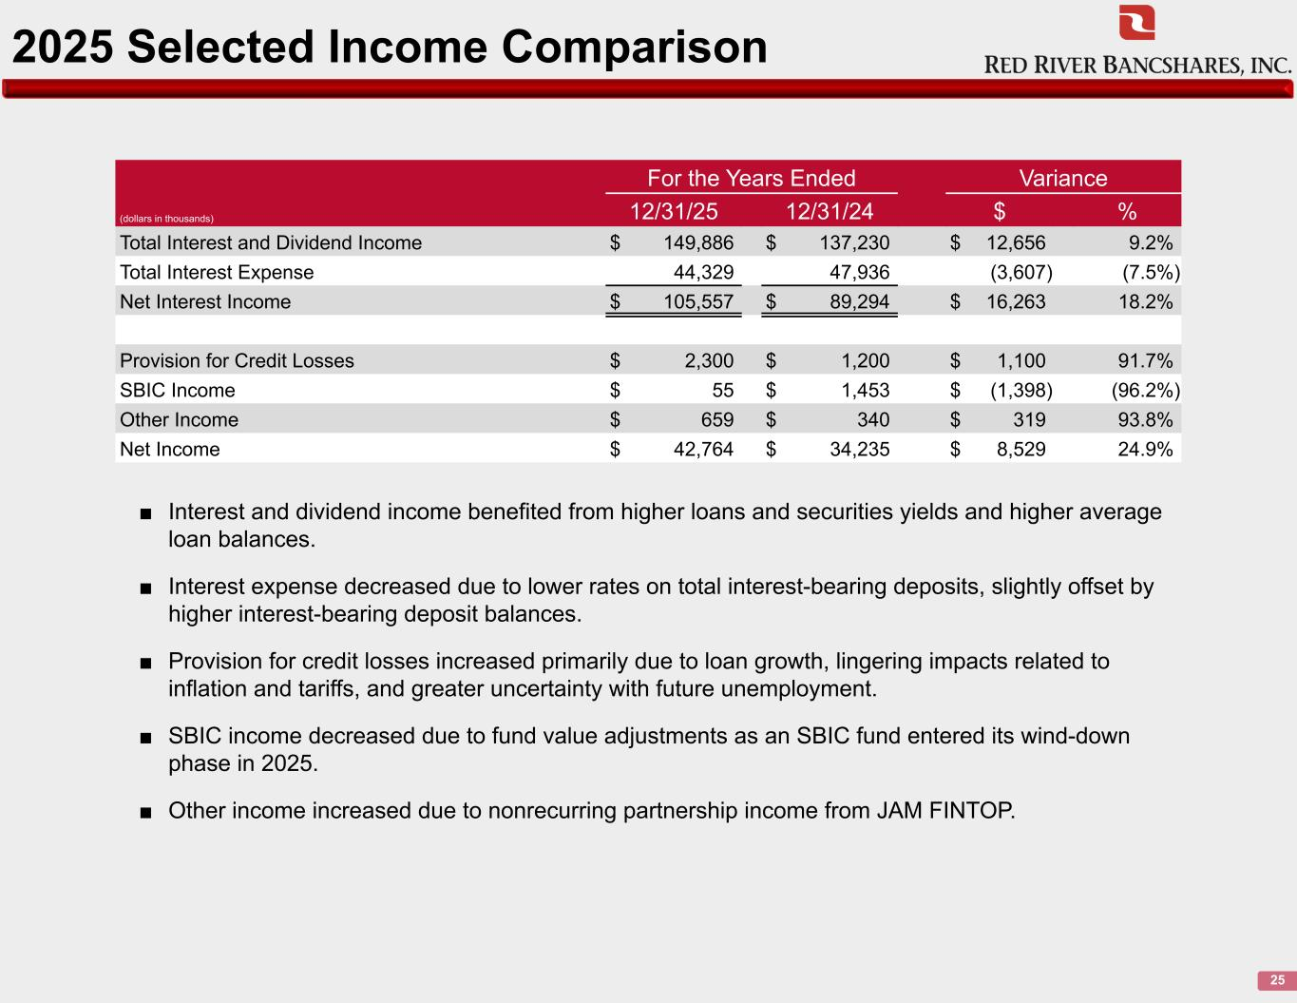
2025 Selected Income Comparison 25 (dollars in thousands) For the Years Ended Variance 12/31/25 12/31/24 $ % Total Interest and Dividend Income $ 149,886 $ 137,230 $ 12,656 9.2% Total Interest Expense 44,329 47,936 (3,607) (7.5%) Net Interest Income $ 105,557 $ 89,294 $ 16,263 18.2% Provision for Credit Losses $ 2,300 $ 1,200 $ 1,100 91.7% SBIC Income $ 55 $ 1,453 $ (1,398) (96.2%) Other Income $ 659 $ 340 $ 319 93.8% Net Income $ 42,764 $ 34,235 $ 8,529 24.9% ■ Interest and dividend income benefited from higher loans and securities yields and higher average loan balances. ■ Interest expense decreased due to lower rates on total interest-bearing deposits, slightly offset by higher interest-bearing deposit balances. ■ Provision for credit losses increased primarily due to loan growth, lingering impacts related to inflation and tariffs, and greater uncertainty with future unemployment. ■ SBIC income decreased due to fund value adjustments as an SBIC fund entered its wind-down phase in 2025. ■ Other income increased due to nonrecurring partnership income from JAM FINTOP.

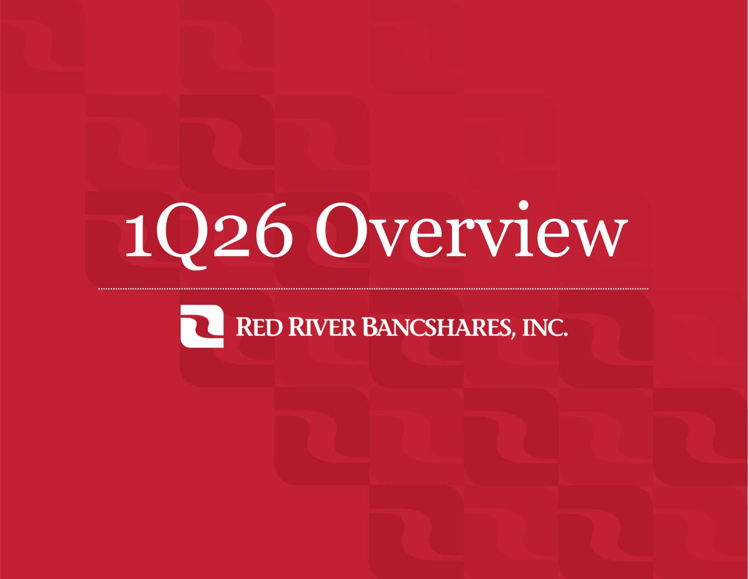
1Q26 Overview

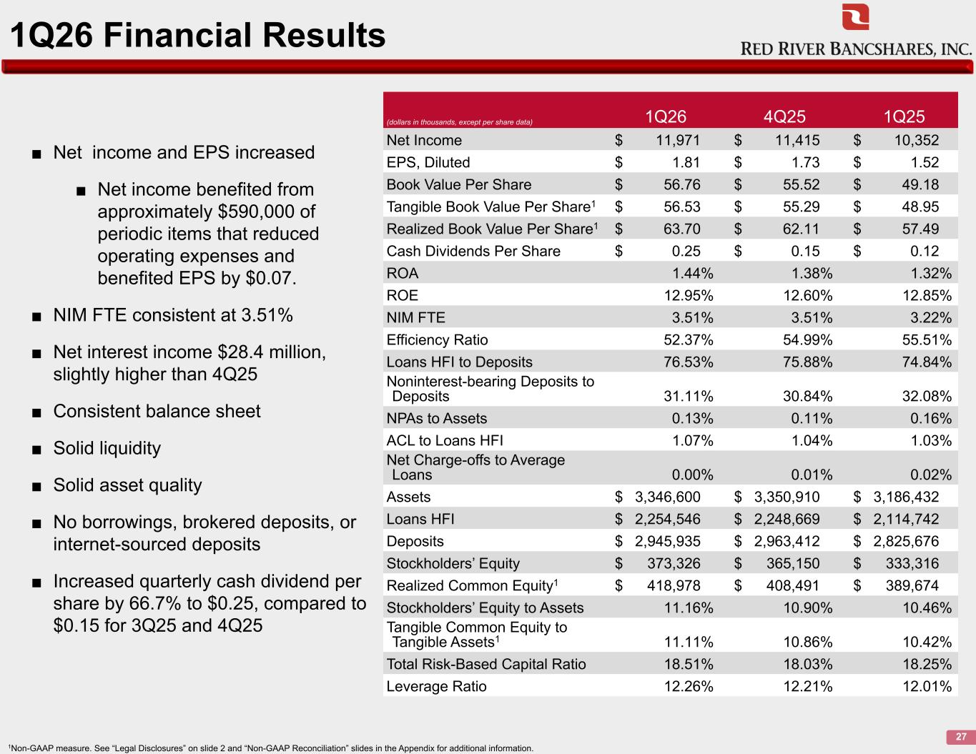
1Q26 Financial Results 27 ■ Net income and EPS increased ■ Net income benefited from approximately $590,000 of periodic items that reduced operating expenses and benefited EPS by $0.07. ■ NIM FTE consistent at 3.51% ■ Net interest income $28.4 million, slightly higher than 4Q25 ■ Consistent balance sheet ■ Solid liquidity ■ Solid asset quality ■ No borrowings, brokered deposits, or internet-sourced deposits ■ Increased quarterly cash dividend per share by 66.7% to $0.25, compared to $0.15 for 3Q25 and 4Q25 (dollars in thousands, except per share data) 1Q26 4Q25 1Q25 Net Income $ 11,971 $ 11,415 $ 10,352 EPS, Diluted $ 1.81 $ 1.73 $ 1.52 Book Value Per Share $ 56.76 $ 55.52 $ 49.18 Tangible Book Value Per Share1 $ 56.53 $ 55.29 $ 48.95 Realized Book Value Per Share1 $ 63.70 $ 62.11 $ 57.49 Cash Dividends Per Share $ 0.25 $ 0.15 $ 0.12 ROA 1.44% 1.38% 1.32% ROE 12.95% 12.60% 12.85% NIM FTE 3.51% 3.51% 3.22% Efficiency Ratio 52.37% 54.99% 55.51% Loans HFI to Deposits 76.53% 75.88% 74.84% Noninterest-bearing Deposits to Deposits 31.11% 30.84% 32.08% NPAs to Assets 0.13% 0.11% 0.16% ACL to Loans HFI 1.07% 1.04% 1.03% Net Charge-offs to Average Loans 0.00% 0.01% 0.02% Assets $ 3,346,600 $ 3,350,910 $ 3,186,432 Loans HFI $ 2,254,546 $ 2,248,669 $ 2,114,742 Deposits $ 2,945,935 $ 2,963,412 $ 2,825,676 Stockholders’ Equity $ 373,326 $ 365,150 $ 333,316 Realized Common Equity1 $ 418,978 $ 408,491 $ 389,674 Stockholders’ Equity to Assets 11.16% 10.90% 10.46% Tangible Common Equity to Tangible Assets1 11.11% 10.86% 10.42% Total Risk-Based Capital Ratio 18.51% 18.03% 18.25% Leverage Ratio 12.26% 12.21% 12.01% 1Non-GAAP measure. See “Legal Disclosures” on slide 2 and “Non-GAAP Reconciliation” slides in the Appendix for additional information.

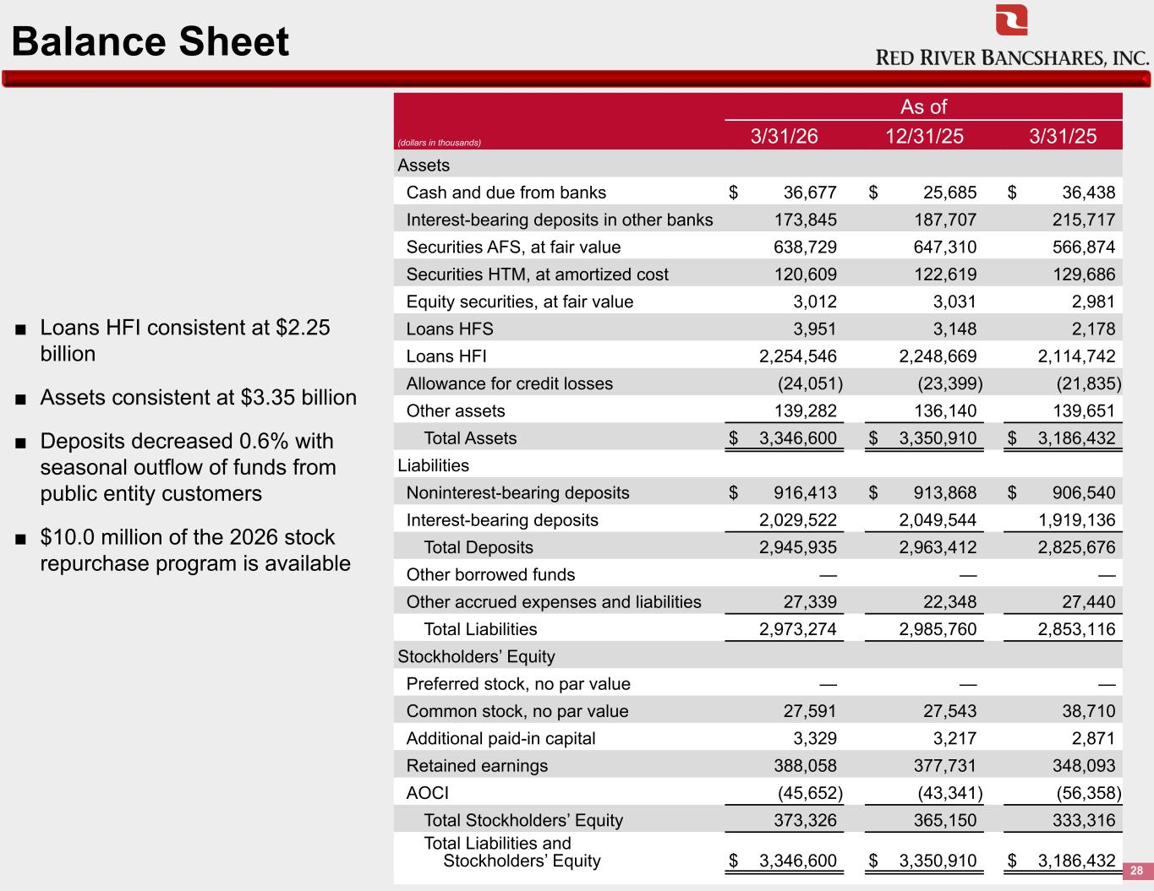
Balance Sheet 28 As of (dollars in thousands) 3/31/26 12/31/25 3/31/25 Assets Cash and due from banks $ 36,677 $ 25,685 $ 36,438 Interest-bearing deposits in other banks 173,845 187,707 215,717 Securities AFS, at fair value 638,729 647,310 566,874 Securities HTM, at amortized cost 120,609 122,619 129,686 Equity securities, at fair value 3,012 3,031 2,981 Loans HFS 3,951 3,148 2,178 Loans HFI 2,254,546 2,248,669 2,114,742 Allowance for credit losses (24,051) (23,399) (21,835) Other assets 139,282 136,140 139,651 Total Assets $ 3,346,600 $ 3,350,910 $ 3,186,432 Liabilities Noninterest-bearing deposits $ 916,413 $ 913,868 $ 906,540 Interest-bearing deposits 2,029,522 2,049,544 1,919,136 Total Deposits 2,945,935 2,963,412 2,825,676 Other borrowed funds — — — Other accrued expenses and liabilities 27,339 22,348 27,440 Total Liabilities 2,973,274 2,985,760 2,853,116 Stockholders’ Equity Preferred stock, no par value — — — Common stock, no par value 27,591 27,543 38,710 Additional paid-in capital 3,329 3,217 2,871 Retained earnings 388,058 377,731 348,093 AOCI (45,652) (43,341) (56,358) Total Stockholders’ Equity 373,326 365,150 333,316 Total Liabilities and Stockholders’ Equity $ 3,346,600 $ 3,350,910 $ 3,186,432 ■ Loans HFI consistent at $2.25 billion ■ Assets consistent at $3.35 billion ■ Deposits decreased 0.6% with seasonal outflow of funds from public entity customers ■ $10.0 million of the 2026 stock repurchase program is available

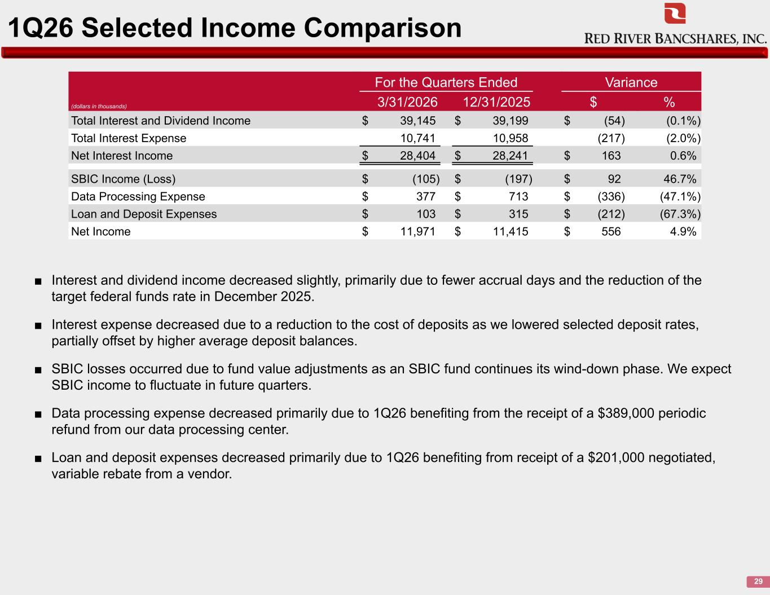
1Q26 Selected Income Comparison 29 ■ Interest and dividend income decreased slightly, primarily due to fewer accrual days and the reduction of the target federal funds rate in December 2025. ■ Interest expense decreased due to a reduction to the cost of deposits as we lowered selected deposit rates, partially offset by higher average deposit balances. ■ SBIC losses occurred due to fund value adjustments as an SBIC fund continues its wind-down phase. We expect SBIC income to fluctuate in future quarters. ■ Data processing expense decreased primarily due to 1Q26 benefiting from the receipt of a $389,000 periodic refund from our data processing center. ■ Loan and deposit expenses decreased primarily due to 1Q26 benefiting from receipt of a $201,000 negotiated, variable rebate from a vendor. (dollars in thousands) For the Quarters Ended Variance 3/31/2026 12/31/2025 $ % Total Interest and Dividend Income $ 39,145 $ 39,199 $ (54) (0.1%) Total Interest Expense 10,741 10,958 (217) (2.0%) Net Interest Income $ 28,404 $ 28,241 $ 163 0.6% SBIC Income (Loss) $ (105) $ (197) $ 92 46.7% Data Processing Expense $ 377 $ 713 $ (336) (47.1%) Loan and Deposit Expenses $ 103 $ 315 $ (212) (67.3%) Net Income $ 11,971 $ 11,415 $ 556 4.9%

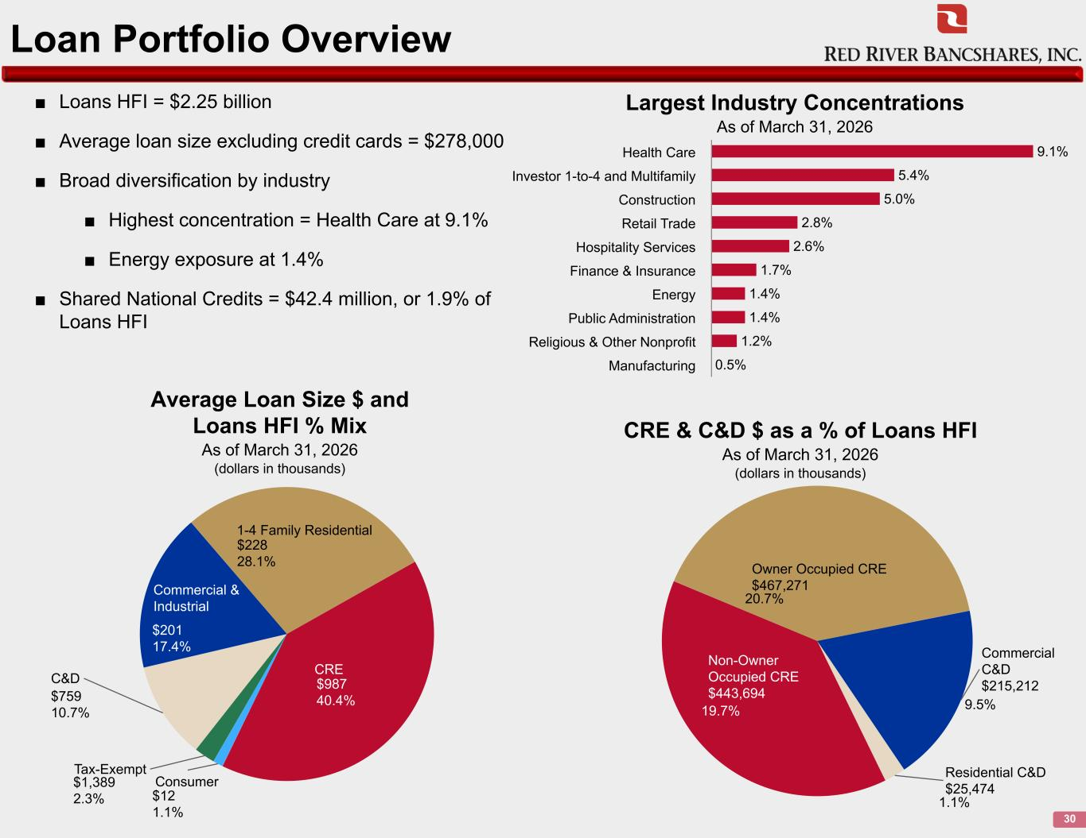
Loan Portfolio Overview 30 ■ Loans HFI = $2.25 billion ■ Average loan size excluding credit cards = $278,000 ■ Broad diversification by industry ■ Highest concentration = Health Care at 9.1% ■ Energy exposure at 1.4% ■ Shared National Credits = $42.4 million, or 1.9% of Loans HFI 9.1% 5.4% 5.0% 2.8% 2.6% 1.7% 1.4% 1.4% 1.2% 0.5% Health Care Investor 1-to-4 and Multifamily Construction Retail Trade Hospitality Services Finance & Insurance Energy Public Administration Religious & Other Nonprofit Manufacturing Consumer Tax-Exempt C&D Commercial & Industrial 1-4 Family Residential CRE Average Loan Size $ and Loans HFI % Mix As of March 31, 2026 (dollars in thousands) Largest Industry Concentrations As of March 31, 2026 Non-Owner Occupied CRE $443,694 Owner Occupied CRE $467,271 Commercial C&D $215,212 Residential C&D $25,474 CRE & C&D $ as a % of Loans HFI As of March 31, 2026 (dollars in thousands) 19.7% 20.7% 9.5% 1.1%$12 1.1% $1,389 2.3% $759 10.7% $201 17.4% $228 28.1% $987 40.4%

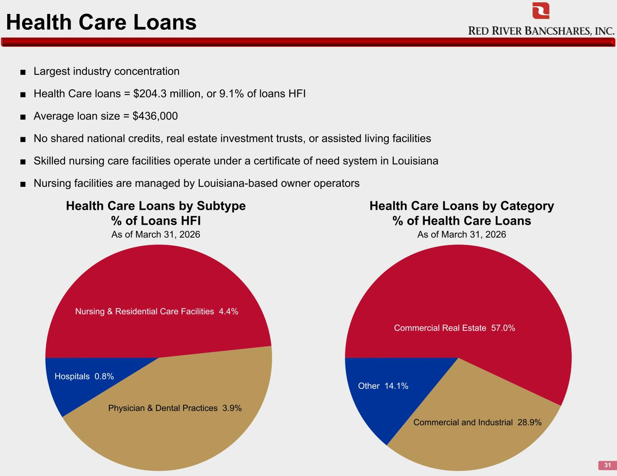
Health Care Loans 31 Nursing & Residential Care Facilities 4.4% Physician & Dental Practices 3.9% Hospitals 0.8% ■ Largest industry concentration ■ Health Care loans = $204.3 million, or 9.1% of loans HFI ■ Average loan size = $436,000 ■ No shared national credits, real estate investment trusts, or assisted living facilities ■ Skilled nursing care facilities operate under a certificate of need system in Louisiana ■ Nursing facilities are managed by Louisiana-based owner operators Health Care Loans by Subtype % of Loans HFI As of March 31, 2026 Health Care Loans by Category % of Health Care Loans As of March 31, 2026 Commercial Real Estate 57.0% Commercial and Industrial 28.9% Other 14.1%

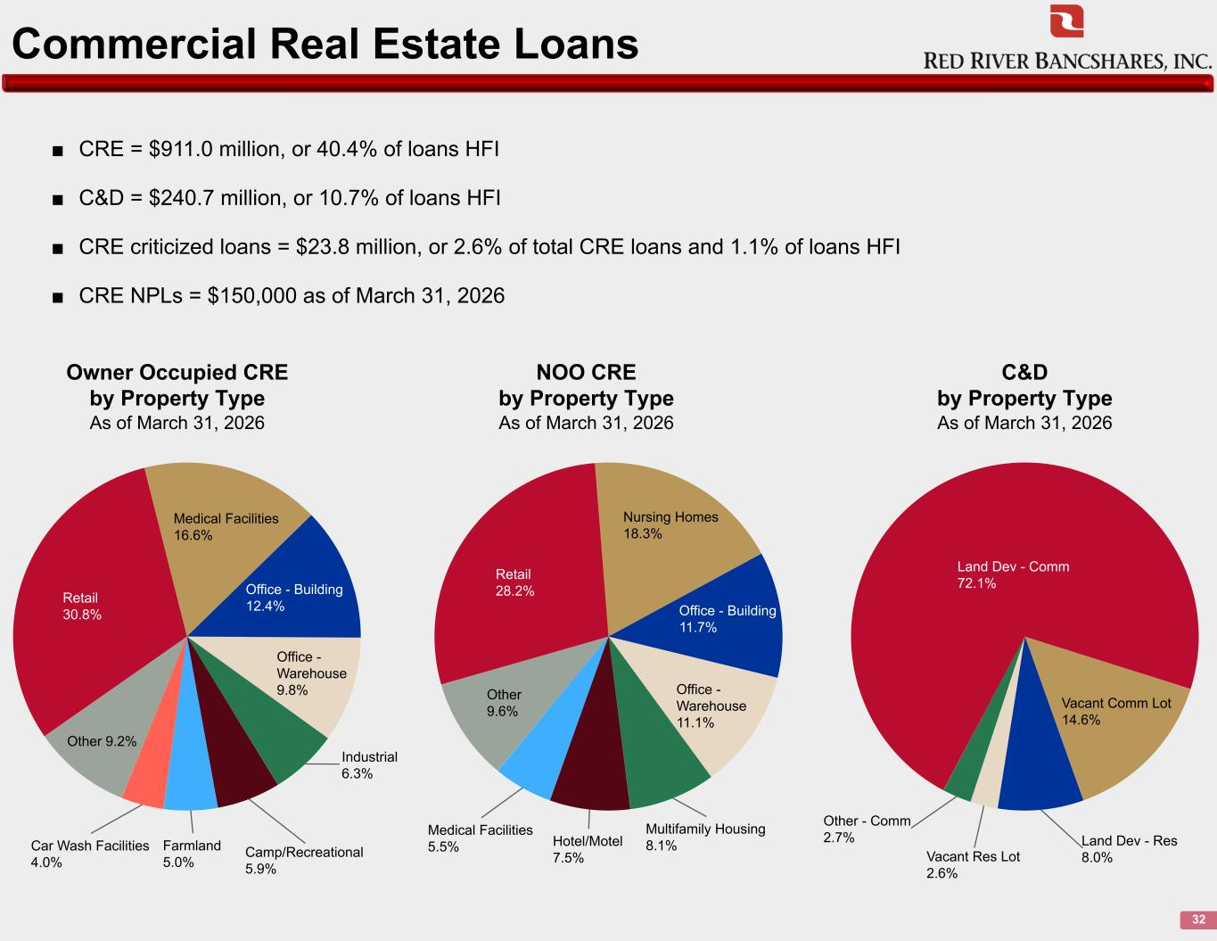
Commercial Real Estate Loans 32 Retail 30.8% Medical Facilities 16.6% Office - Building 12.4% Office - Warehouse 9.8% Industrial 6.3% Camp/Recreational 5.9% Farmland 5.0% Car Wash Facilities 4.0% Other 9.2% Owner Occupied CRE by Property Type As of March 31, 2026 Retail 28.2% Nursing Homes 18.3% Office - Building 11.7% Office - Warehouse 11.1% Multifamily Housing 8.1%Hotel/Motel 7.5% Medical Facilities 5.5% Other 9.6% NOO CRE by Property Type As of March 31, 2026 Land Dev - Comm 72.1% Vacant Comm Lot 14.6% Land Dev - Res 8.0%Vacant Res Lot 2.6% Other - Comm 2.7% C&D by Property Type As of March 31, 2026 ■ CRE = $911.0 million, or 40.4% of loans HFI ■ C&D = $240.7 million, or 10.7% of loans HFI ■ CRE criticized loans = $23.8 million, or 2.6% of total CRE loans and 1.1% of loans HFI ■ CRE NPLs = $150,000 as of March 31, 2026

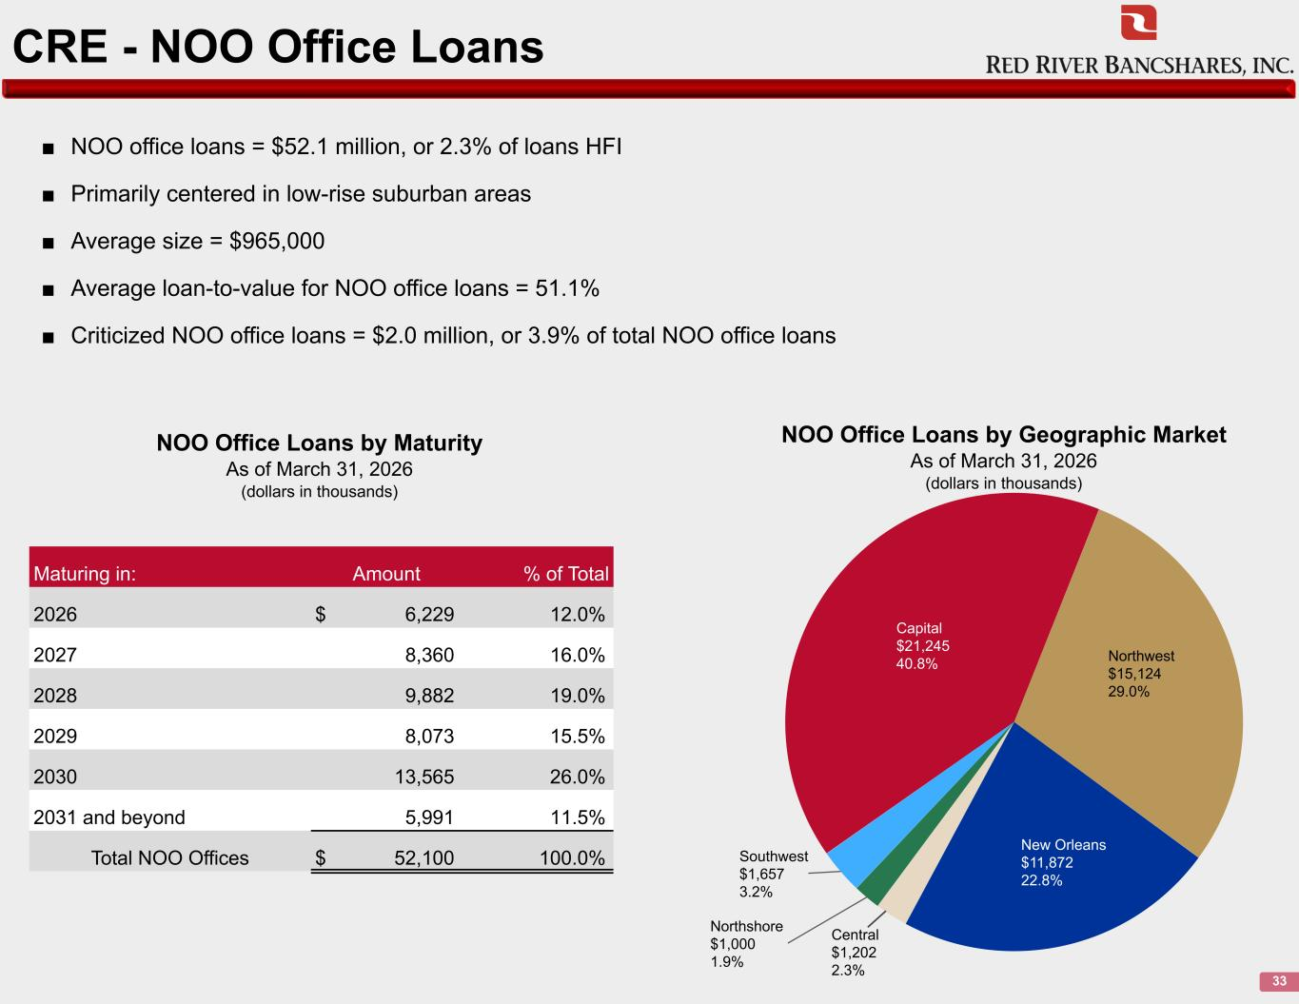
CRE - NOO Office Loans 33 Capital $21,245 40.8% Northwest $15,124 29.0% New Orleans $11,872 22.8% Central $1,202 2.3% Northshore $1,000 1.9% Southwest $1,657 3.2% ■ NOO office loans = $52.1 million, or 2.3% of loans HFI ■ Primarily centered in low-rise suburban areas ■ Average size = $965,000 ■ Average loan-to-value for NOO office loans = 51.1% ■ Criticized NOO office loans = $2.0 million, or 3.9% of total NOO office loans NOO Office Loans by Geographic Market As of March 31, 2026 (dollars in thousands) NOO Office Loans by Maturity As of March 31, 2026 (dollars in thousands) Maturing in: Amount % of Total 2026 $ 6,229 12.0% 2027 8,360 16.0% 2028 9,882 19.0% 2029 8,073 15.5% 2030 13,565 26.0% 2031 and beyond 5,991 11.5% Total NOO Offices $ 52,100 100.0%

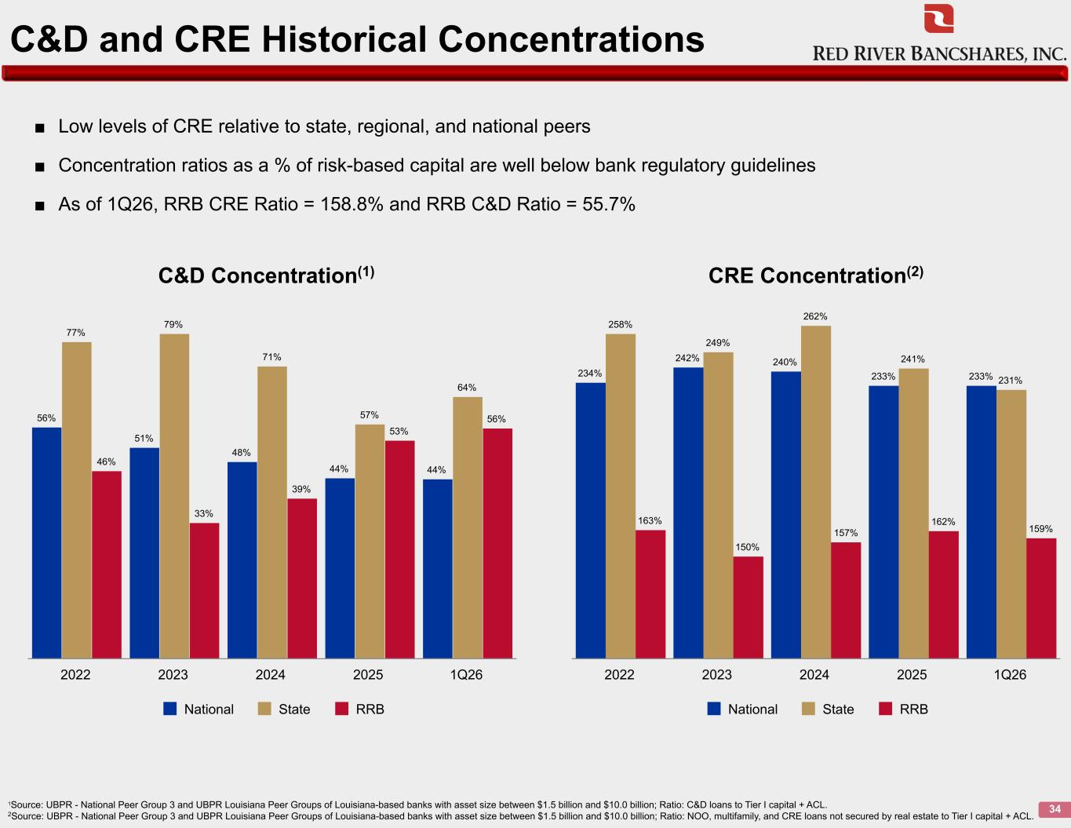
C&D and CRE Historical Concentrations 34 56% 51% 48% 44% 44% 77% 79% 71% 57% 64% 46% 33% 39% 53% 56% National State RRB 2022 2023 2024 2025 1Q26 234% 242% 240% 233% 233% 258% 249% 262% 241% 231% 163% 150% 157% 162% 159% National State RRB 2022 2023 2024 2025 1Q26 1Source: UBPR - National Peer Group 3 and UBPR Louisiana Peer Groups of Louisiana-based banks with asset size between $1.5 billion and $10.0 billion; Ratio: C&D loans to Tier I capital + ACL. 2Source: UBPR - National Peer Group 3 and UBPR Louisiana Peer Groups of Louisiana-based banks with asset size between $1.5 billion and $10.0 billion; Ratio: NOO, multifamily, and CRE loans not secured by real estate to Tier I capital + ACL. C&D Concentration(1) CRE Concentration(2) ■ Low levels of CRE relative to state, regional, and national peers ■ Concentration ratios as a % of risk-based capital are well below bank regulatory guidelines ■ As of 1Q26, RRB CRE Ratio = 158.8% and RRB C&D Ratio = 55.7%

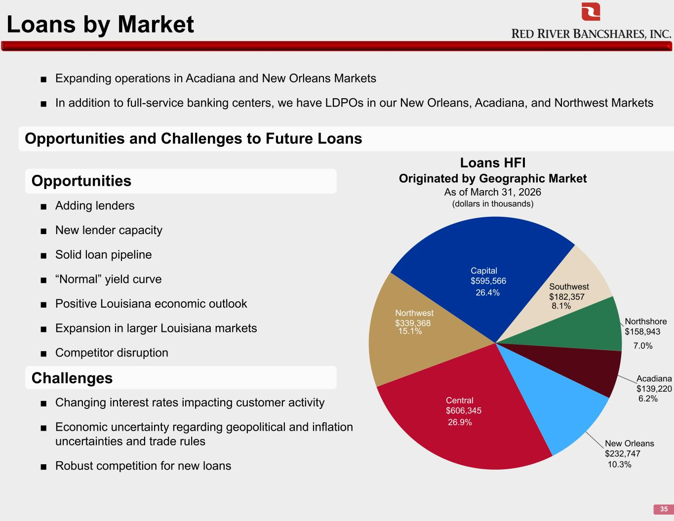
Loans by Market 35 ■ Changing interest rates impacting customer activity ■ Economic uncertainty regarding geopolitical and inflation uncertainties and trade rules ■ Robust competition for new loans Central $606,345 Northwest $339,368 Capital $595,566 Southwest $182,357 Northshore $158,943 Acadiana $139,220 New Orleans $232,747 Loans HFI Originated by Geographic Market As of March 31, 2026 (dollars in thousands) Opportunities and Challenges to Future Loans ■ Adding lenders ■ New lender capacity ■ Solid loan pipeline ■ “Normal” yield curve ■ Positive Louisiana economic outlook ■ Expansion in larger Louisiana markets ■ Competitor disruption ■ Expanding operations in Acadiana and New Orleans Markets ■ In addition to full-service banking centers, we have LDPOs in our New Orleans, Acadiana, and Northwest Markets Opportunities Challenges 26.4% 8.1% 15.1% 26.9% 7.0% 6.2% 10.3%

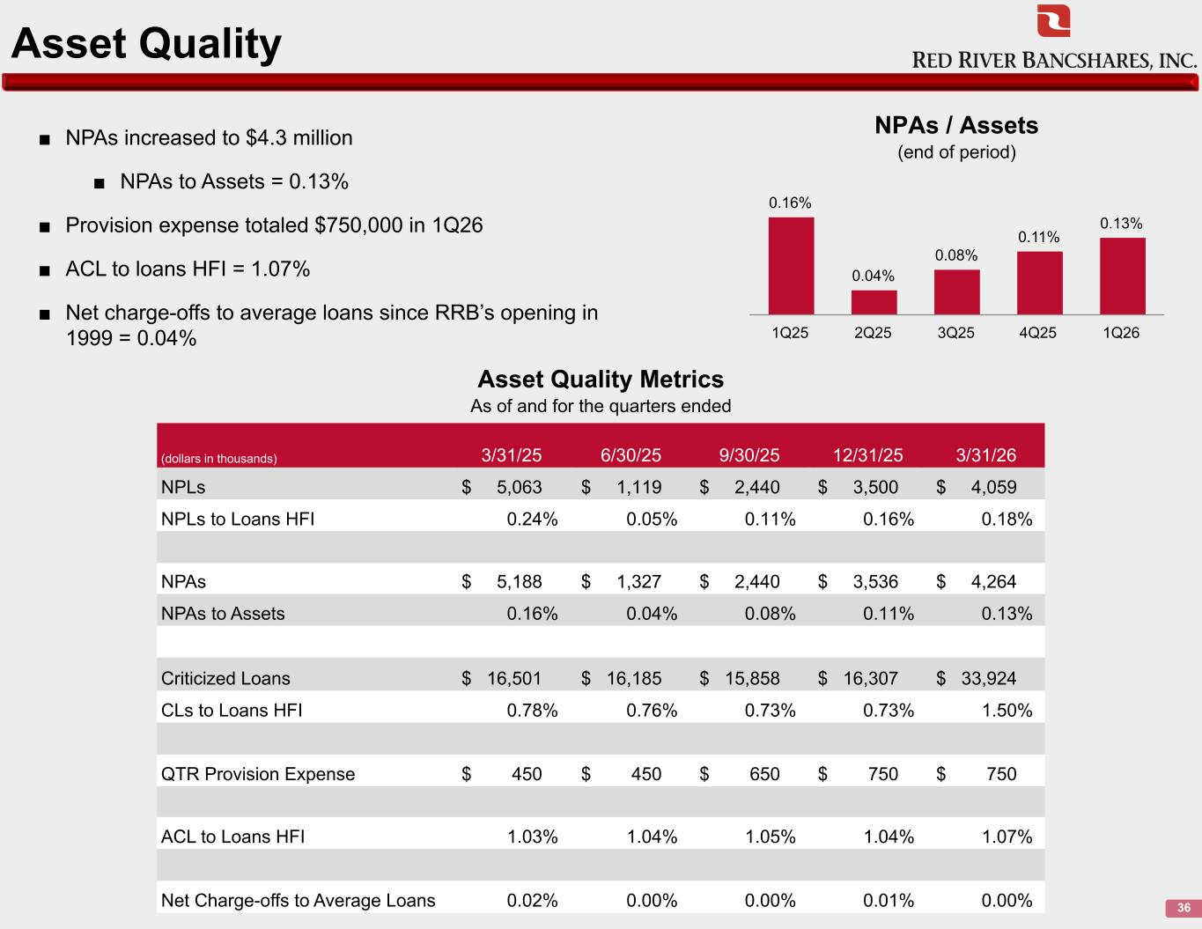
Asset Quality 36 ■ NPAs increased to $4.3 million ■ NPAs to Assets = 0.13% ■ Provision expense totaled $750,000 in 1Q26 ■ ACL to loans HFI = 1.07% ■ Net charge-offs to average loans since RRB’s opening in 1999 = 0.04% 0.16% 0.04% 0.08% 0.11% 0.13% 1Q25 2Q25 3Q25 4Q25 1Q26 (dollars in thousands) 3/31/25 6/30/25 9/30/25 12/31/25 3/31/26 NPLs $ 5,063 $ 1,119 $ 2,440 $ 3,500 $ 4,059 NPLs to Loans HFI 0.24% 0.05% 0.11% 0.16% 0.18% NPAs $ 5,188 $ 1,327 $ 2,440 $ 3,536 $ 4,264 NPAs to Assets 0.16% 0.04% 0.08% 0.11% 0.13% Criticized Loans $ 16,501 $ 16,185 $ 15,858 $ 16,307 $ 33,924 CLs to Loans HFI 0.78% 0.76% 0.73% 0.73% 1.50% QTR Provision Expense $ 450 $ 450 $ 650 $ 750 $ 750 ACL to Loans HFI 1.03% 1.04% 1.05% 1.04% 1.07% Net Charge-offs to Average Loans 0.02% 0.00% 0.00% 0.01% 0.00% NPAs / Assets (end of period) Asset Quality Metrics As of and for the quarters ended

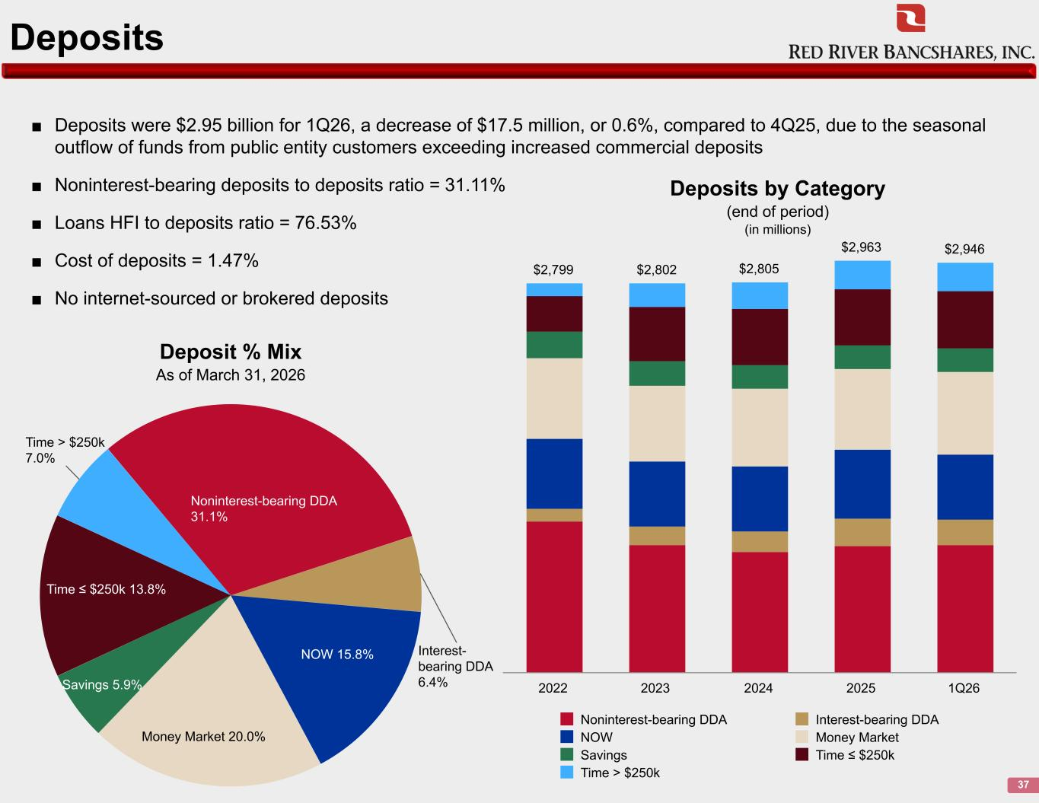
Deposits 37 ■ Deposits were $2.95 billion for 1Q26, a decrease of $17.5 million, or 0.6%, compared to 4Q25, due to the seasonal outflow of funds from public entity customers exceeding increased commercial deposits ■ Noninterest-bearing deposits to deposits ratio = 31.11% ■ Loans HFI to deposits ratio = 76.53% ■ Cost of deposits = 1.47% ■ No internet-sourced or brokered deposits Noninterest-bearing DDA 31.1% Interest- bearing DDA 6.4% NOW 15.8% Money Market 20.0% Savings 5.9% Time ≤ $250k 13.8% Time > $250k 7.0% $2,799 $2,802 $2,805 $2,963 $2,946 Noninterest-bearing DDA Interest-bearing DDA NOW Money Market Savings Time ≤ $250k Time > $250k 2022 2023 2024 2025 1Q26 Deposit % Mix As of March 31, 2026 Deposits by Category (end of period) (in millions)

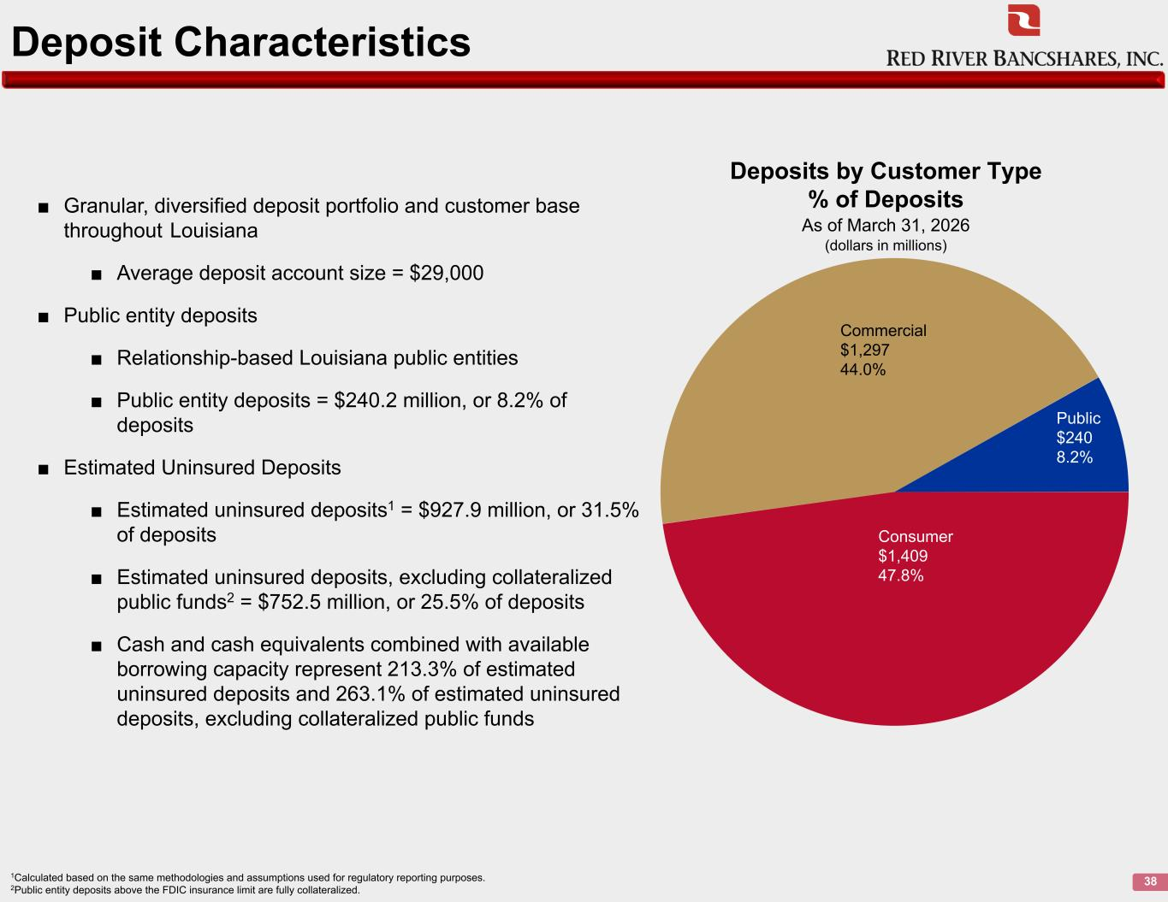
Deposit Characteristics 38 ■ Granular, diversified deposit portfolio and customer base throughout Louisiana ■ Average deposit account size = $29,000 ■ Public entity deposits ■ Relationship-based Louisiana public entities ■ Public entity deposits = $240.2 million, or 8.2% of deposits ■ Estimated Uninsured Deposits ■ Estimated uninsured deposits1 = $927.9 million, or 31.5% of deposits ■ Estimated uninsured deposits, excluding collateralized public funds2 = $752.5 million, or 25.5% of deposits ■ Cash and cash equivalents combined with available borrowing capacity represent 213.3% of estimated uninsured deposits and 263.1% of estimated uninsured deposits, excluding collateralized public funds 1Calculated based on the same methodologies and assumptions used for regulatory reporting purposes. 2Public entity deposits above the FDIC insurance limit are fully collateralized. Deposits by Customer Type % of Deposits As of March 31, 2026 (dollars in millions) Public $240 8.2% Consumer $1,409 47.8% Commercial $1,297 44.0%

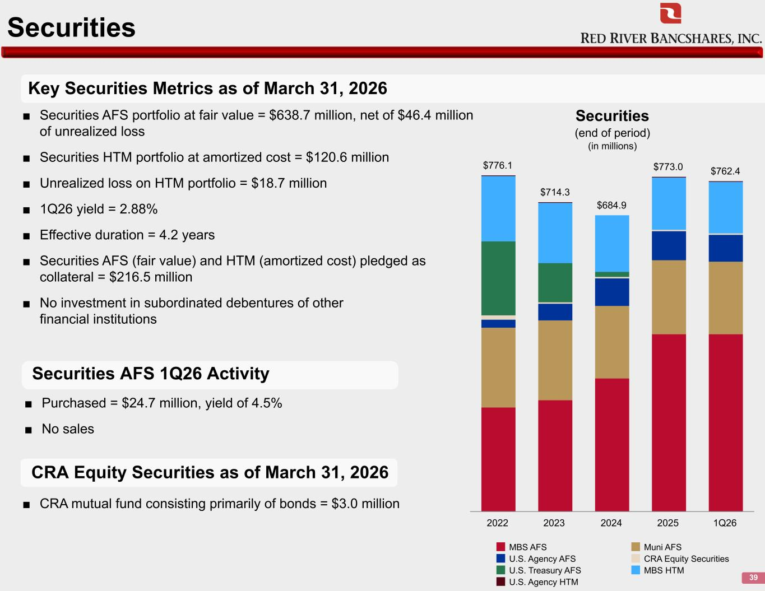
Securities 39 Key Securities Metrics as of March 31, 2026 Securities AFS 1Q26 Activity ■ Securities AFS portfolio at fair value = $638.7 million, net of $46.4 million of unrealized loss ■ Securities HTM portfolio at amortized cost = $120.6 million ■ Unrealized loss on HTM portfolio = $18.7 million ■ 1Q26 yield = 2.88% ■ Effective duration = 4.2 years ■ Securities AFS (fair value) and HTM (amortized cost) pledged as collateral = $216.5 million ■ No investment in subordinated debentures of other financial institutions $776.1 $714.3 $684.9 $773.0 $762.4 MBS AFS Muni AFS U.S. Agency AFS CRA Equity Securities U.S. Treasury AFS MBS HTM U.S. Agency HTM 2022 2023 2024 2025 1Q26 Securities (end of period) (in millions) CRA Equity Securities as of March 31, 2026 ■ Purchased = $24.7 million, yield of 4.5% ■ No sales ■ CRA mutual fund consisting primarily of bonds = $3.0 million

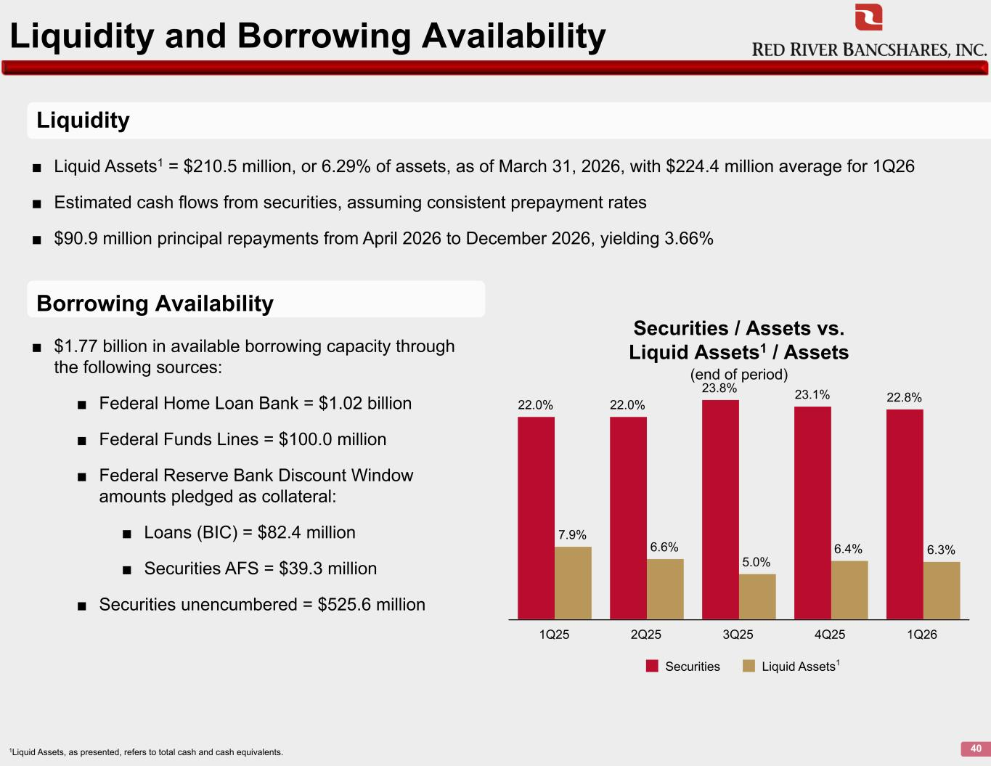
Liquidity and Borrowing Availability 40 22.0% 22.0% 23.8% 23.1% 22.8% 7.9% 6.6% 5.0% 6.4% 6.3% Securities Liquid Assets 1Q25 2Q25 3Q25 4Q25 1Q26 Securities / Assets vs. Liquid Assets1 / Assets (end of period) 1Liquid Assets, as presented, refers to total cash and cash equivalents. Liquidity Borrowing Availability ■ Liquid Assets1 = $210.5 million, or 6.29% of assets, as of March 31, 2026, with $224.4 million average for 1Q26 ■ Estimated cash flows from securities, assuming consistent prepayment rates ■ $90.9 million principal repayments from April 2026 to December 2026, yielding 3.66% ■ $1.77 billion in available borrowing capacity through the following sources: ■ Federal Home Loan Bank = $1.02 billion ■ Federal Funds Lines = $100.0 million ■ Federal Reserve Bank Discount Window amounts pledged as collateral: ■ Loans (BIC) = $82.4 million ■ Securities AFS = $39.3 million ■ Securities unencumbered = $525.6 million 1

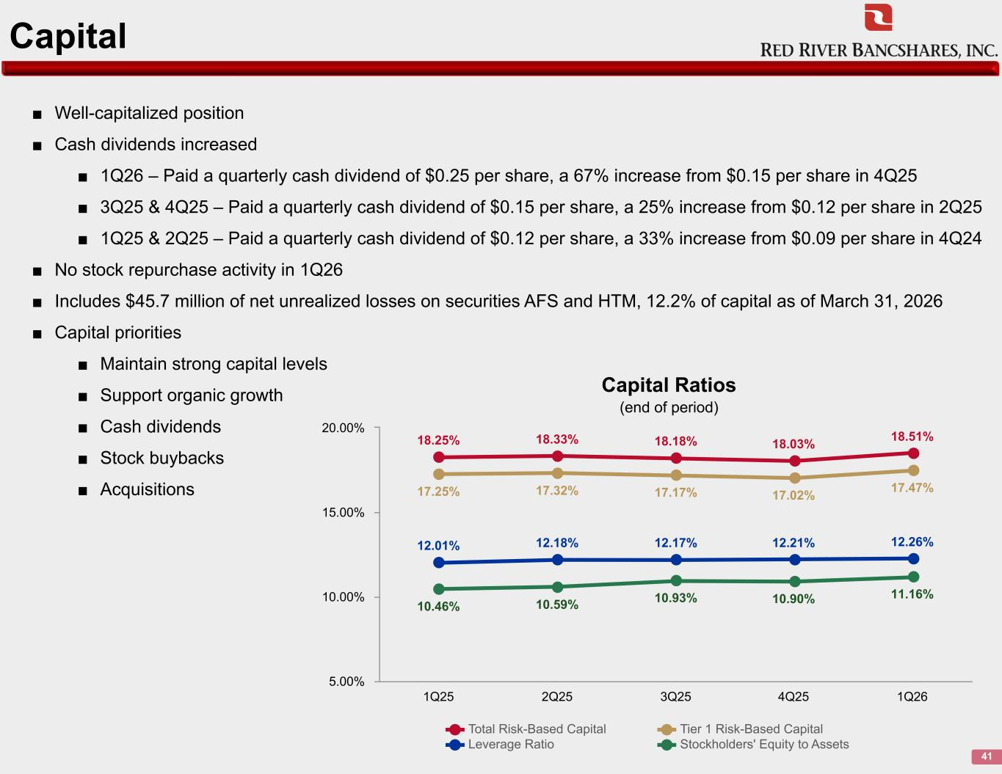
Capital 41 ■ Well-capitalized position ■ Cash dividends increased ■ 1Q26 – Paid a quarterly cash dividend of $0.25 per share, a 67% increase from $0.15 per share in 4Q25 ■ 3Q25 & 4Q25 – Paid a quarterly cash dividend of $0.15 per share, a 25% increase from $0.12 per share in 2Q25 ■ 1Q25 & 2Q25 – Paid a quarterly cash dividend of $0.12 per share, a 33% increase from $0.09 per share in 4Q24 ■ No stock repurchase activity in 1Q26 ■ Includes $45.7 million of net unrealized losses on securities AFS and HTM, 12.2% of capital as of March 31, 2026 ■ Capital priorities ■ Maintain strong capital levels ■ Support organic growth ■ Cash dividends ■ Stock buybacks ■ Acquisitions 18.25% 18.33% 18.18% 18.03% 18.51% 17.25% 17.32% 17.17% 17.02% 17.47% 12.01% 12.18% 12.17% 12.21% 12.26% 10.46% 10.59% 10.93% 10.90% 11.16% Total Risk-Based Capital Tier 1 Risk-Based Capital Leverage Ratio Stockholders' Equity to Assets 1Q25 2Q25 3Q25 4Q25 1Q26 5.00% 10.00% 15.00% 20.00% Capital Ratios (end of period)

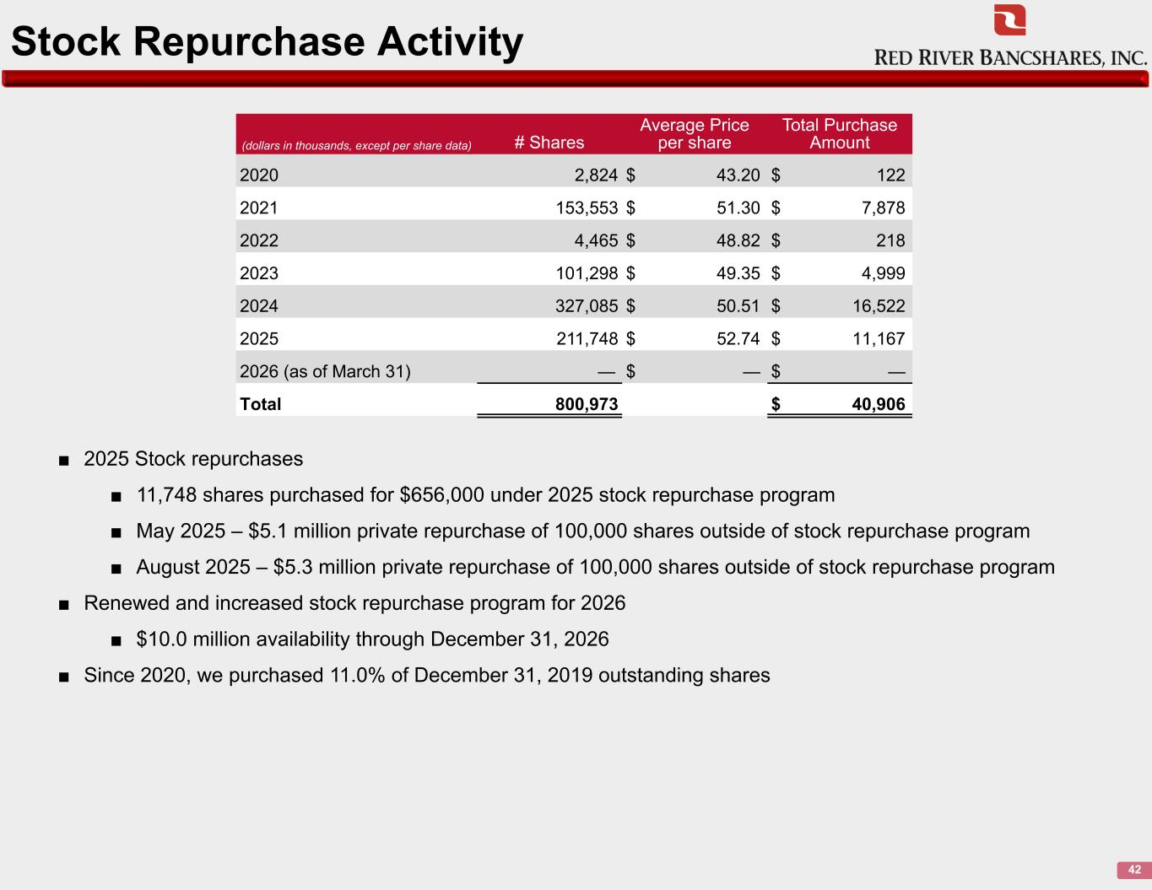
Stock Repurchase Activity 42 (dollars in thousands, except per share data) # Shares Average Price per share Total Purchase Amount 2020 2,824 $ 43.20 $ 122 2021 153,553 $ 51.30 $ 7,878 2022 4,465 $ 48.82 $ 218 2023 101,298 $ 49.35 $ 4,999 2024 327,085 $ 50.51 $ 16,522 2025 211,748 $ 52.74 $ 11,167 2026 (as of March 31) — $ — $ — Total 800,973 $ 40,906 ■ 2025 Stock repurchases ■ 11,748 shares purchased for $656,000 under 2025 stock repurchase program ■ May 2025 – $5.1 million private repurchase of 100,000 shares outside of stock repurchase program ■ August 2025 – $5.3 million private repurchase of 100,000 shares outside of stock repurchase program ■ Renewed and increased stock repurchase program for 2026 ■ $10.0 million availability through December 31, 2026 ■ Since 2020, we purchased 11.0% of December 31, 2019 outstanding shares

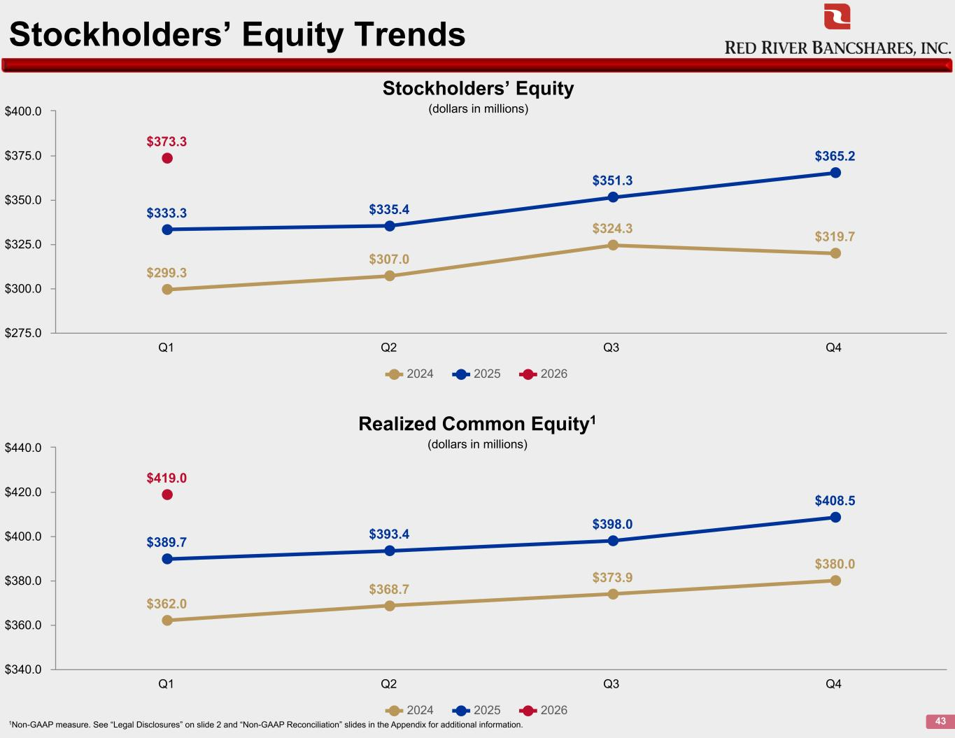
Stockholders’ Equity Trends 43 $299.3 $307.0 $324.3 $319.7 $333.3 $335.4 $351.3 $365.2 $373.3 2024 2025 2026 Q1 Q2 Q3 Q4 $275.0 $300.0 $325.0 $350.0 $375.0 $400.0 Stockholders’ Equity (dollars in millions) $362.0 $368.7 $373.9 $380.0 $389.7 $393.4 $398.0 $408.5 $419.0 2024 2025 2026 Q1 Q2 Q3 Q4 $340.0 $360.0 $380.0 $400.0 $420.0 $440.0 Realized Common Equity1 (dollars in millions) 1Non-GAAP measure. See “Legal Disclosures” on slide 2 and “Non-GAAP Reconciliation” slides in the Appendix for additional information.

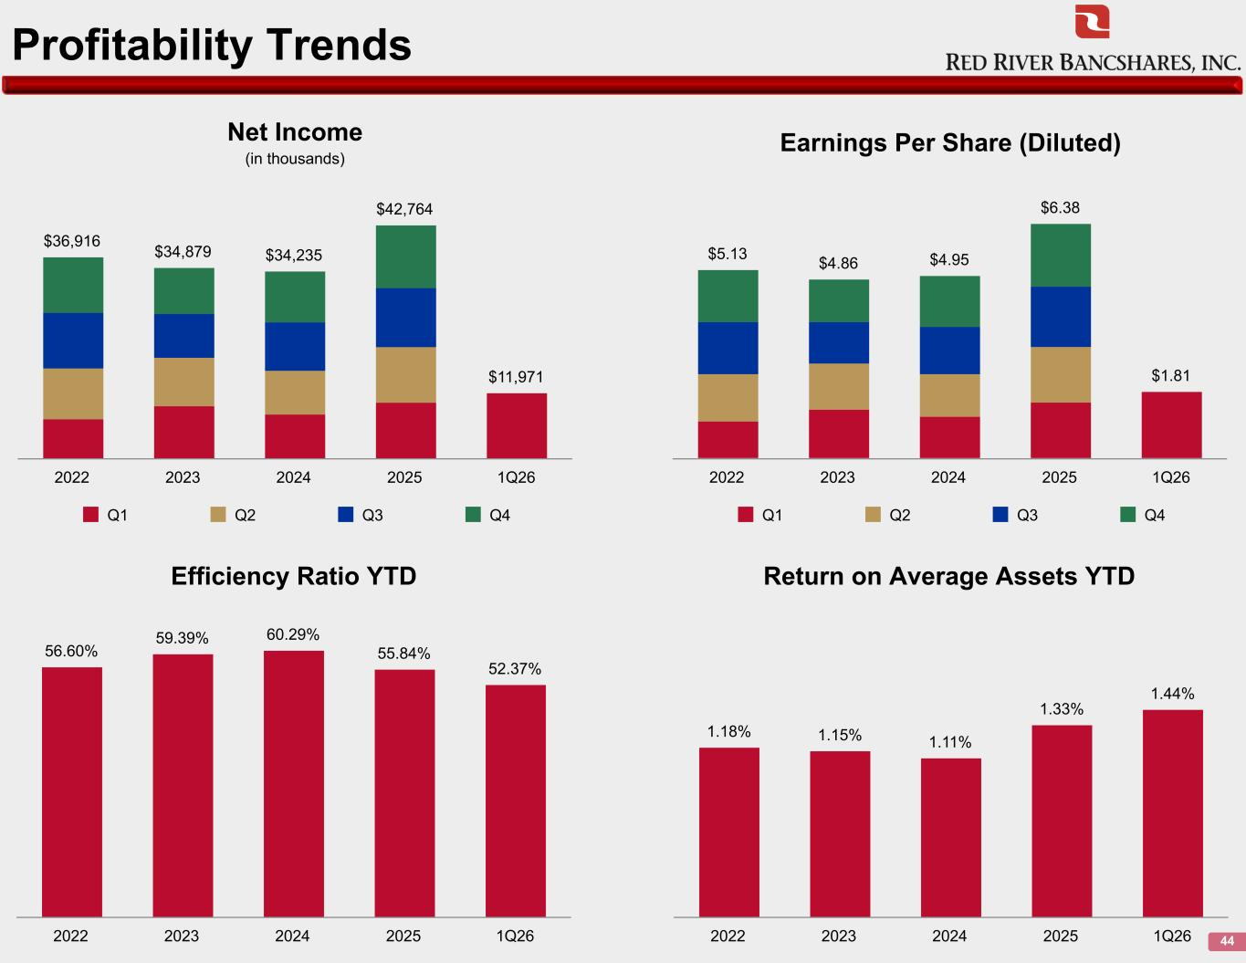
Profitability Trends 44 $36,916 $34,879 $34,235 $42,764 $11,971 Q1 Q2 Q3 Q4 2022 2023 2024 2025 1Q26 Net Income (in thousands) $5.13 $4.86 $4.95 $6.38 $1.81 Q1 Q2 Q3 Q4 2022 2023 2024 2025 1Q26 Earnings Per Share (Diluted) 56.60% 59.39% 60.29% 55.84% 52.37% 2022 2023 2024 2025 1Q26 Efficiency Ratio YTD Return on Average Assets YTD 1.18% 1.15% 1.11% 1.33% 1.44% 2022 2023 2024 2025 1Q26

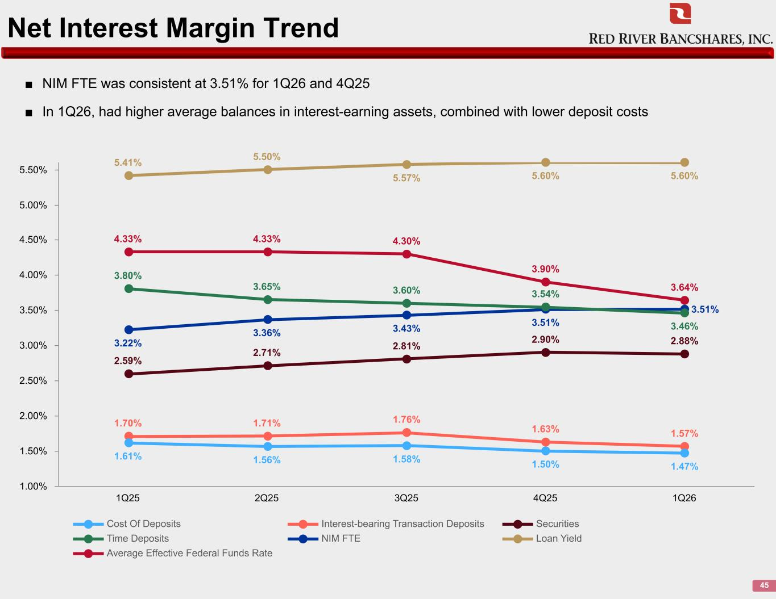
Net Interest Margin Trend 45 ■ NIM FTE was consistent at 3.51% for 1Q26 and 4Q25 ■ In 1Q26, had higher average balances in interest-earning assets, combined with lower deposit costs 4.33% 4.33% 4.30% 3.90% 3.64% 5.41% 5.50% 5.57% 5.60% 5.60% 3.22% 3.36% 3.43% 3.51% 3.51% 3.80% 3.65% 3.60% 3.54% 3.46% 2.59% 2.71% 2.81% 2.90% 2.88% 1.70% 1.71% 1.76% 1.63% 1.57% 1.61% 1.56% 1.58% 1.50% 1.47% Cost Of Deposits Interest-bearing Transaction Deposits Securities Time Deposits NIM FTE Loan Yield Average Effective Federal Funds Rate 1Q25 2Q25 3Q25 4Q25 1Q26 1.00% 1.50% 2.00% 2.50% 3.00% 3.50% 4.00% 4.50% 5.00% 5.50%

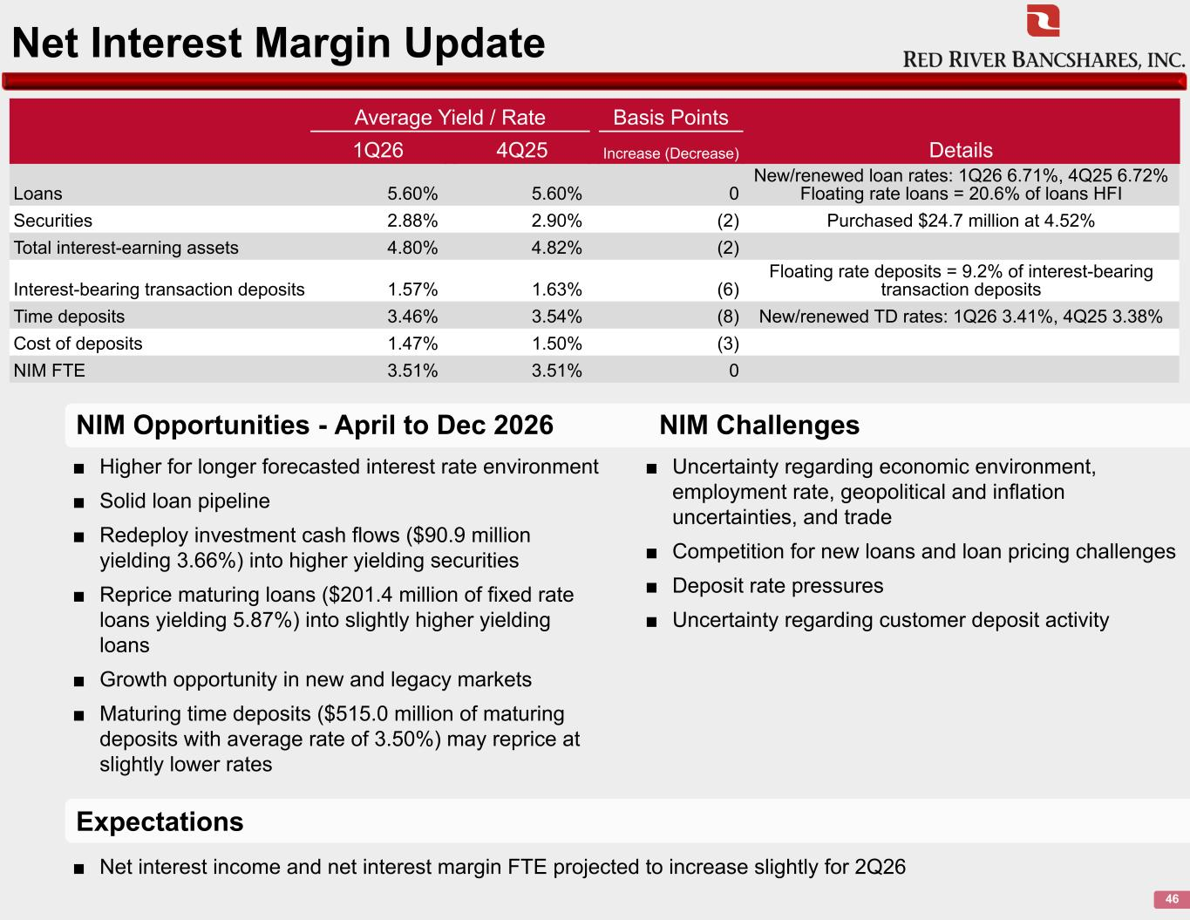
Net Interest Margin Update 46 ■ Higher for longer forecasted interest rate environment ■ Solid loan pipeline ■ Redeploy investment cash flows ($90.9 million yielding 3.66%) into higher yielding securities ■ Reprice maturing loans ($201.4 million of fixed rate loans yielding 5.87%) into slightly higher yielding loans ■ Growth opportunity in new and legacy markets ■ Maturing time deposits ($515.0 million of maturing deposits with average rate of 3.50%) may reprice at slightly lower rates Average Yield / Rate Basis Points Details1Q26 4Q25 Increase (Decrease) Loans 5.60% 5.60% 0 New/renewed loan rates: 1Q26 6.71%, 4Q25 6.72% Floating rate loans = 20.6% of loans HFI Securities 2.88% 2.90% (2) Purchased $24.7 million at 4.52% Total interest-earning assets 4.80% 4.82% (2) Interest-bearing transaction deposits 1.57% 1.63% (6) Floating rate deposits = 9.2% of interest-bearing transaction deposits Time deposits 3.46% 3.54% (8) New/renewed TD rates: 1Q26 3.41%, 4Q25 3.38% Cost of deposits 1.47% 1.50% (3) NIM FTE 3.51% 3.51% 0 ■ Uncertainty regarding economic environment, employment rate, geopolitical and inflation uncertainties, and trade ■ Competition for new loans and loan pricing challenges ■ Deposit rate pressures ■ Uncertainty regarding customer deposit activity ■ Net interest income and net interest margin FTE projected to increase slightly for 2Q26 Expectations NIM Opportunities - April to Dec 2026 NIM Challenges

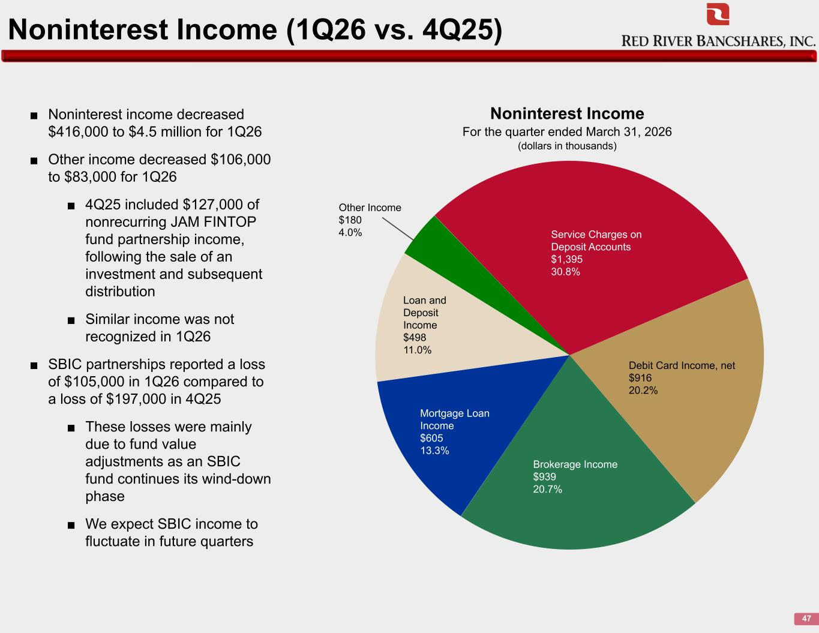
Noninterest Income (1Q26 vs. 4Q25) 47 ■ Noninterest income decreased $416,000 to $4.5 million for 1Q26 ■ Other income decreased $106,000 to $83,000 for 1Q26 ■ 4Q25 included $127,000 of nonrecurring JAM FINTOP fund partnership income, following the sale of an investment and subsequent distribution ■ Similar income was not recognized in 1Q26 ■ SBIC partnerships reported a loss of $105,000 in 1Q26 compared to a loss of $197,000 in 4Q25 ■ These losses were mainly due to fund value adjustments as an SBIC fund continues its wind-down phase ■ We expect SBIC income to fluctuate in future quarters Service Charges on Deposit Accounts $1,395 30.8% Debit Card Income, net $916 20.2% Brokerage Income $939 20.7% Mortgage Loan Income $605 13.3% Loan and Deposit Income $498 11.0% Other Income $180 4.0% Noninterest Income For the quarter ended March 31, 2026 (dollars in thousands)

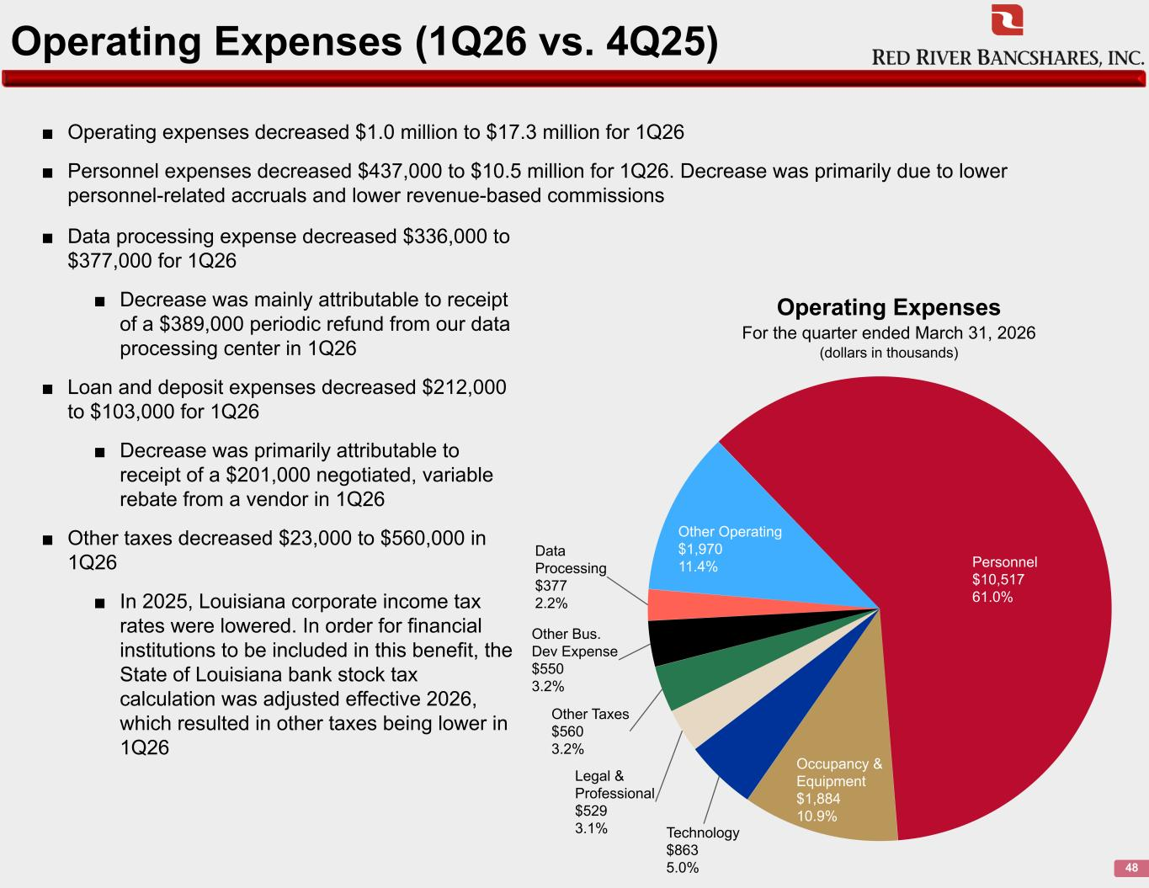
Operating Expenses (1Q26 vs. 4Q25) 48 ■ Operating expenses decreased $1.0 million to $17.3 million for 1Q26 ■ Personnel expenses decreased $437,000 to $10.5 million for 1Q26. Decrease was primarily due to lower personnel-related accruals and lower revenue-based commissions Personnel $10,517 61.0% Occupancy & Equipment $1,884 10.9% Technology $863 5.0% Legal & Professional $529 3.1% Other Taxes $560 3.2% Other Bus. Dev Expense $550 3.2% Data Processing $377 2.2% Other Operating $1,970 11.4% Operating Expenses For the quarter ended March 31, 2026 (dollars in thousands) ■ Data processing expense decreased $336,000 to $377,000 for 1Q26 ■ Decrease was mainly attributable to receipt of a $389,000 periodic refund from our data processing center in 1Q26 ■ Loan and deposit expenses decreased $212,000 to $103,000 for 1Q26 ■ Decrease was primarily attributable to receipt of a $201,000 negotiated, variable rebate from a vendor in 1Q26 ■ Other taxes decreased $23,000 to $560,000 in 1Q26 ■ In 2025, Louisiana corporate income tax rates were lowered. In order for financial institutions to be included in this benefit, the State of Louisiana bank stock tax calculation was adjusted effective 2026, which resulted in other taxes being lower in 1Q26

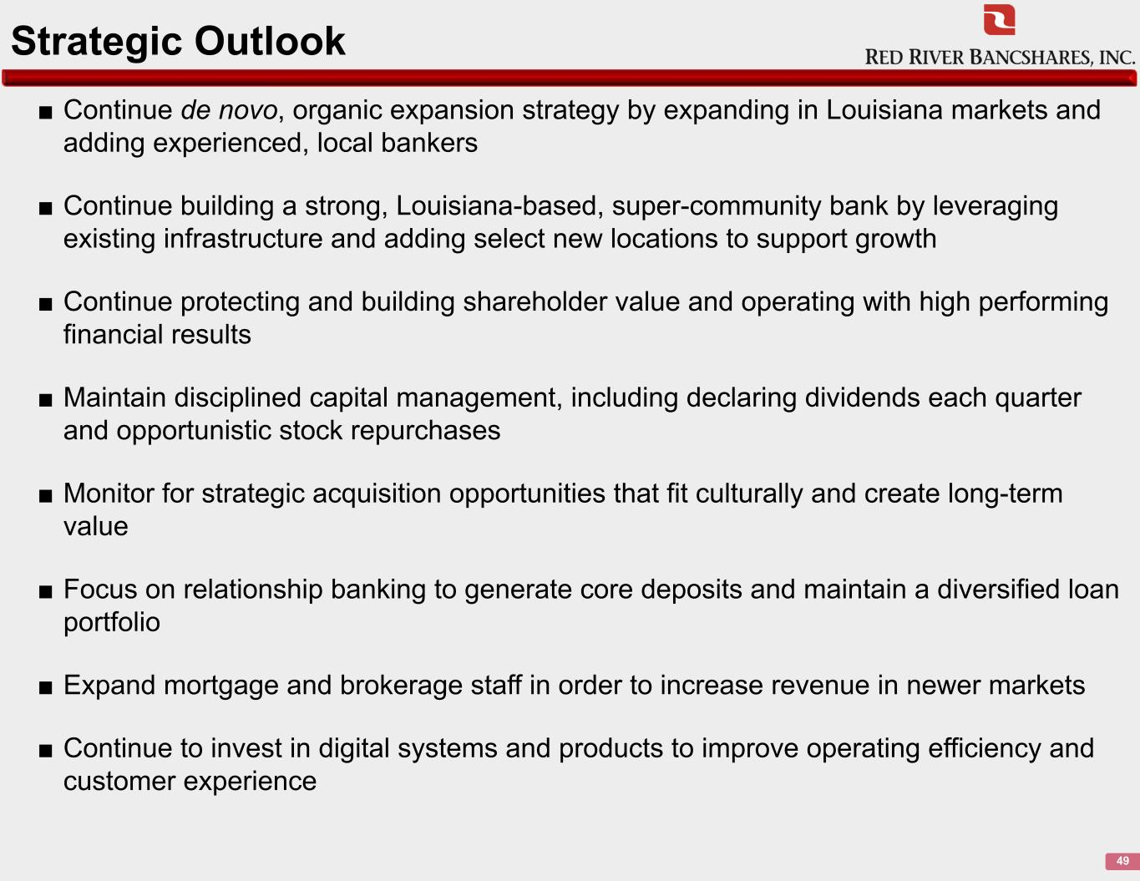
Strategic Outlook 49 ■ Continue de novo, organic expansion strategy by expanding in Louisiana markets and adding experienced, local bankers ■ Continue building a strong, Louisiana-based, super-community bank by leveraging existing infrastructure and adding select new locations to support growth ■ Continue protecting and building shareholder value and operating with high performing financial results ■ Maintain disciplined capital management, including declaring dividends each quarter and opportunistic stock repurchases ■ Monitor for strategic acquisition opportunities that fit culturally and create long-term value ■ Focus on relationship banking to generate core deposits and maintain a diversified loan portfolio ■ Expand mortgage and brokerage staff in order to increase revenue in newer markets ■ Continue to invest in digital systems and products to improve operating efficiency and customer experience

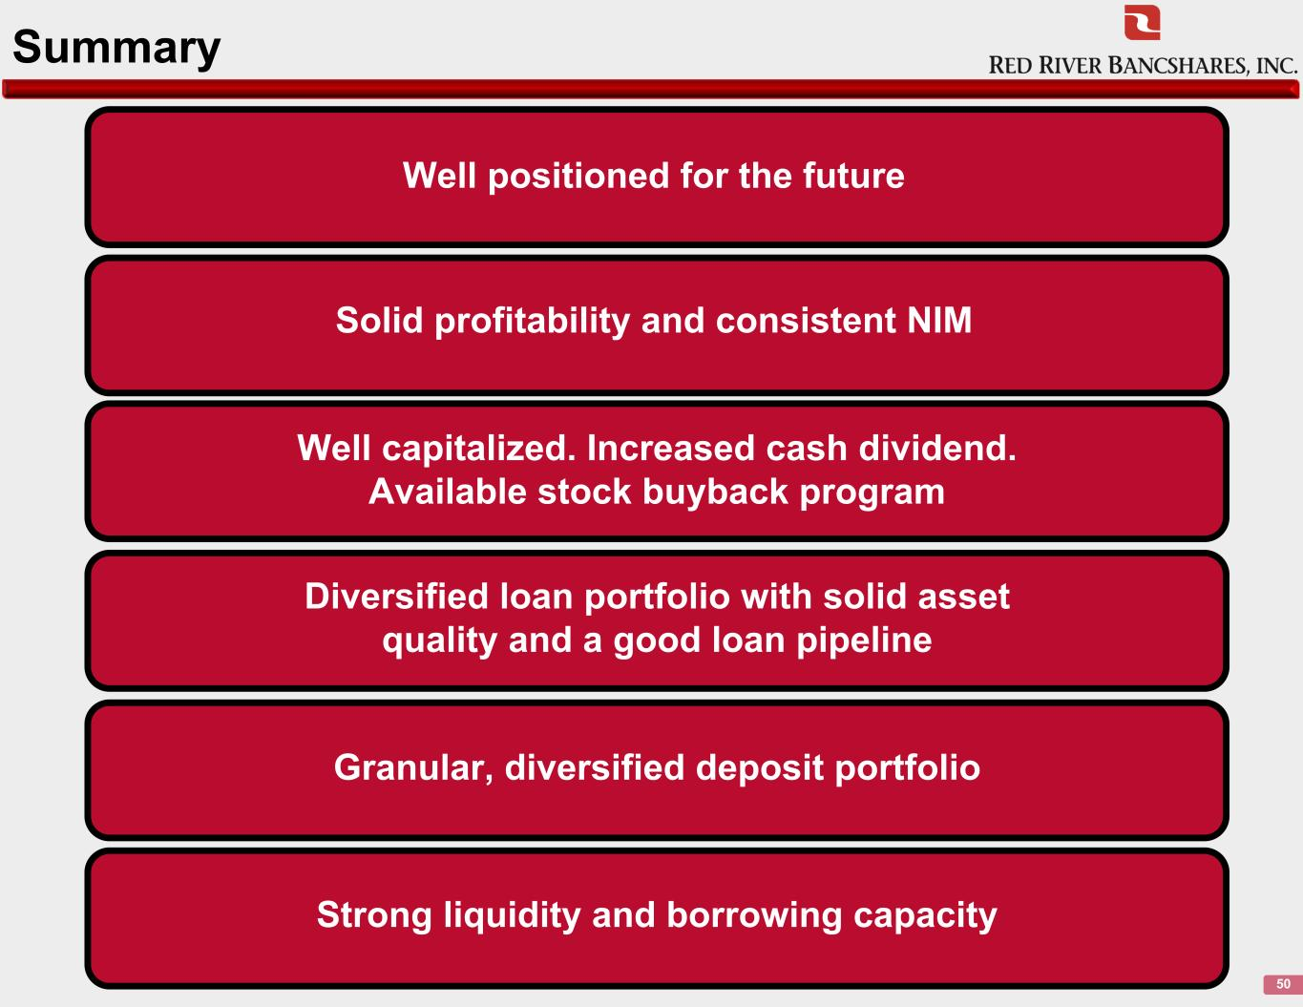
Summary 50 Solid profitability and consistent NIM Well positioned for the future Well capitalized. Increased cash dividend. Available stock buyback program Diversified loan portfolio with solid asset quality and a good loan pipeline Granular, diversified deposit portfolio Strong liquidity and borrowing capacity


Appendix

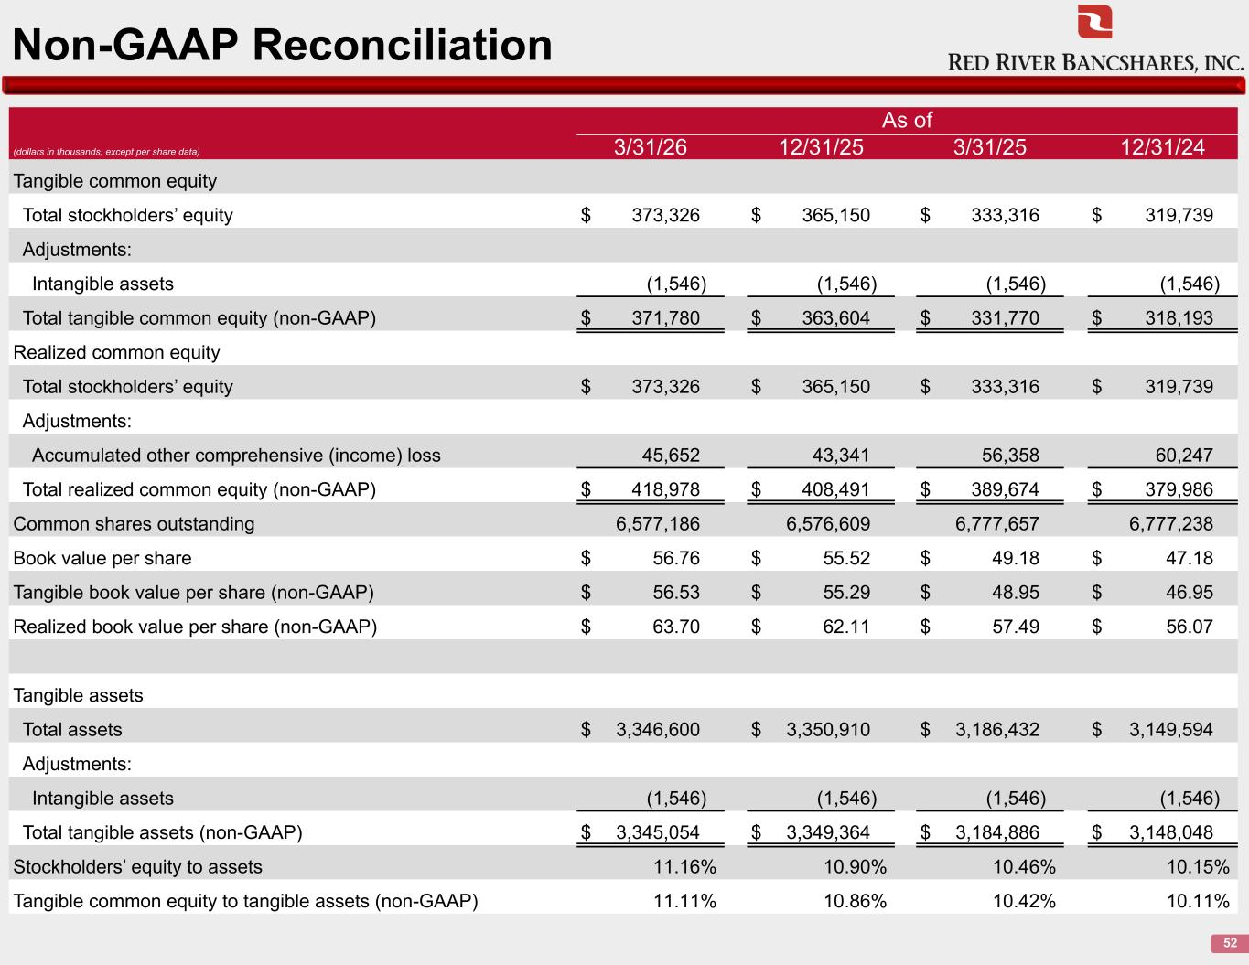
Non-GAAP Reconciliation 52 As of (dollars in thousands, except per share data) 3/31/26 12/31/25 3/31/25 12/31/24 Tangible common equity Total stockholders’ equity $ 373,326 $ 365,150 $ 333,316 $ 319,739 Adjustments: Intangible assets (1,546) (1,546) (1,546) (1,546) Total tangible common equity (non-GAAP) $ 371,780 $ 363,604 $ 331,770 $ 318,193 Realized common equity Total stockholders’ equity $ 373,326 $ 365,150 $ 333,316 $ 319,739 Adjustments: Accumulated other comprehensive (income) loss 45,652 43,341 56,358 60,247 Total realized common equity (non-GAAP) $ 418,978 $ 408,491 $ 389,674 $ 379,986 Common shares outstanding 6,577,186 6,576,609 6,777,657 6,777,238 Book value per share $ 56.76 $ 55.52 $ 49.18 $ 47.18 Tangible book value per share (non-GAAP) $ 56.53 $ 55.29 $ 48.95 $ 46.95 Realized book value per share (non-GAAP) $ 63.70 $ 62.11 $ 57.49 $ 56.07 Tangible assets Total assets $ 3,346,600 $ 3,350,910 $ 3,186,432 $ 3,149,594 Adjustments: Intangible assets (1,546) (1,546) (1,546) (1,546) Total tangible assets (non-GAAP) $ 3,345,054 $ 3,349,364 $ 3,184,886 $ 3,148,048 Stockholders’ equity to assets 11.16% 10.90% 10.46% 10.15% Tangible common equity to tangible assets (non-GAAP) 11.11% 10.86% 10.42% 10.11%

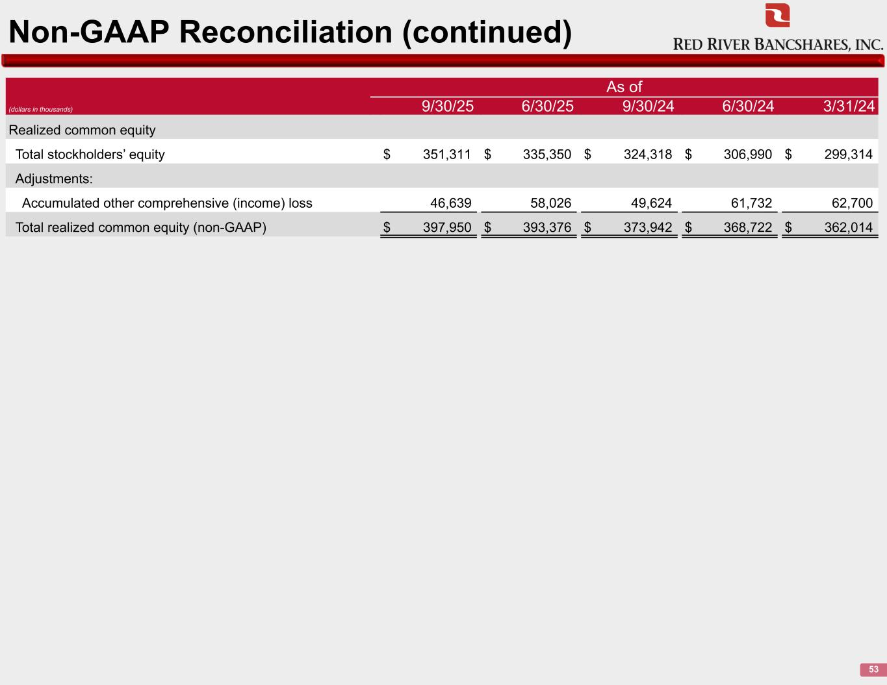
Non-GAAP Reconciliation (continued) 53 As of (dollars in thousands) 9/30/25 6/30/25 9/30/24 6/30/24 3/31/24 Realized common equity Total stockholders’ equity $ 351,311 $ 335,350 $ 324,318 $ 306,990 $ 299,314 Adjustments: Accumulated other comprehensive (income) loss 46,639 58,026 49,624 61,732 62,700 Total realized common equity (non-GAAP) $ 397,950 $ 393,376 $ 373,942 $ 368,722 $ 362,014

